Welcome to the Automotive L2 Course! Product Development Module.
This course provides you with an overview of the Automotive Industry.

It is part of a series of courses that provide you with the knowledge you need to work with clients involved in Automotive Industry.

When you are ready to begin, select START or the Vision & Strategy topics below.
Product Vision
A Product Vision is a description of the essence of your product.
It describes the overarching long-term mission of your product.
Vision statements are aspirational and communicate concisely where the product hopes to go and what it hopes to achieve in the long term.
Characteristics of Vision:
A vision should unite the organization and provide a stable, transcendent goal. The vision should avoid using jargon and buzz words and should use understandable terminology. Writing concise sentences is another way of clarifying a vision statement.
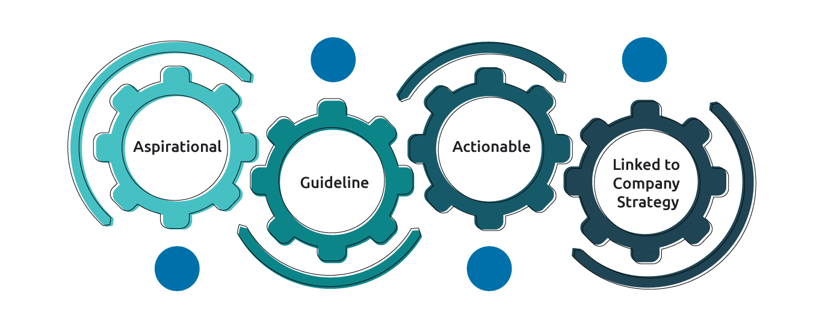
Aspirational
Product visions give your teams a bigger picture of what they are working on and why.
Guideline
The vision statement should serve as a guide and reminder to all stakeholders involved in a product’s development, it provide guidelines to entire team, on what they should be aimed to achieve it.
Actionable
Gives the team an array of actionable goals
Linked to Company Strategy
Product vision is always aligned with your company strategy of how they would like to see themselves in the market.
Product strategy
- Product strategy defines the high-level plan for developing and marketing a product. The product roadmaps systematically ascertain how the product will support the business strategy and goals.
- It also helps to envision the direction for new product development. Companies utilize the product strategy in strategic planning and marketing to set the direction of the company's activities.
- The product strategy comprises of several sequential processes to achieve the vision effectively. The strategy must be clear in terms of the target customer and market of the product to plan the roadmap needed to achieve strategic goals
- To accelerate the world’s transition to sustainable energy
- Tesla
- We ignite opportunity by setting the world in motion
- Uber
- People working together as a lean, global enterprise to make people’s lives better through automotive and mobility leadership
- Ford
- To be the most successful premium manufacturer in the industry
- BMW
- To offer freedom of movement with distinctive, affordable and reliable mobility solutions
- Stellantis
- To create a future of zero crashes, zero emissions, and zero congestion, and we have committed ourselves to leading the way toward this future.
- General Motors
- To be the most desired and successful transport solution provider in the world
- Volvo
- We will lead the future mobility society, enriching lives around the world with the safest and most responsible ways of moving people
- Toyota
Vision & Strategy in Automotive

Corporate strategy, planning & control involves defining the strategy, setting up the roadmaps to follow and keeping control on the way the company works. Let us explore in detail some of the key aspects.
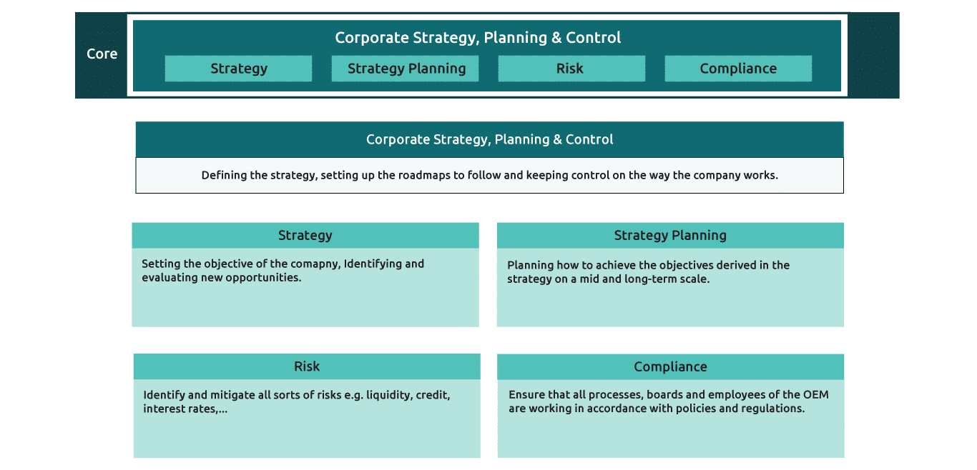
The German Automotive Market Unit domain experts and Business Technology Solutions (BTS) team have prepared this Automotive Capability Map. This Map lays out the capabilities of an automotive OEM and can be used for various purposes such as mapping Capgemini's projects to the value chain.
Trends & Technologies
Today’s economies are dramatically changing, triggered by development in emerging markets, the accelerated rise of new technologies, sustainability policies, and changing consumer preferences around ownership.
Digitization, increasing automation, and new business models have revolutionized other industries, and automotive will be no exception. These forces are giving rise to five disruptive technology-driven trends in the automotive sector:

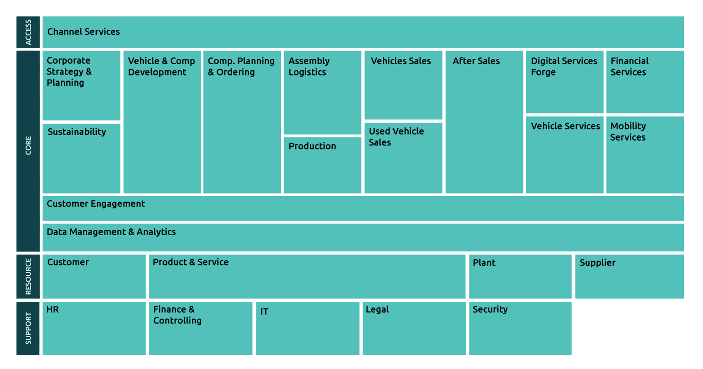
Knowledge Check
Identify and drag each of the below example whether it belongs to:
Strategy/Strategic Planning/ Risk/Compliance
Autonomous Vehicles
A self-driving car, also known as an autonomous car, driver-less car, or robotic car, is a car incorporating vehicular automation, that is, a ground vehicle that is capable of sensing its environment and moving safely with little or no human input.
Alternative Power Trains
These include propulsion systems that are not based exclusively on the popular internal combustion engine. This may include hybrids, full battery electrics, hydrogen fuel cells, compressed air, and many other types.
Predictive Maintenance via IOT Implementation
IoT-based predictive maintenance enables more efficient use of existing assets by providing the ability to predict machine failures and reduce maintenance issues. It can help identify the causes of delays, whether they're internal or external, and help set up processes to address these causes.
Car System Upgrade via Software Update
Software updates are issued by vehicle manufacturers periodically for a variety of reasons, including to correct bugs, improve vehicle performance, add new features, or protect against recently discovered vulnerabilities that could allow hackers to gain access to vehicle software and control vehicle systems.
Industry 4.0 Technologies in Manufacturing of Automobiles
The term industry 4.0 refers to a further developmental stage in the organization and management of the entire value chain process involved in manufacturing industry. Another term for this process is the fourth industrial revolution.
Product Development
There are initial design drafts as well as competition analysis and concept development. The result of the product definition is a design of the complete vehicle including a rough concept of the package, safety, production technology, and aerodynamic values.
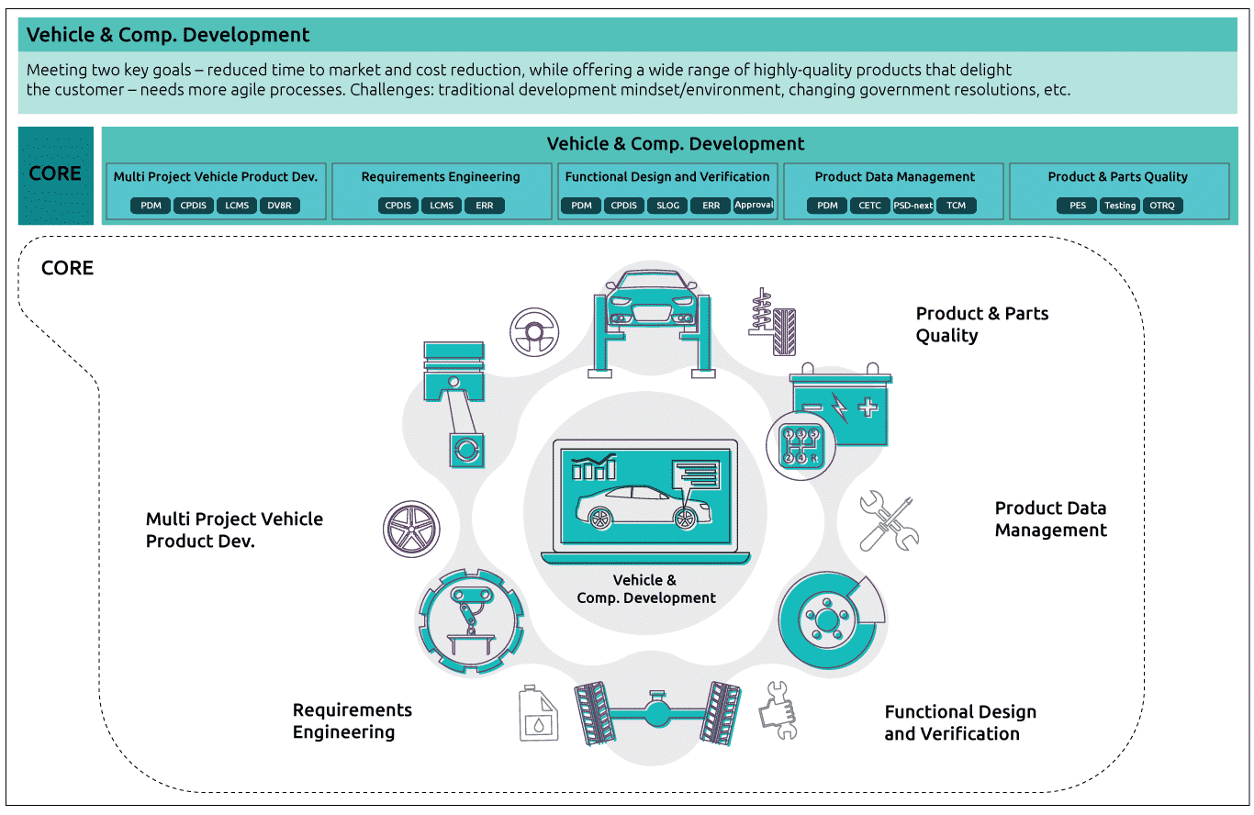
PDM, CPDIS, LCMS, DV8R
Product Data Management (PDM)
All electric and electronic components of vehicles are documented and regularly updated in this system.

Cross-Platform Design Info System (CPDIS)
Custom designing tool to map hybrid communication channels associated with various interior components with AUTOSAR i.e. for ECU communication modelling. Helps provide hardware specifications.

Launch & Change Mgmt System (LCMS)
Planning of Launch Management and Change Management (Model and type versioning). Supports and standardizes the cross-departmental sub processes related to ramp-up management and parts readiness management.

Deviator (DV8R)
Web-based workflow system to approve DTC, EOLT, TD, Test reports for all vehicle programs and plants globally.
Cross-Platform Design Info System (CPDIS)
Custom designing tool to map hybrid communication channels associated with various interior components with AUTOSAR i.e. for ECU communication modelling. Helps provide hardware specifications.

Launch & Change Management System (LCMS)
Planning of Launch Management and Change Management (Model and type versioning). Supports and standardizes the cross-departmental sub processes related to ramp-up management and parts readiness management.

Electronic Release Request (ERR)
Serves the maintenance of release requirements through car developers. Make changes in hardware components which is further used in prototyping.
PDM, CPDIS, S-LOG, ERR, APPROVAL
Product Data Management (PDM)
All electric and electronic components of vehicles are documented and regularly updated in this system.

Cross-Platform Design Info System (CPDIS)
Custom designing tool to map hybrid communication channels associated with various interior components with AUTOSAR i.e. for ECU communication modelling. Helps provide hardware specifications.

S-LOG (Software Logistics)
Enables changes in electronic components for prototyping, managing software changes and logistics.

Electronic Release Request (ERR)
Serves the maintenance of release requirements through car developers. Make changes in hardware components which is further used in prototyping.
CETC, PDM, PSD Next, TCM
CETC (PTTOOLKIT)
Used by ME Powertrain Data Management to Validate and Import Machinery & Equipment Design and BOM info.

Product Data Management (PDM)
All electric and electronic components of vehicles are documented and regularly updated in this system.

Product & Systems Data-Next (PSD-Next)
Consulting project for further evolution of product data management area at BMW.

Technical Change Mgmt (TCM)
DevOps engagement taking care of engineering change management processes to ensure synchronization of changes to vehicle products.
PES, TESTING, OTRQ
Parts Evaluation System (PES)
Through communicating sampling results, Evidence Validation Results etc. The system is responsible for carrying out inspection on third-party manufactured parts delivered for production.

OTR Quality (OTRQ)
DevOps engagement assuring quality of vehicle products by detecting and handling errors of vehicles received OTA on-the-road.
Product Data Management (PDM)
All electric and electronic components of vehicles are documented and regularly updated in this system.

Cross-Platform Design Info System (CPDIS)
Custom designing tool to map hybrid communication channels associated with various interior components with AUTOSAR i.e. for ECU communication modelling. Helps provide hardware specifications.

Launch & Change Mgmt System (LCMS)
Planning of Launch Management and Change Management (Model and type versioning). Supports and standardizes the cross-departmental sub processes related to ramp-up management and parts readiness management.

Deviator (DV8R)
Web-based workflow system to approve DTC, EOLT, TD, Test reports for all vehicle programs and plants globally.
Vehicle Test Analysis (VTA)
Vehicle test analysis system acts as a cockpit by integrating all the user test data and expert test feedback from various systems, for vehicles manufactured by a leading German OEM, to monitor and fix defects.
Bill of Materials (BOM)
What is BOM?
A listing of all the subassemblies, intermediates, parts, and raw materials that go into a parent assembly showing the quantity of each required to make an assembly. It is mandatory for Material Requirements Planning (MRP).
E BOM
Engineering Bill of Materials – as designed:
- EBOMs are created in engineering
- They are driven from the CAD tool and are usually centric to the final assemblies list of parts or components that make up the as designed or EBOM
- Organized with regards to how the product is designed
Example: 1.2-meter hydraulic tube, or the part should be painted (not specified in the EBOM with quantity) or cut out of steel with a certain thickness.
M BOM
Manufacturing Bill of Materials – as shipped
- MBOM will be driven by EBOM
- MBOM make up the ‘end item’, or product as shipped
- MBOM is focused on the parts that are needed to manufacture a product and includes reference designators
- MBOM requires additional things like shipping containers, crates, or packing foam, plastic bags for accessories, power cords, or items necessary to complete the product that are not defined on the EBOM
Example: MBOM provide unique components that help enterprises remain organized and connected throughout a product’s lifecycle.
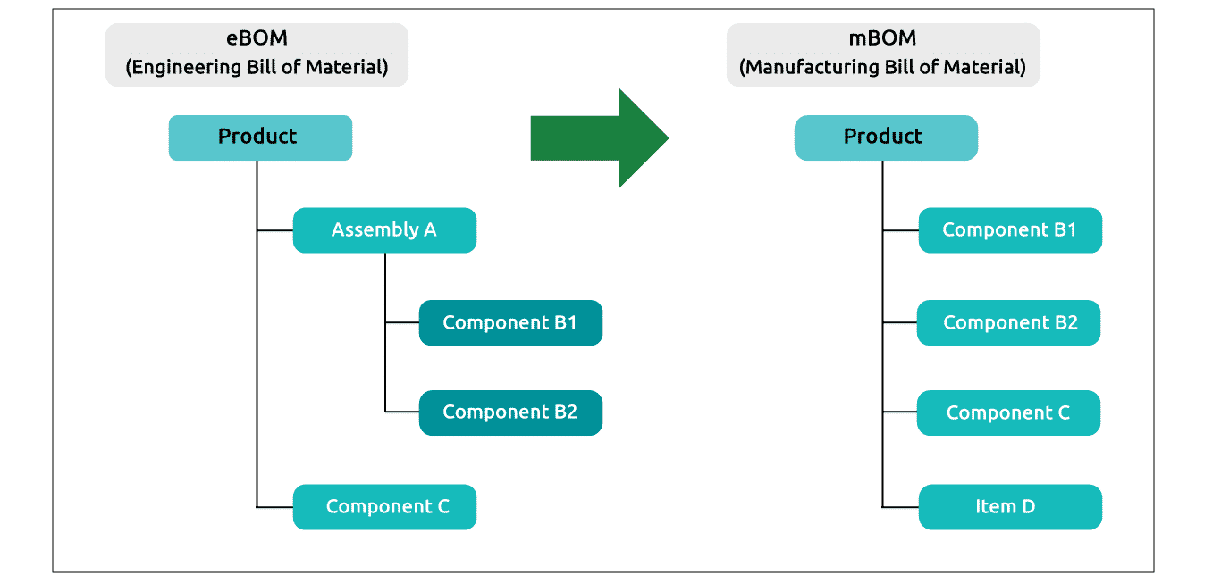
At the basic level, an engineering change is a process used to implement changes to components or products. The requirement for engineering change arises from the necessity that designs that evolve over the lifetime of the product.
Let's learn more about engineering change management (ECM) in detail.
- 1
The ECM process is a complex process, especially under a collaborative environment, where various independent entities work together for a common cause of product development.
- 2
It is an important competency in New Product Development.
- 3
The changes during the initial stages of the project are addressed by design iterations, while the changes after the product design is complete are addressed using a formal ECM process.
- 4
There are numerous approaches(can we name few of them) on how to cope with engineering changes exist in form of complex ECM systems.
- 5
However, start-ups and small companies have difficulties implementing these systems due to the lack of flexibility and agility—in addition to financial aspects.
High Level Change Management Process
A high level change management process can be defined as follows:
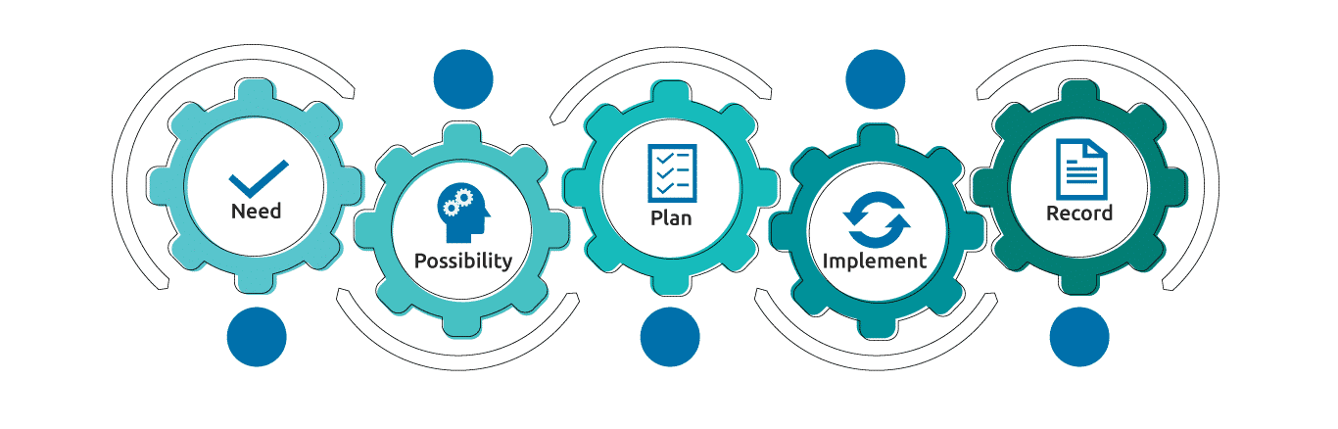
Need
Requesting or identifying the need for change
Possibility
Determining if the change is possible and desirable
Plan
Planning the change
Implement
Implementing the change
Record
Recording and following the change to ensure traceability and effectivity
The primary goals of an engineering change management process are to ensure minimal disruption to products, quality improvements, reduction in waste, and cost-effective implementation.
The ECM is continuously adapted along the different stages of maturity of the agile product development to cope with this shift of requirements.
Engineering changes are necessary to efficiently respond to market demands, service requirements, safety issues, functional and competitive challenges, as well as governmental requirements.
Passive Safety: Steering wheel, airbag modules, seatbelts and bags.
Active Safety: Video and radar sensors enable advanced driver assist functionality, automatic emergency braking and collision mitigation braking.
Components: Engine valves, entry systems and presence control systems.
Companies that manufacture goods that are used in the production process of an automobile or become part of an automobile, such that they supply these goods directly or indirectly to an automobile manufacturer.
The importance of process monitoring in the Automotive Industry. In the aim to differentiate from competitors, improve the product's quality and reduce costs.
IR is the effort to quickly identify an attack, minimize its effects, contain damage, and remediate the cause to reduce the risk of future incidents.
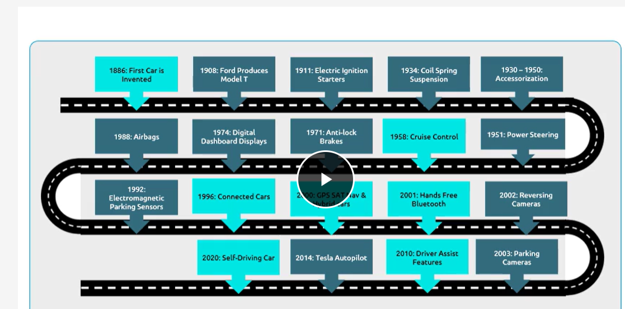
What is Manufacturing Strategy?
The manufacturing strategy is constituted, therefore, of the plans, policies and programs of actions implemented by the company, more specifically by the function production (in the areas of decision and in the processes of businesses), so that the competitive priorities are reached.
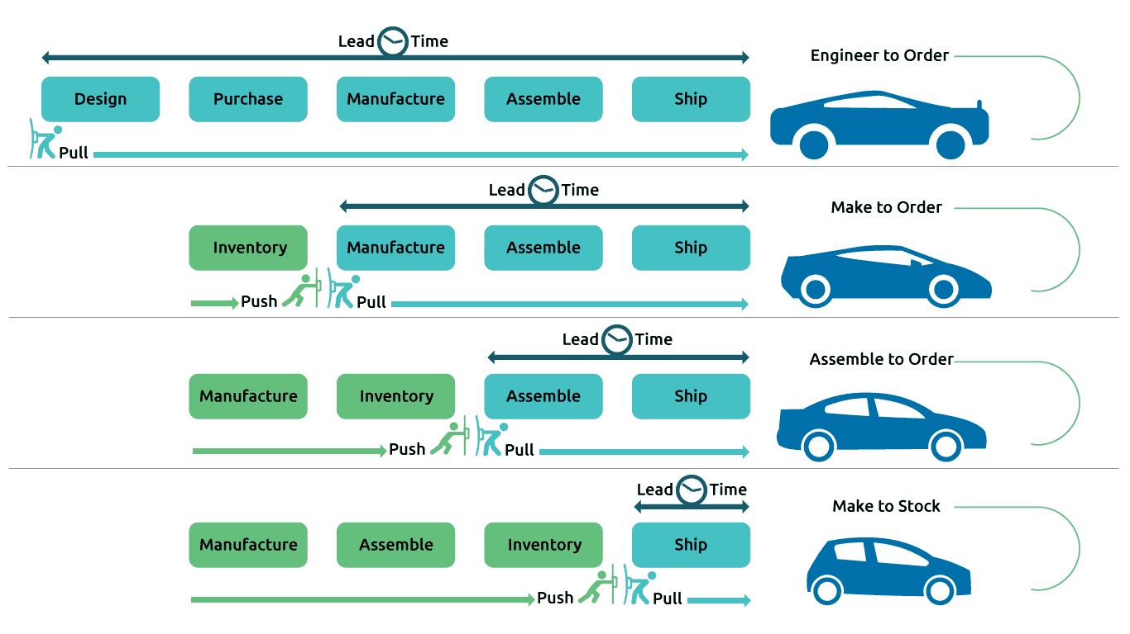
Engineer-To-Order (ETO)
FEATURES
Custom designed
Unique BOM
Unique item numbers
Long lead times
Low product volume
High product variety
BUSINESS ENVIRONMENT
No finished goods
Difficult to forecast
EXAMPLES:
High-end Luxury car
Make-To-Order (MTO)
FEATURES
Some repeat products
Long lead times
Low product volume
Large profit margins
High-end product variety
More variety than MTS
BUSINESS ENVIRONMENT
Raw materials are stocked in anticipation of future sales.
EXAMPLES
High value sports car
Assembled-To-Order (ATO)
FEATURES
Fewer products than MTO
High product volume than MTO
Some standard sub-assemblies
Build to forecast at the option level
Configured to customer order
Planning bills
BUSINESS ENVIRONMENT
Materials are stocked at a semi-finished stocking point
Maximum product flexibility
EXAMPLE
Sedan
Make-To-Stock (MTS)
FEATURES
Build to forecast
Rapid delivery
Standard product
High product volume
Low product variety
Lower profit margins, per unit
BUSINESS ENVIRONMENT
Finished goods are stocked
Forecast error costs money
EXAMPLE
Mid-value Hatchbacks

Product Regulatory Compliance
It plays a significant role in shipment of products to foreign and domestic customers. Evidence should be readily available for an audit.
Documentation
Organizing and providing a secure known location for Product Regulatory Compliance documentation is key to uninterrupted shipment of goods.
Self-Certification
In this type of compliance activity, the OEM owns and controls the test schedule, preparation and execution.
Type Approval / Witnessed Test
Type approval authority influences the test schedule, preparation and execution.
Homologation
Homologation is the process of bringing a product into compliance with, and/or certified to guidelines established by a regulating authority, generally at a national level.
Homologation and legal regulatory compliance for domestic as per CMVR rules (AIS) & Export as per requirement (EEC/ISO/OECD).
Homologation Division Strengths are the Following:
- 1
Homologation, which has been used in the automotive industry for some time, can also be applied to regulatory compliance of non-automotive products, components, and systems.
- 2
Outstanding short delivery times for certificates.
- 3
Cutting-edge facilities: proving grounds and testing laboratories and virtual capabilities (CAE).
- 4
Active participation in the rulemaking process in Geneva working groups within WP29.
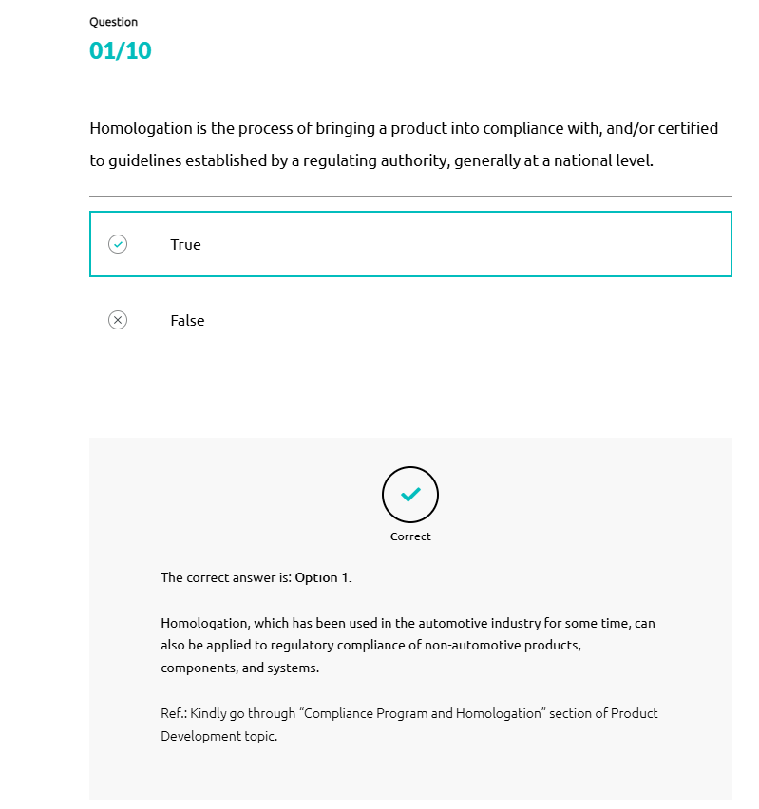
There are 5 levels of Autonomous Vehicles as defined by SAE. They are:
Level 0 ( No Driving Automation - Hands On)
Level 1 ( Driver Assistance - Hands On)
Level 2 ( Partial Driving Automation - Hands Off)
Level 3 ( Conditional Driving Automation - Eyes Off)
Level 4 ( High Driving Automation - Mind Off)
Level 5 ( Full Driving Automation - Driverless)
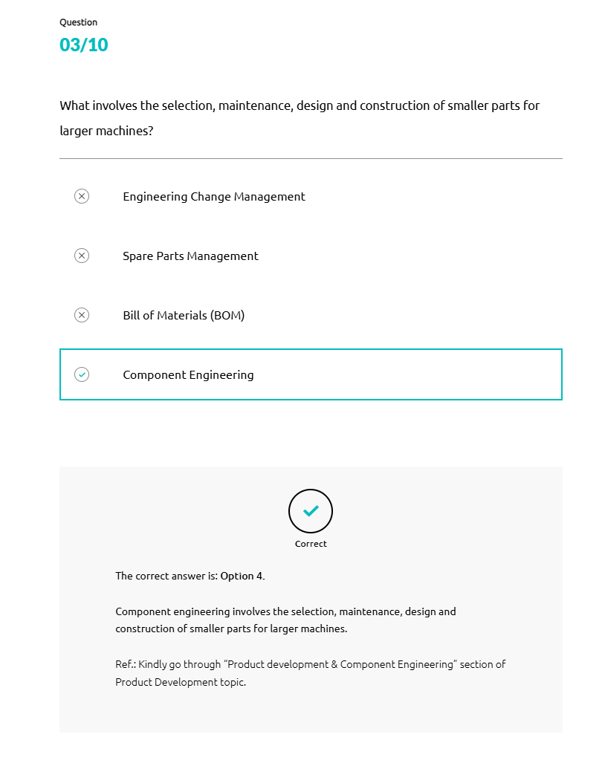
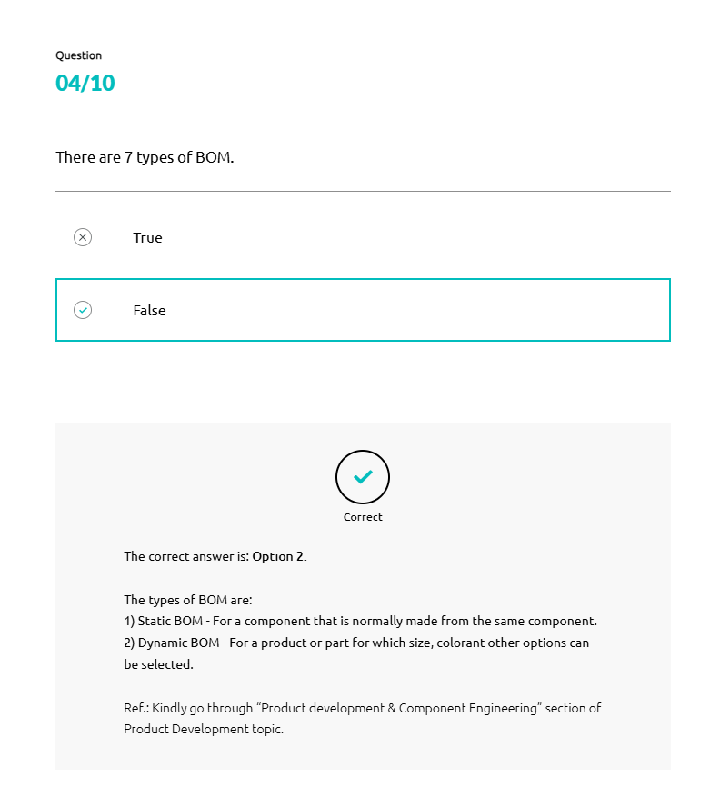
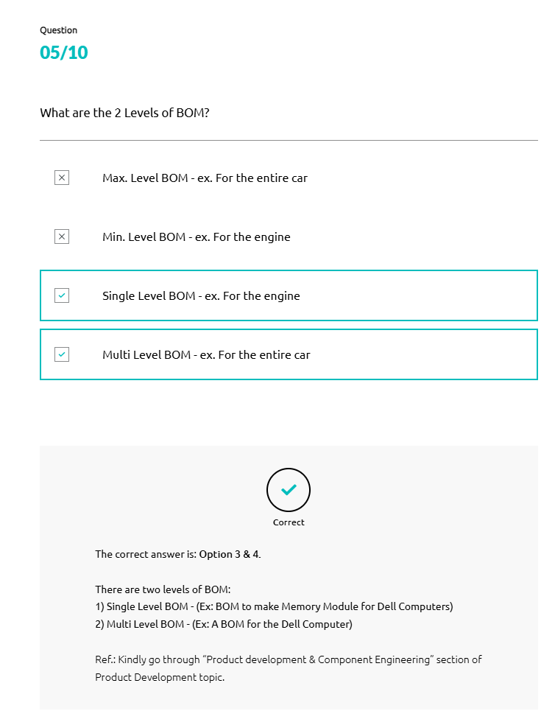

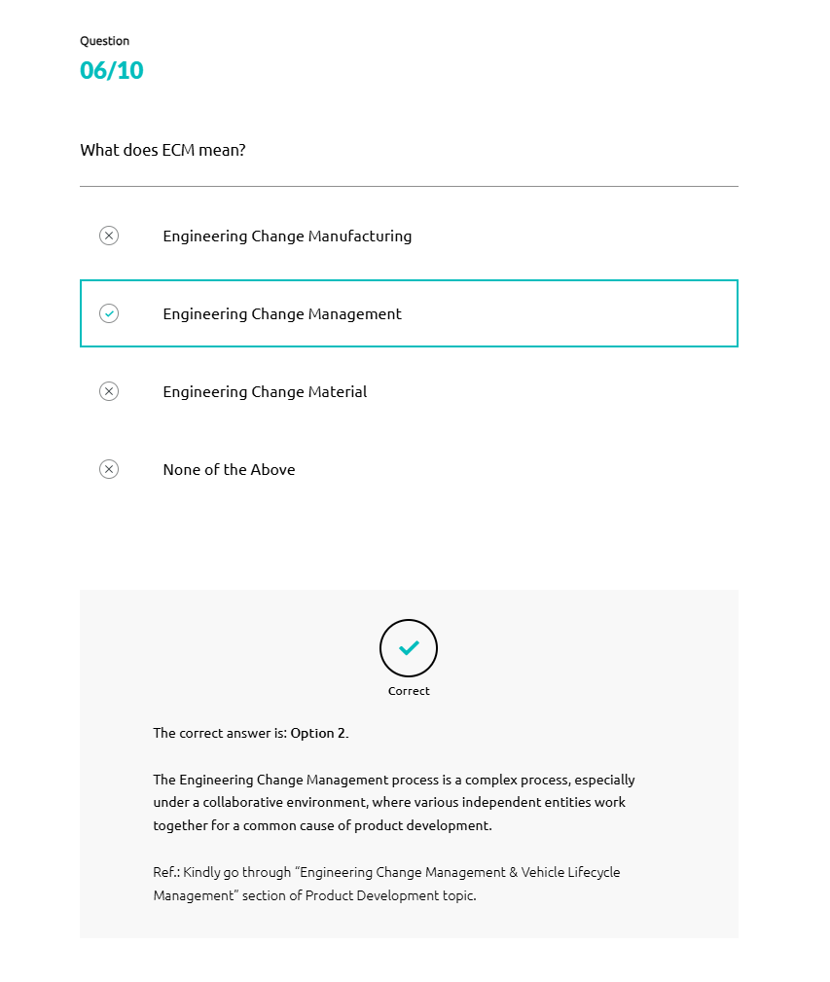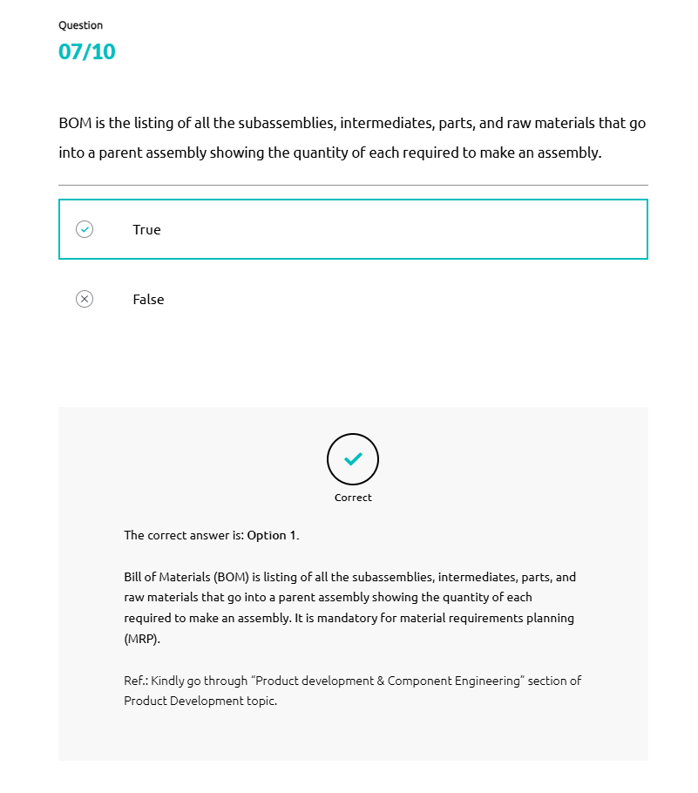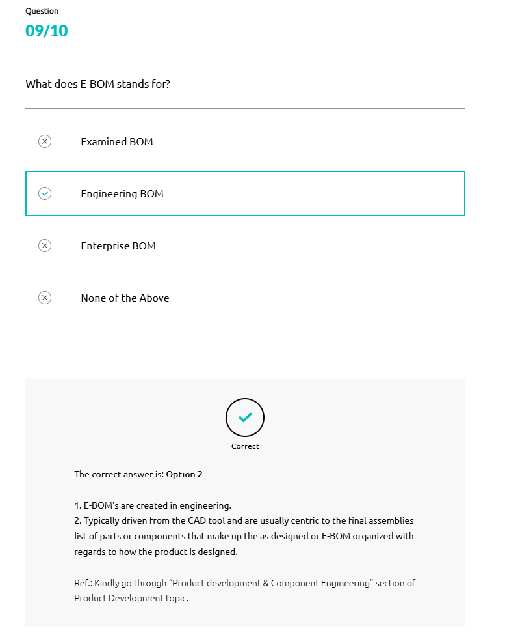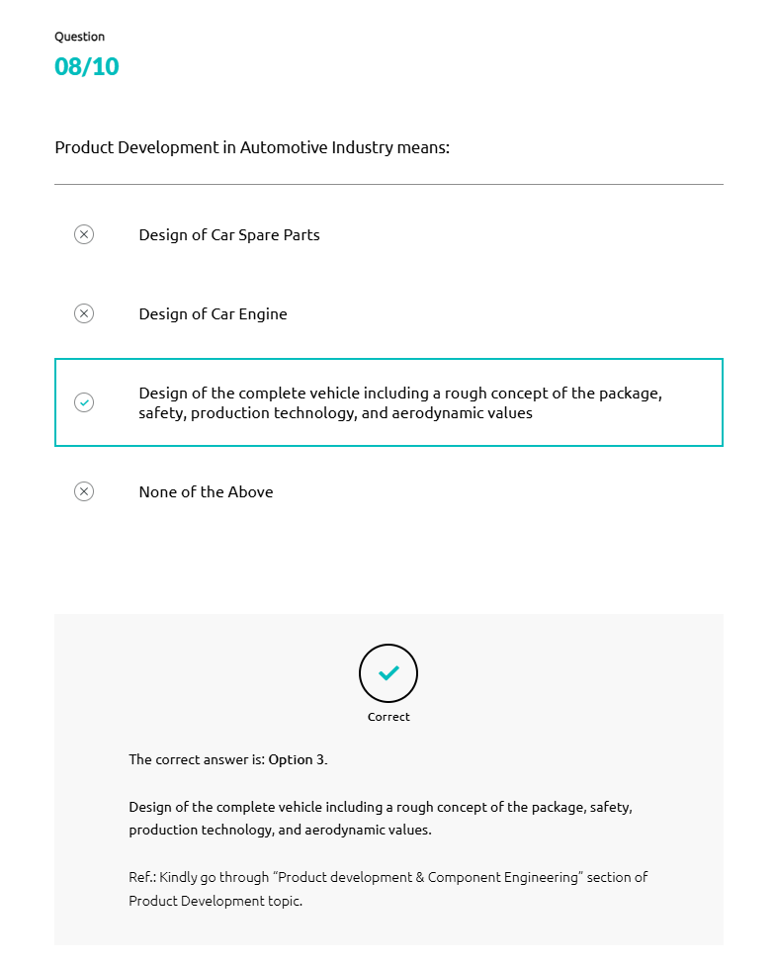
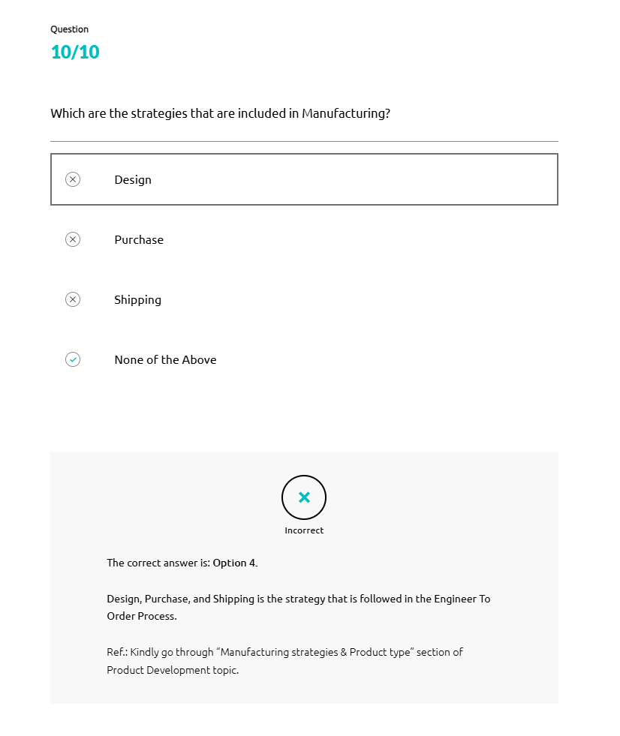
What is Manufacturing?
Manufacturing refers to the processing of finished products from raw materials using various methods, human labor, and equipment according to a detailed plan in a cost-effective way.
Large-scale manufacturing uses core assets, including assembly line processes and sophisticated technologies for the mass production of goods.
To set up a successful manufacturing unit, there are various plans need to be implemented. Let’s have look at these various plans.
PRODUCTION PLANNING
Production planning is the process of deciding how a product or service will be manufactured before the manufacturing process begins.
It is very important for manufacturers as it affects other important aspects of their business such as:
- •
Supply chain management
- •
Production scheduling
- •
Material requirements planning
- •
Production lead time
- •
Capacity planning
Inputs to Production Planning
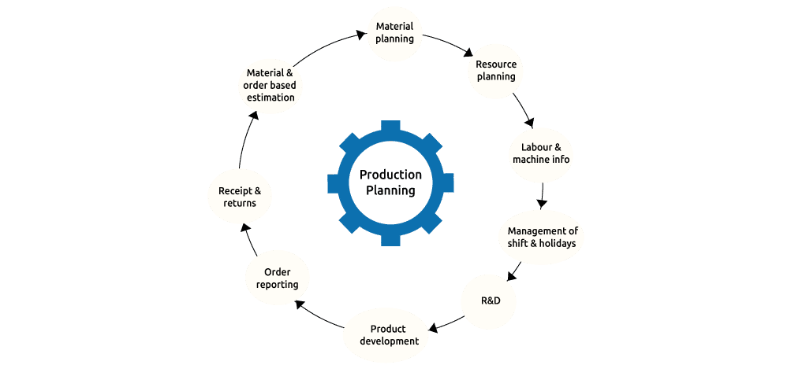
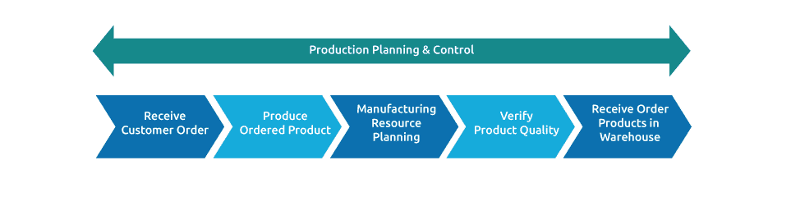
Receive Customer Order
- Receive finalized customer order
- Create master production schedule
Produce Ordered Product
- Release MPS
- Production design
- Raw material avl
- Resource avl
- Material handling
- Equipment avl
- Material receipt
- Inspection
- Update inventory
Manufacturing Resource Planning
- Production order scheduling
- Freed inventory to line
- Manufacture
Verify Product Quality
- In process inspection
- Approve or reject product
- Tagging and moving to warehouse
Receive Order Products in Warehouse
- Intimation from inspection and tag identification
- Update customer about order completion
- Dispatch products to identified location
- Update inventory
RESOURCE PLANNING

Resource planning is a strategic approach to using resources in the most effective way, across a single project or a portfolio of work. When executed properly, organizations achieve maximum efficiency and optimization in their use of resources, without under or over-utilizing any one resource.
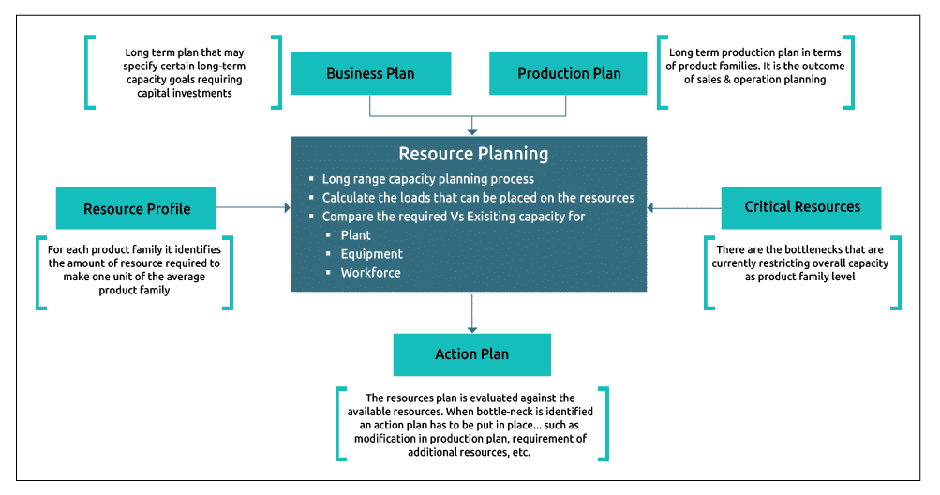
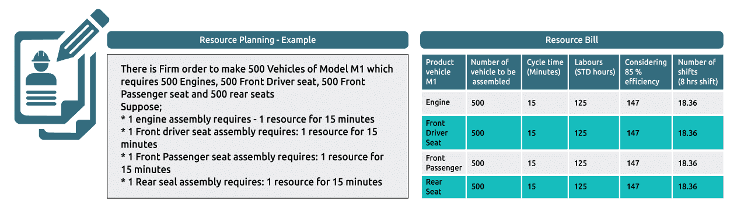
MATERIAL REQUIREMENTS PLANNING
Material Requirements Planning (MRP) is a system for calculating the materials and components needed to manufacture a product.
It consists of three primary steps:
- 1
Taking inventory of the materials and components on hand
- 2
Identifying which additional ones are needed
- 3
Scheduling their production
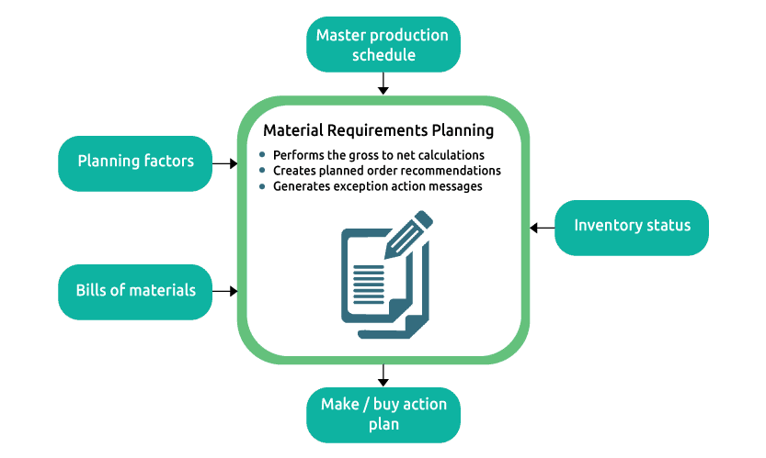
Master production schedule
- What should be produced?
- How many?
- When is it needed?
Inventory status
- What is on hand?
- What is on order?
- What is the lead time?
- Is safety stock required?
Make / buy action
- What should be ordered?
- What orders should be expedited?
- What orders should be cancelled?
- What should be de-expedited?
Bill of materials
- What parts do I need to make the product and in what quantities?
Master production schedule
- What should be produced?
- How many?
- When is it needed?
How Does MRP Work?
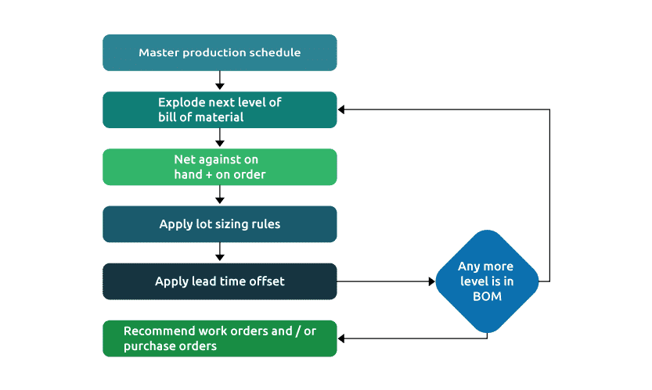
CAPACITY PLANNING
Capacity Planning refers to the process of deciphering how many resources you're going to need to meet demand. This demand can be for any unit of time. It can be for the coming week, next season, or even in a year's time.
Employing staff to meet the coming demand also falls under Capacity Planning.
Establishes whether critical resources are available:
- Bottleneck operations
- Critical labor resources
- Critical material
Often uses a resource bill for a single product

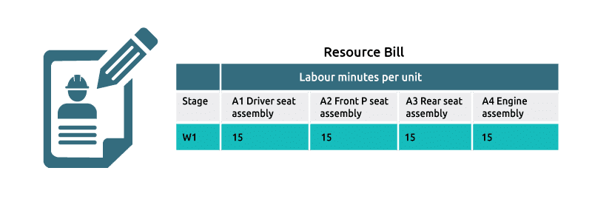
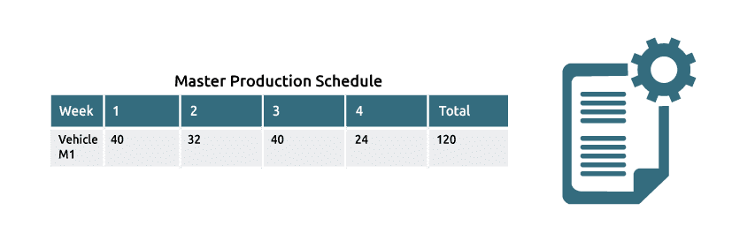
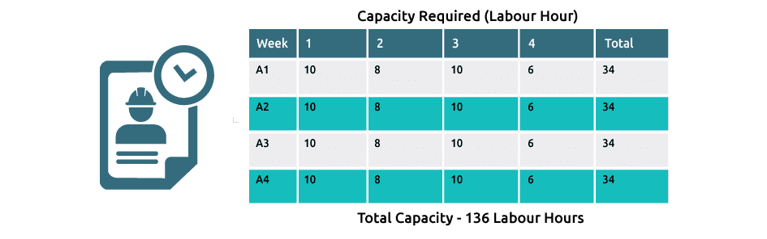
PLANT SAFETY PLANNING
There are some basic safety planning steps are followed in a manufacturing plant. They are:

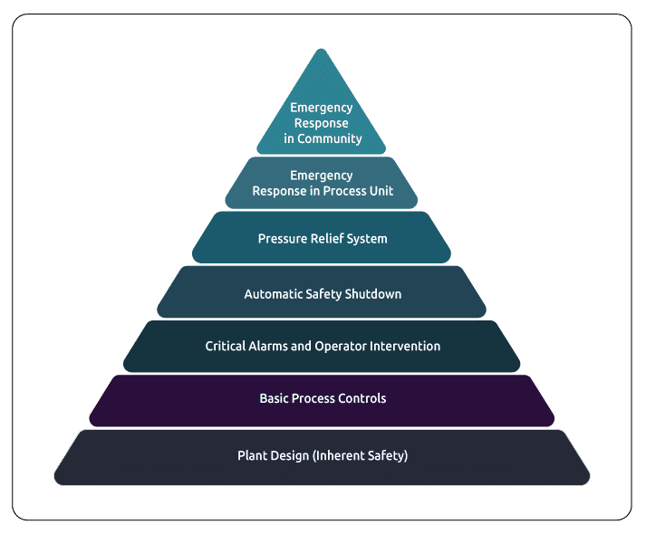
Types of Management and Management Policies
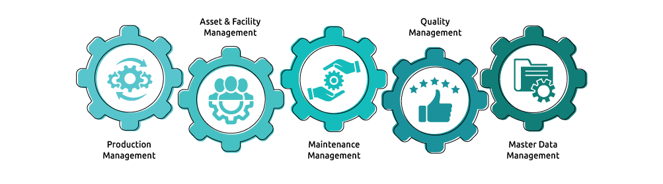
Different management policies are required to be implemented to run a manufacturing unit successfully. They are:
Production Management
Production Management refers to the process of managing the activities of a business to furnish desired outputs of products and services. It involves planning, executing, and directing operations to convert raw materials into finished goods and services.
Asset and Facility Management
Asset Management is defined as an organization's effort to measure and fulfill the value provided by all tangible and intangible assets. Facility Management, on the other hand, is restricted to physical assets that are utilized by the organization.
Maintenance Management
Maintenance management is the process of maintaining a company's assets and resources while controlling time and cost. The purpose is to ensure that production proceeds efficiently and that resources are used effectively.
Quality Management
Master Data Management
Quality management is the act of overseeing all activities and tasks needed to maintain a desired level of excellence. Quality management includes the determination of a quality policy, creating and implementing quality planning and assurance, quality control, and quality improvement.
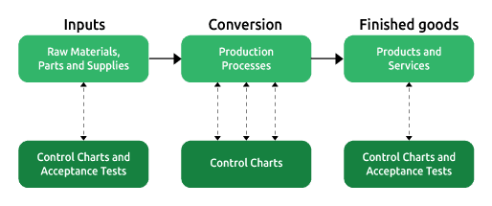
Master Data Management (MDM) is a discipline where business and information technology work together to ensure the uniformity, accuracy, stewardship, consistency, and accountability of the enterprise's official shared master data assets.

There are three essential components of MDM. They are:
- Enterprise Data Management: EDM describes an organization’s ability to integrate, govern, secure, and circulate data from multiple data sources. It means the organization’s capacity to transfer data accurately and securely among partners, subsidiaries, applications, and processes
- Analytics Platform Services: APS includes all methods, tools, and services which help to make new data-driven knowledge available to the whole enterprise and enable domain-specific analytics including advanced AI technology
- Domain-specific Data Services: DSDS includes all methods, tools, and services to enable data-driven business by providing domain-specific analytics and insights using the analytics platform services
There are a few basic steps for Vehicle Manufacturing. They are:
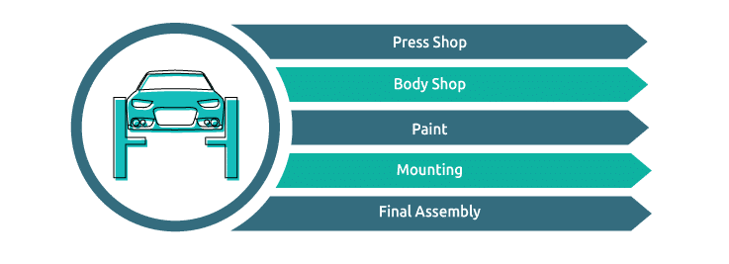
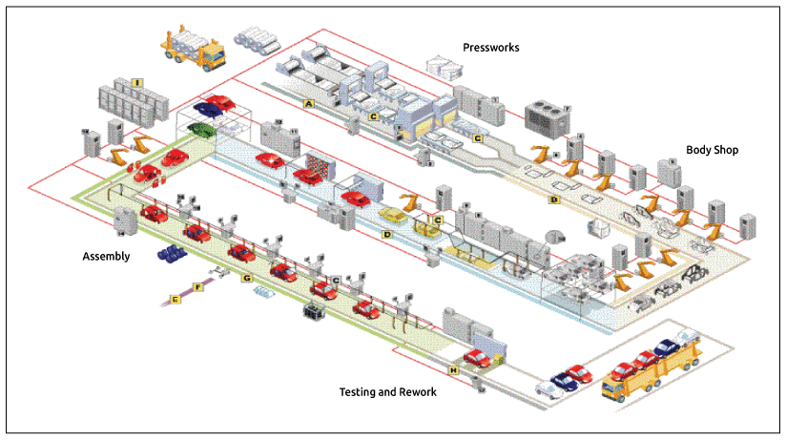
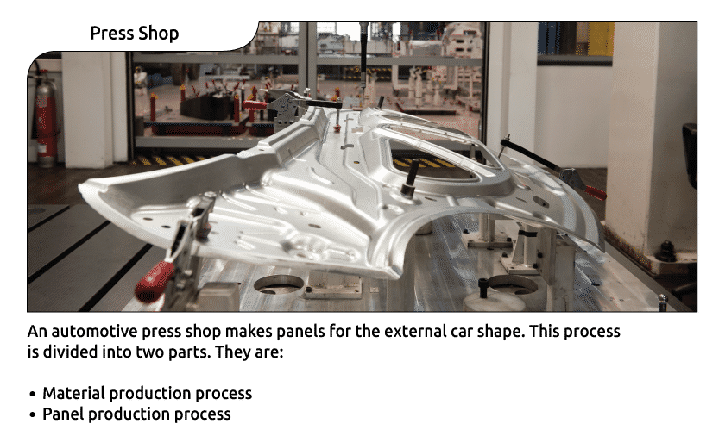
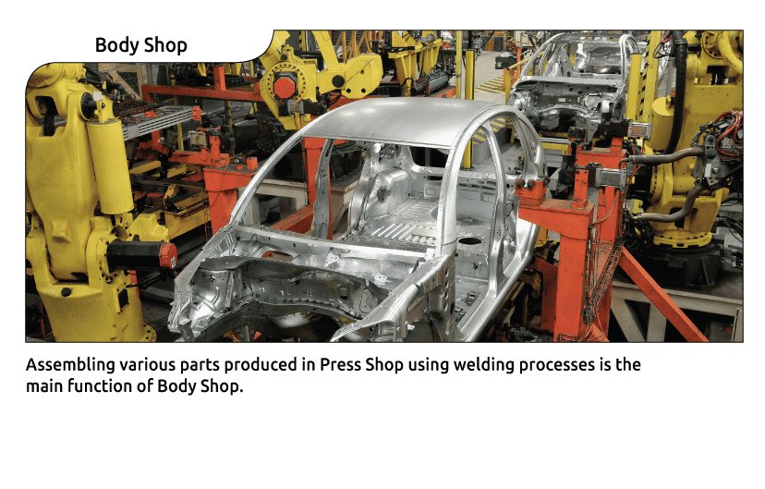
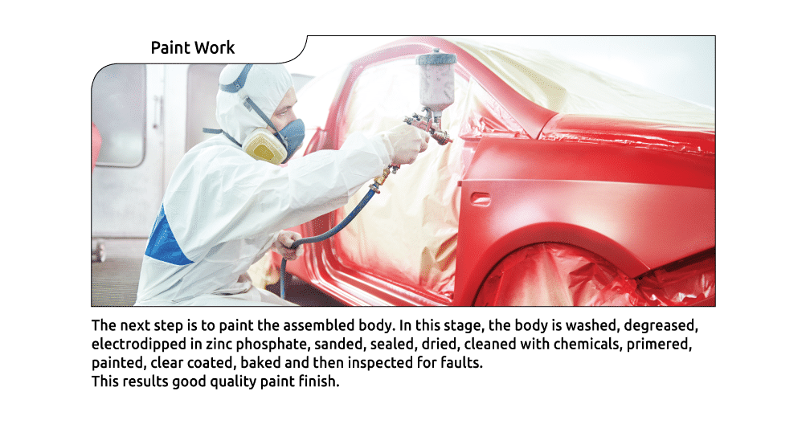
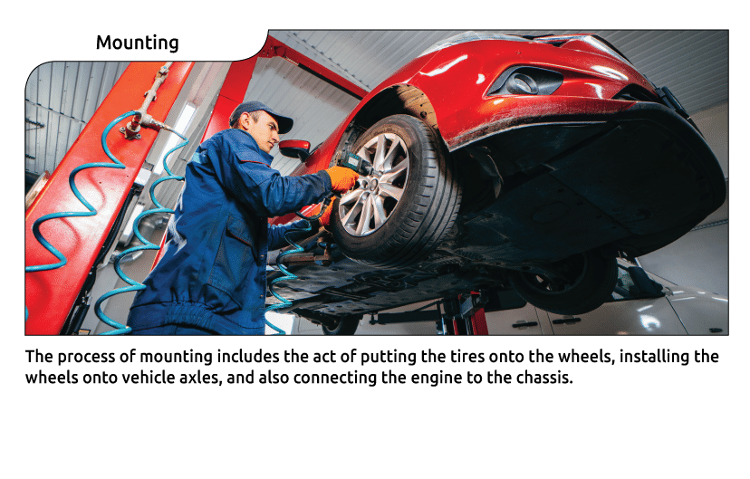
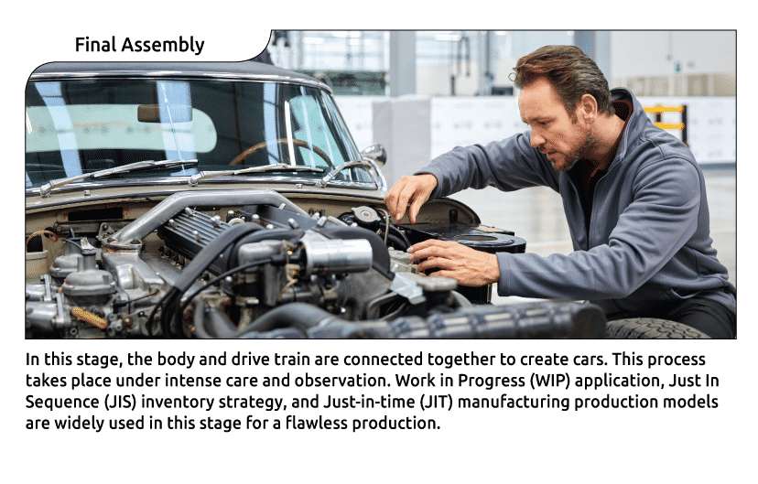
Quality Validation
Cars are more reliable these days than ever before. That's because carmakers have mastered the art of manufacturing quality control. In any industry, quality control is a process to ensure a bug-free product. In auto manufacturing, cars go through rigorous testing to make sure they're well-engineered, safe, and comfortable.
The objective of validating quality targets is to achieve the desired level of product standards and customer satisfaction. It can be achieved by:
- •
Monitoring process to minimize defects cost
- •
Ensuring regulatory compliance
- •
Implementing standardize acceptance criteria
Quality means conformance to specifications. To ensure the quality of products, the following activities are performed:
- 1
Examine the incoming materials to make sure to meet the appropriate specifications
- 2
Analyze the quality of partially completed products to determine if production processes are functioning properly
- 3
Study the finished goods and services to determine if they meet customer expectations
Quality Verification and Validation Process in Automotive Manufacturing
Quality verification and validation processes in vehicle manufacturing involve a series of checks and tests to ensure that vehicles meet the required standards of safety, performance, and reliability. These processes are crucial to ensuring that the vehicles produced are of high quality and meet customer expectations.
The quality verification process involves checking the design and production processes to ensure that they meet the required quality standards. This includes
- Checking the materials used in production
- Inspecting the parts and components used in the vehicle.
- Verifying that the production processes meet the required specifications.
- Conducting tests on the vehicle to ensure that it meets the necessary safety and performance standards.
The quality validation process involves testing the vehicle to ensure that it meets the required quality standards.
- Conducting a series of tests on the vehicle, such as crash tests, durability tests, and performance tests, to ensure that it meets the necessary safety and performance standards.
- Testing the vehicle under different environmental conditions, such as extreme temperatures, to ensure that it can operate under a wide range of conditions.
Throughout the quality verification and validation processes, manufacturers use various tools and techniques to monitor the quality of the vehicles being produced. These tools include statistical process control, quality audits, and quality control charts, which enable manufacturers to identify and correct any quality issues that may arise during the production process.
Overall, the quality verification and validation processes in vehicle manufacturing are critical to ensuring that the vehicles produced are of high quality, safe, and reliable. By conducting rigorous checks and tests, manufacturers can identify and address any quality issues before the vehicles are released to the market, ensuring customer satisfaction and maintaining the manufacturer's reputation for quality.
Assembly and Testing
Vehicle Assembly Processing uses machines, equipment, and workers to assemble various vehicle parts and materials in a pre-defined format to manufacture vehicles. There are three types of Assembly Processing.
Trim Assembly
- Harnesses and controls-other electrical
- Pedal assembly, insulator
- Air duct, heater, headliner
- Weatherstrip, horn, stop switch
Chassis Line
- Brake tube, filler neck, splash shield
- Fuel pipe, fuel tank, canister
- Rear axle, stabilizer
Final Assembly
- Rear pillar trim, trunk lid latch
- License plate lamp, radiator, hose
- Heat hose, steering shaft
- The parking brake, garnish
Layout of Trim and Final Assembly
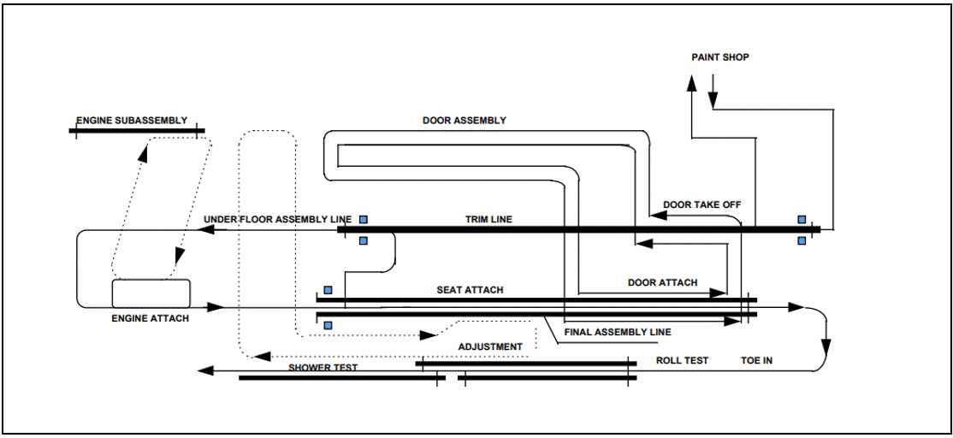
Testing
After the vehicle comes out of the final assembly line, it is driven on its power to the vehicle testing area. Various types of inspection equipment are used to test a vehicle. They are:
- Wheel Alignment Tester
- Turning Radius Tester
- Headlight Tester
- Side Slip Tester
- Drum Tester
- Brake Tester
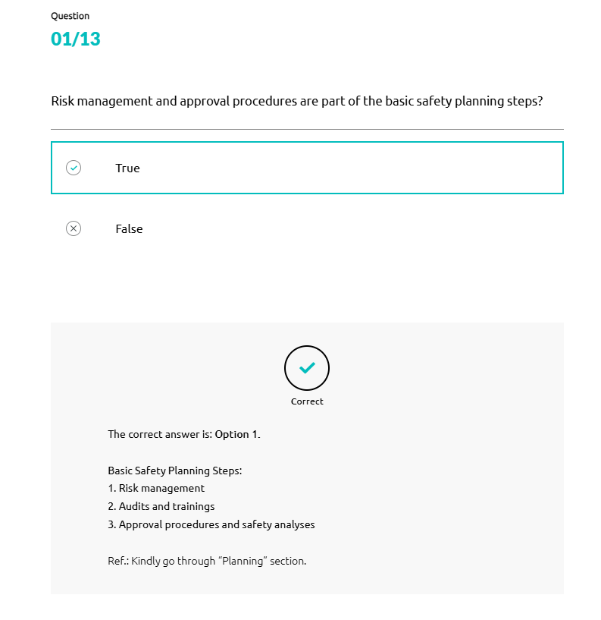
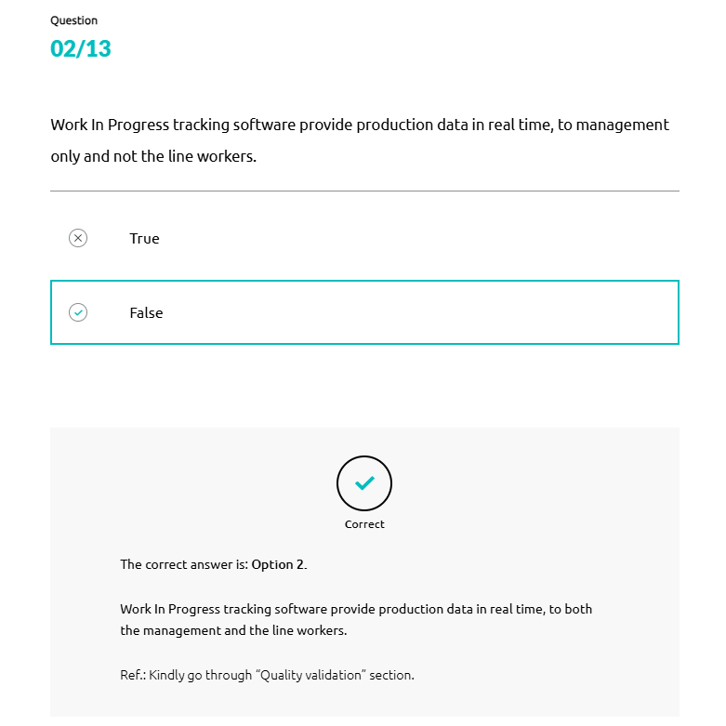
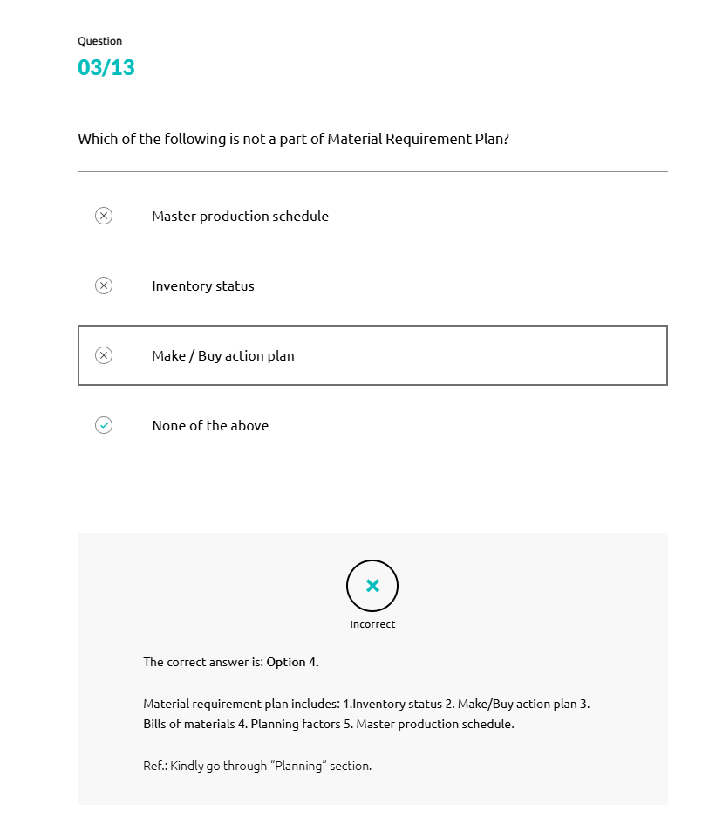
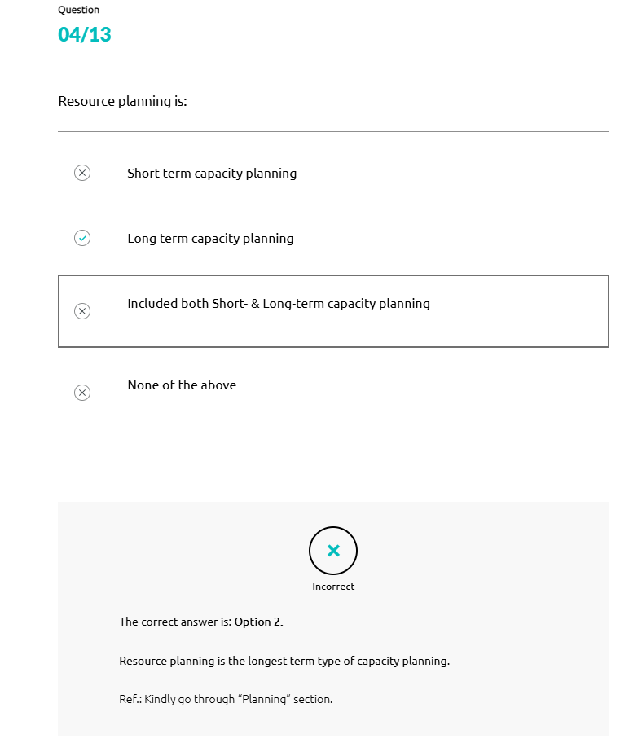
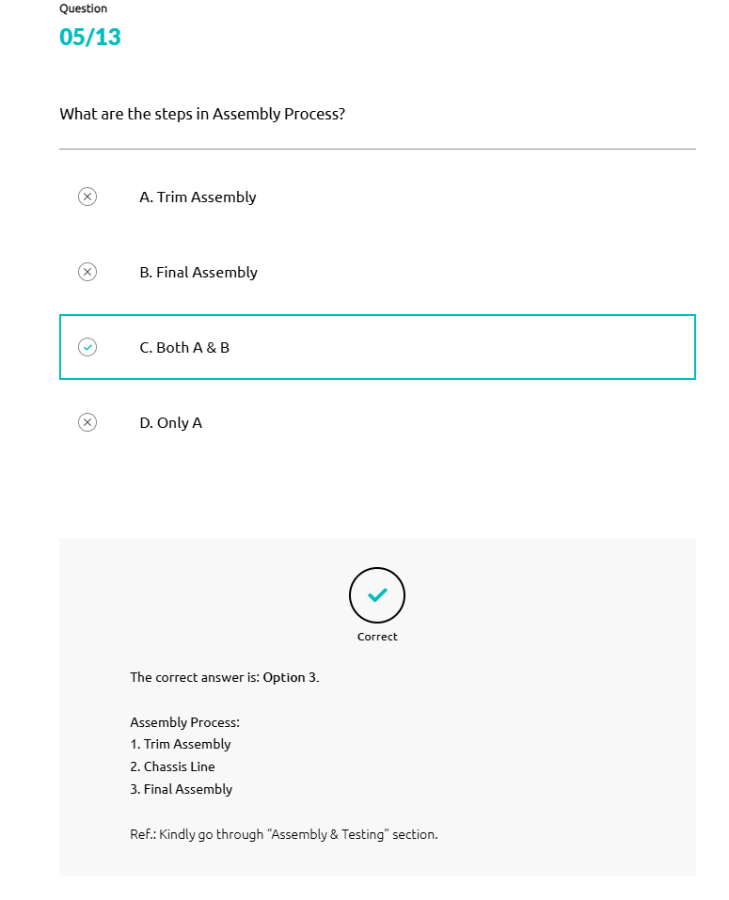
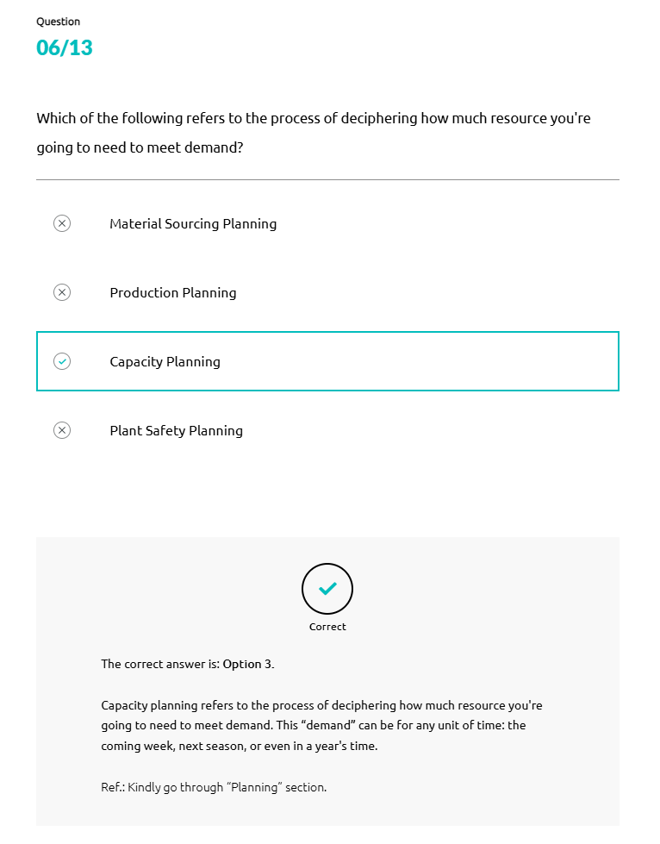
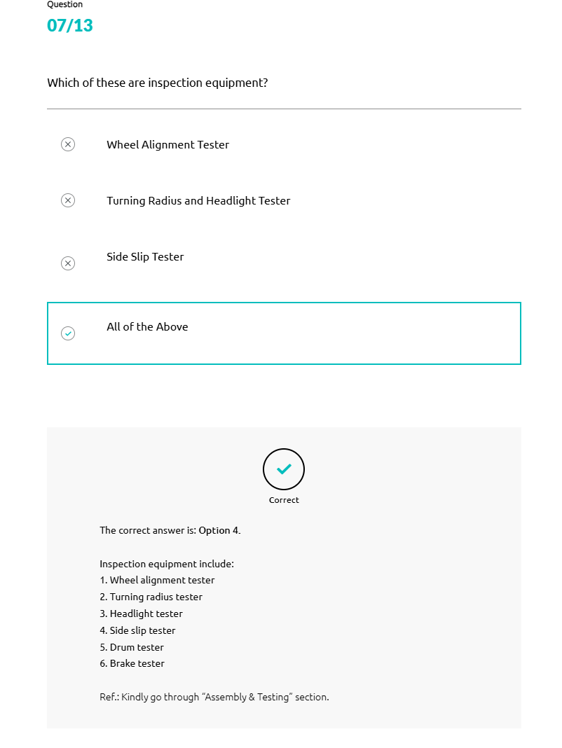
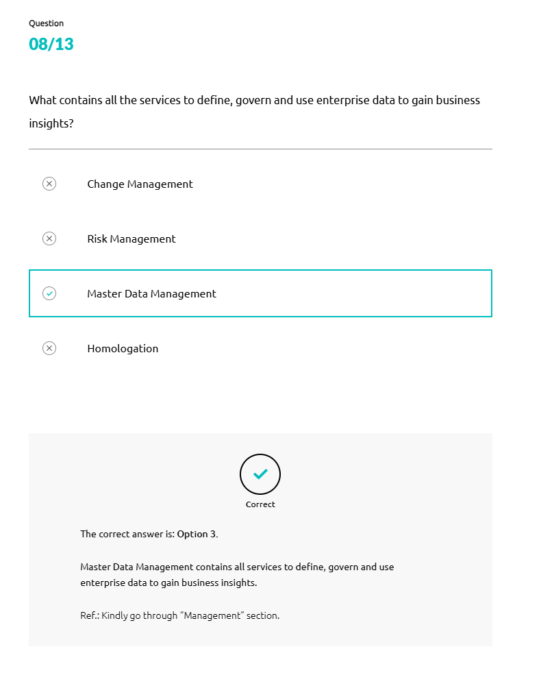
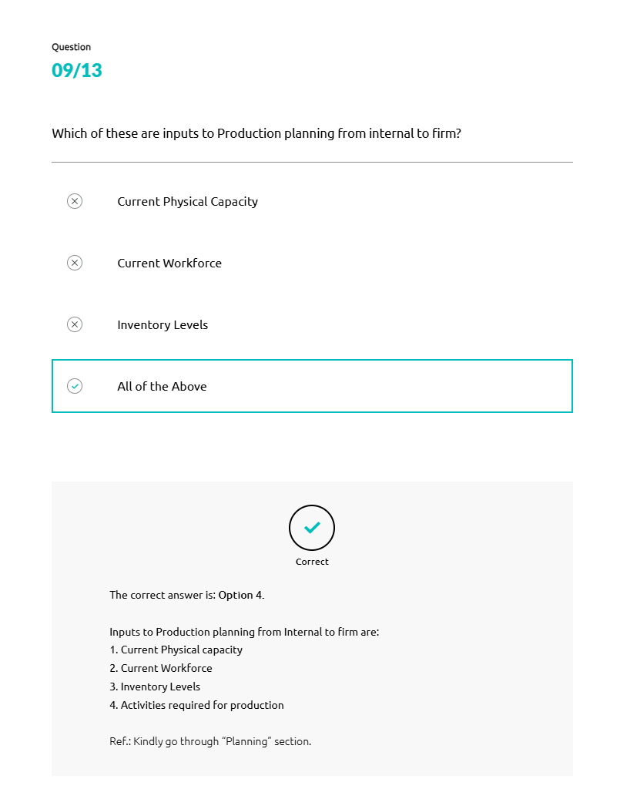
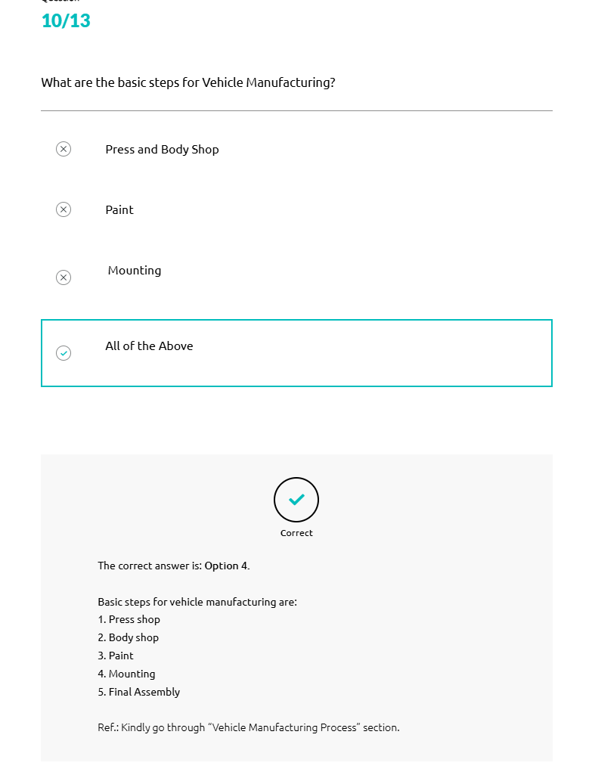
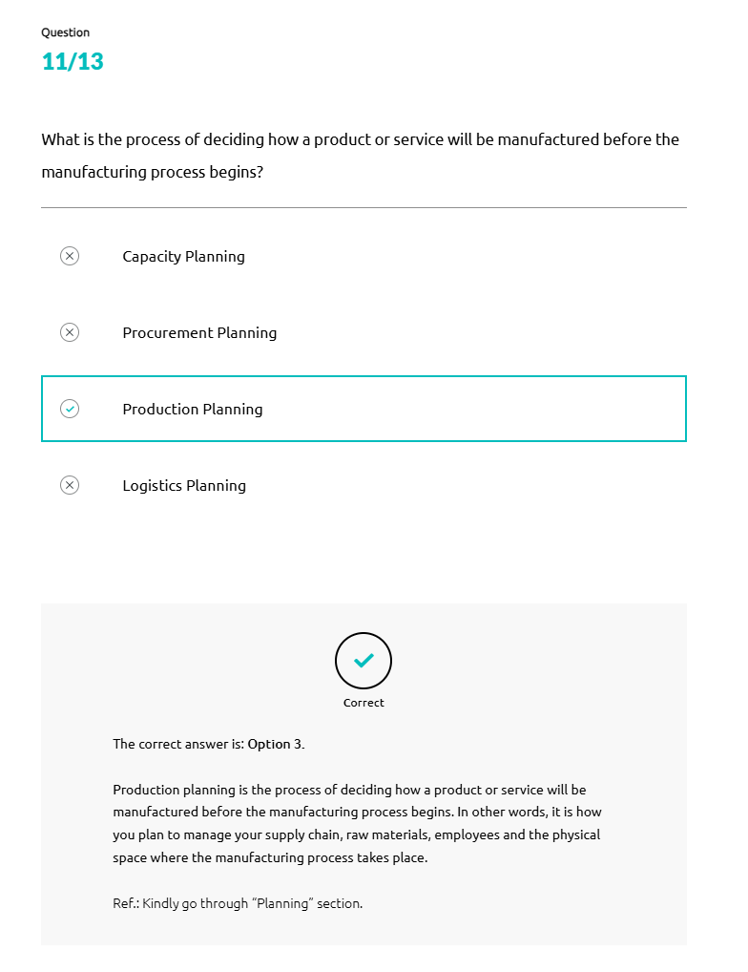
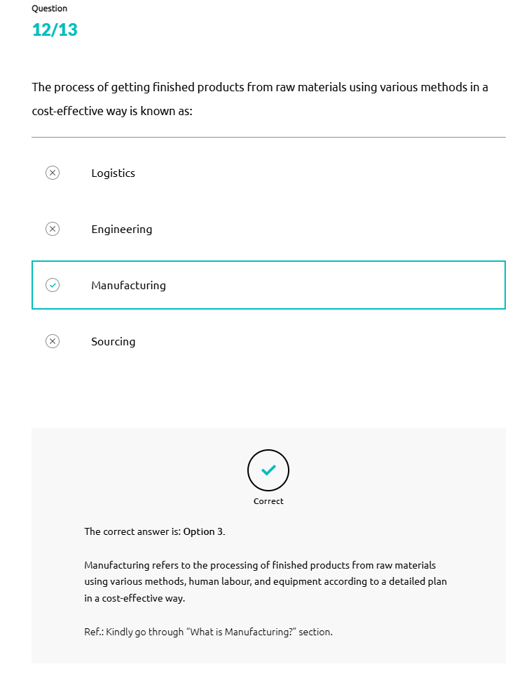
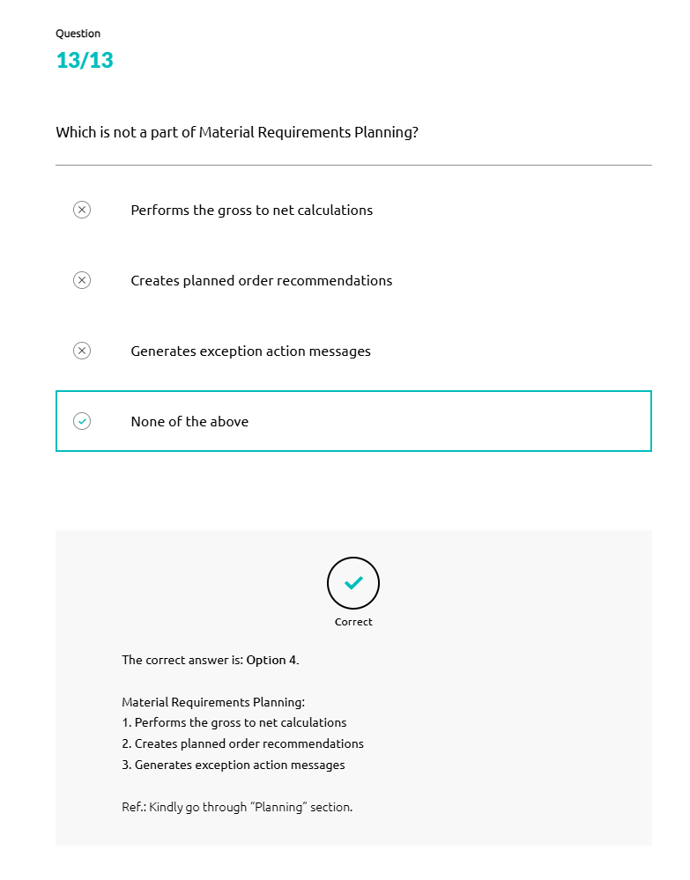
What is Sales and Marketing?
Sales and marketing are two crucial pillars of every business.
Both these are closely related and act as a revenue-generating mechanism in a company.
- Front of card
No image alternative text
Sales is the process of selling goods and services. It involves convincing potential customers to buy from your company. The process of convincing customers can be through various ways. One can explain the benefits of using the product, offer discounts to make a product more attractive than the other competitors. A sale can be made through various channels e.g., online via ecommerce websites, or offline through physical retail stores/showrooms. This opens the door for discussion on direct sales model later.
Marketing is an important part of any industry, and the automotive industry is no exception. It is the process of bringing attention to a business offering, or a product by highlighting its benefits to the potential buyers through different ways of communication. Some common examples of marketing are, television commercials, billboards on the side of the road, online advertisement and magazine advertisements.
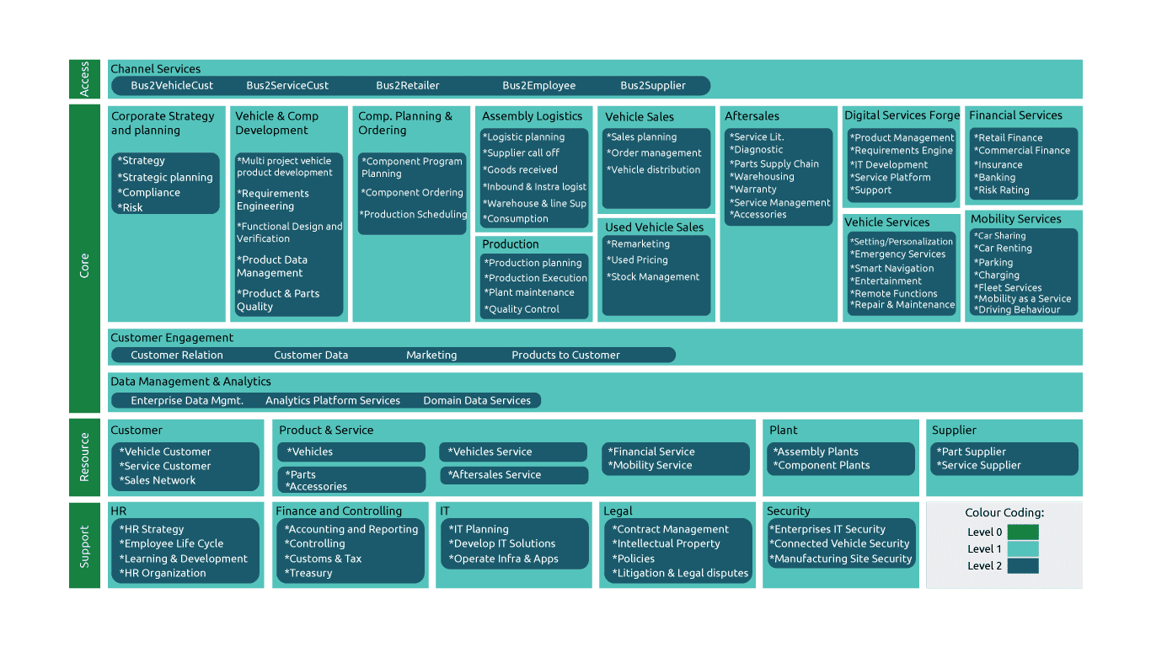
Market Research and Consumer Study
Below are the Types of Marketing Strategies for the Automotive Industry (Digital Marketing):
- 1
SEO (Search Engine Optimization): The main aim of automotive SEO is to drive more organic traffic to your website. In simple terms, this means getting your website to show up on Google and other search engines (preferably on page one) for keywords that your potential customers are searching for.
- 2
PPC (Pay Per Click): PPC aims to drive more traffic to your website by having it show up within the paid ads on search engines. These are often the very first results you see at the top of a Google search page – the listings with the little ‘Ad’ symbol next to the website. Being listed in these gives your website a prominent position in the search results and attracts more clicks.
- 3
PR (Press Release): PR is using the press and other media organizations – local, national, or international – to earn more exposure for your brand, and to get your name in front of relevant people. This is often done by capitalizing on industry developments or company milestones.
- 4
Social Media Marketing: Social media marketing is reaching out to more of your potential customers by connecting and engaging with them via the social media websites that they are using. This may include having a presence on everything from Facebook, Twitter & Instagram to Pinterest, Snapchat, and even more niche social networking platforms.
- 5
Affiliate Marketing: Affiliate marketing is a great way to get others outside of your company to help you with your marketing and sales.
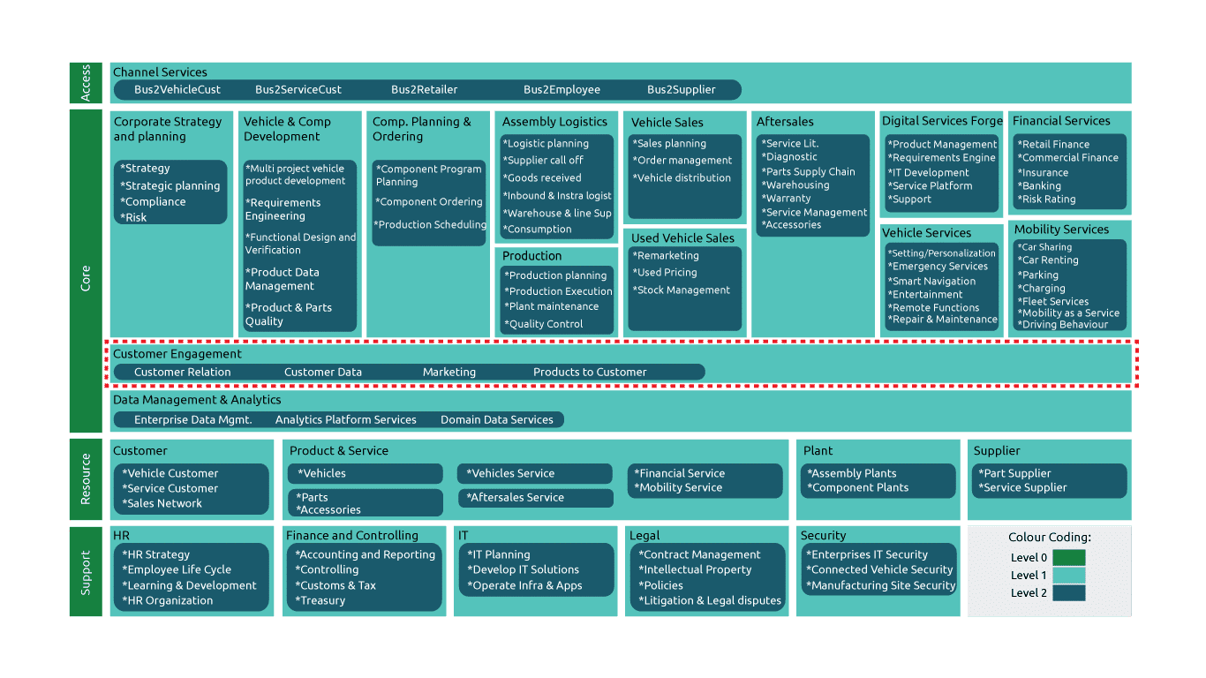
Customer Engagement
In the past, providing superior products is traditionally considered a successful business strategy in the automotive industry. But it is no longer a secret key to success anymore, as almost all companies started providing equal levels of quality products to the customers. In the present time, providing a complete, consistent, and seamless customer experience is the most important factor to retain your customers.
Customer Engagement covers all domains that enable and drive the transformation from a product orientation to customer orientation. This includes especially the gathering and analysis of customer data, customer interaction as well as the product offering to the customer.
Effective Customer Engagement Management:

Customer engagement is how a company creates a relationship with its customer by adding value to their experience to keep the brand at the front of their minds. There are various tools used to provide these services in the automotive industry.
Marketing
Marketing includes different communication measures, the creation of brochures, advertising campaigns, PR, events, market, and competition monitoring, etc.
Customer Relation
Customer Relation defines all services regarding customer feedback, customer consent, customer-driven product developments, and customer relationship management across the whole customer lifecycle.
Customer Data
Customer Data comprises all services for collecting and analyzing customer data. This also includes the unification of the customer data as well as the introduction and maintenance of a global customer record.
Product and Services
Products and Services to customers define all services regarding product and service configuration, bundling, pricing, and offerings.
Develop Sales and Marketing Planning and Strategy
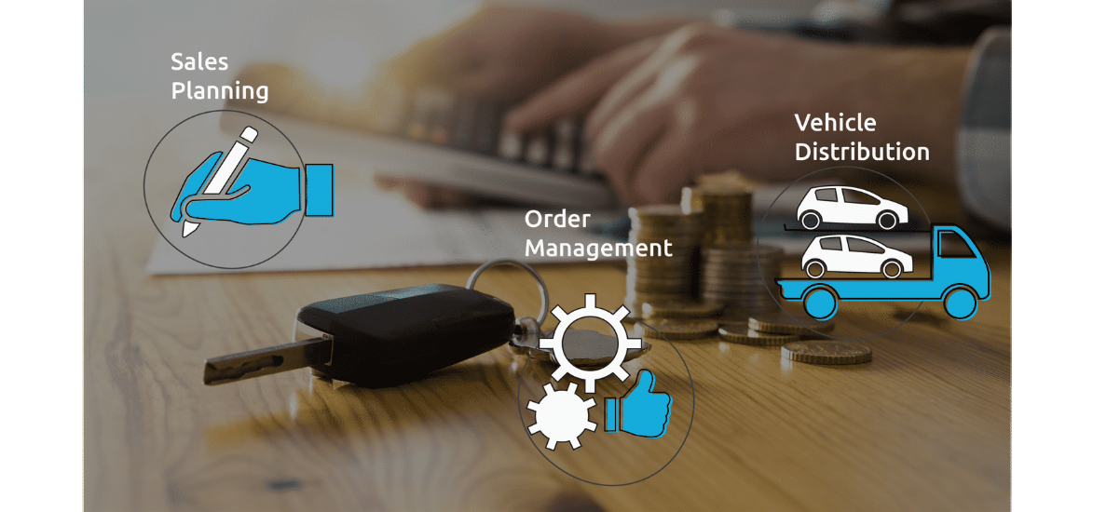
Sales Planning
Planning sales on the different levels of the sales network. E.g., wholesale, retail, etc.
Order Management
Getting orders from the sales network, checking them, and processing them to production.
Vehicle Distribution
Get produced vehicles from the production and distribute them to the sales network.
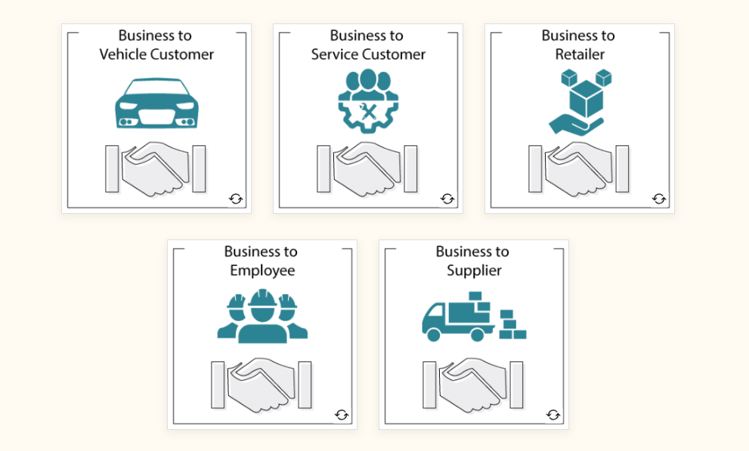
Business to Vehicle Customer: This covers all the functionalities a vehicle customer or prospect needs to access OEM services irrespective of specific device or technology.
Business to Service Customer: This covers all the functionalities a service customer or prospect needs to access OEM services without any device or technology.
Business to Retailer: This covers all the functionalities a dealer, agent, importer, or third party needs to access OEM services without any device or technology.
Business to Employee: This covers all the functionalities an employee needs to access OEM services without any device or technology.
Business to Supplier: This covers all the functionalities a supplier needs to access OEM services without any device or technology.
Sales Planning and Forecasting
Sales planning and forecasting play a prominent role in the automobile industry on revenue generation. These are commonly used to develop sales and marketing strategies.
Sales planning is the process of setting sales targets and defining the steps a company needs to take to reach those targets. Forecasting, on the other hand, is the process of predicting future sales based on past and present performance data, as well as current market trends. Forecasting data are often used to create effective Sales Planning.

Intricate Planning Process
- Strategic Planning over 2 to 5 years.
- Sales and Operation Planning (S&OP) from 12 to 18 months (car line level planning).
- MPS (Manufacturing Planning and Scheduling) and MRP (Manufacturing Resource Planning) that will come later to manage the cumulative lead time of a product or a sub assembly.
Pricing and Discounts
Setting lucrative prices and providing discounts can be the most effective method to increase sales, which is followed by many successful companies. Value-based pricing is a price-setting strategy that exclusively focuses on the consumer's perceived value of a service or product.

Also, seasonal rebate where you will sell fewer convertible cars in winter than in summer.
Agency Sales
Under the agency model, the franchise dealer no longer is the focal point of a new vehicle sale; instead, the customer places an order directly with the OEM and names a preferred delivery dealer. The price and dealership markup or commission is set by the OEM.
Traditional Sales Model (Three-tiered, mainly offline) v/s Agency Sales Model
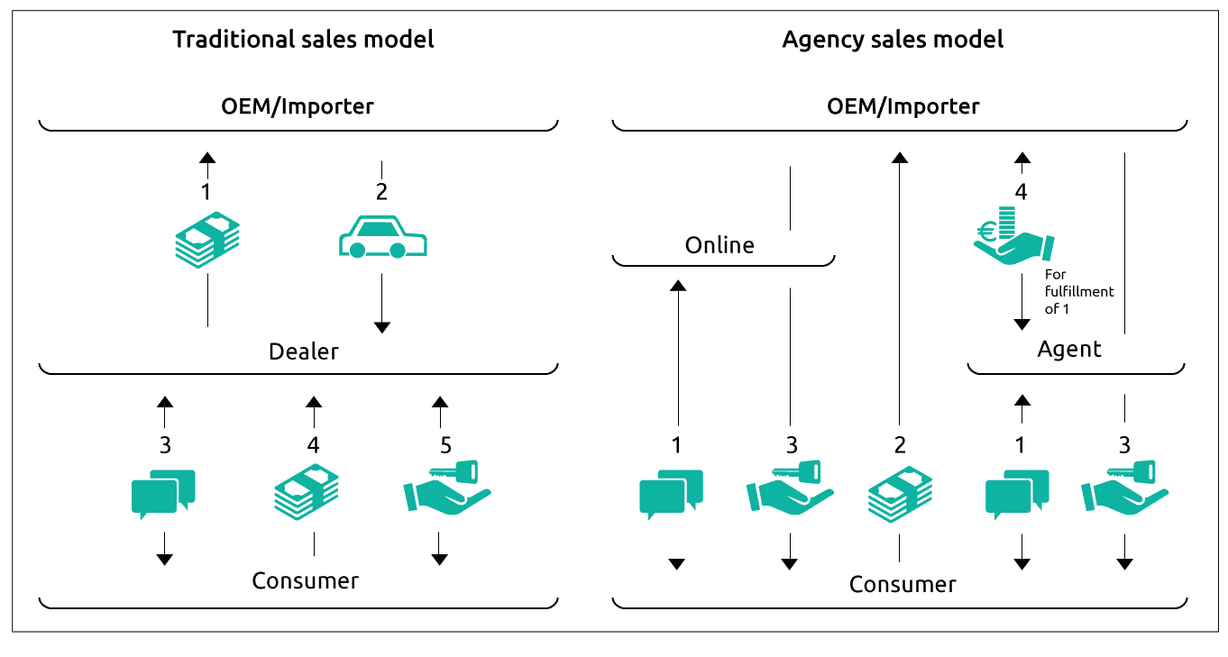
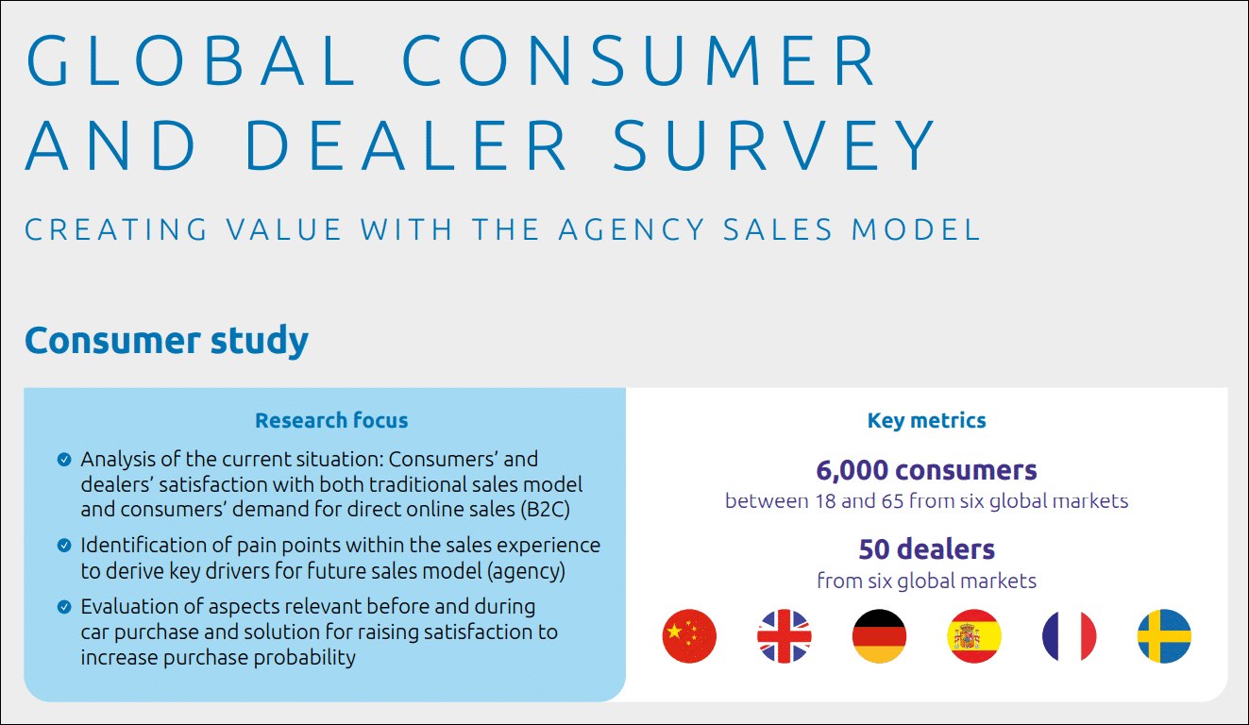
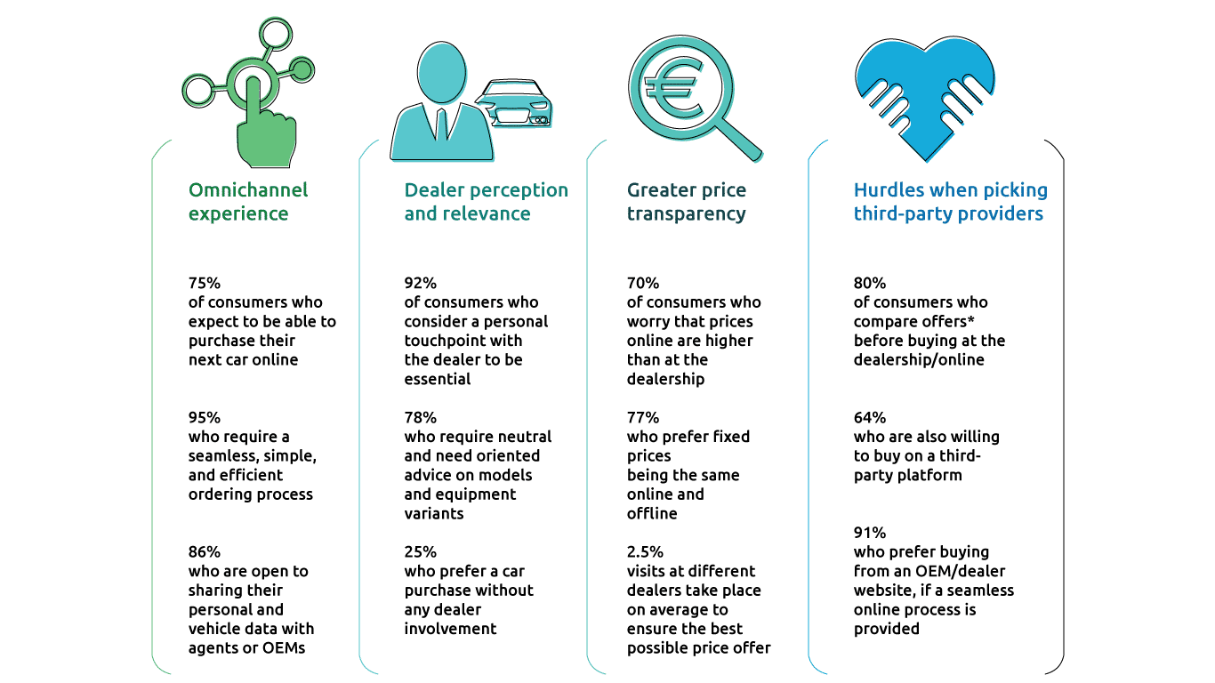
Strategic and Organizational Considerations for Agency Sales
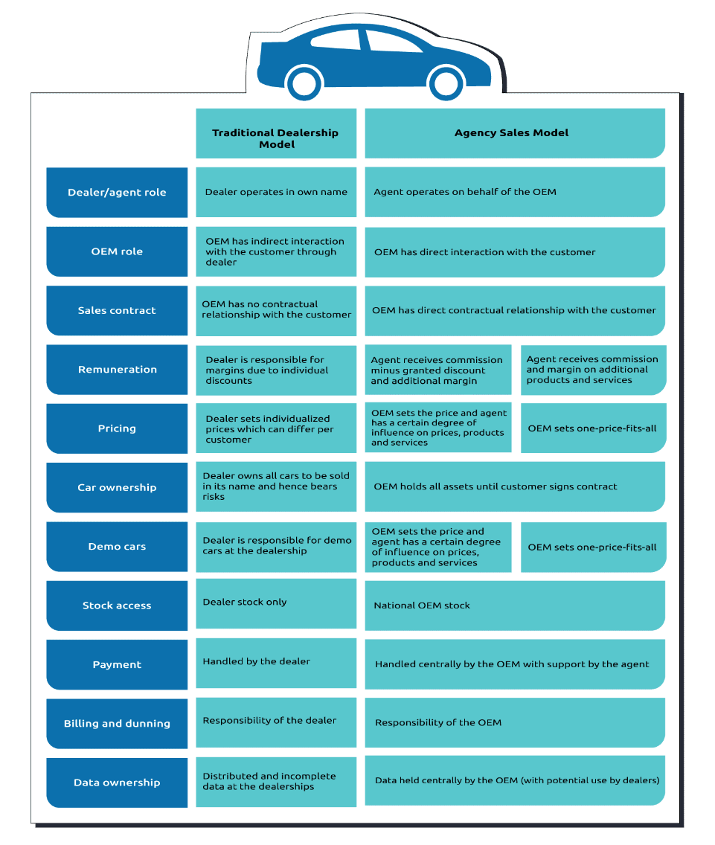
The Agency Sales Journey
We know that each customer experiences a unique sales journey which is mostly not linear – but for strategic decisions a simplified journey can be used to answer relevant questions.
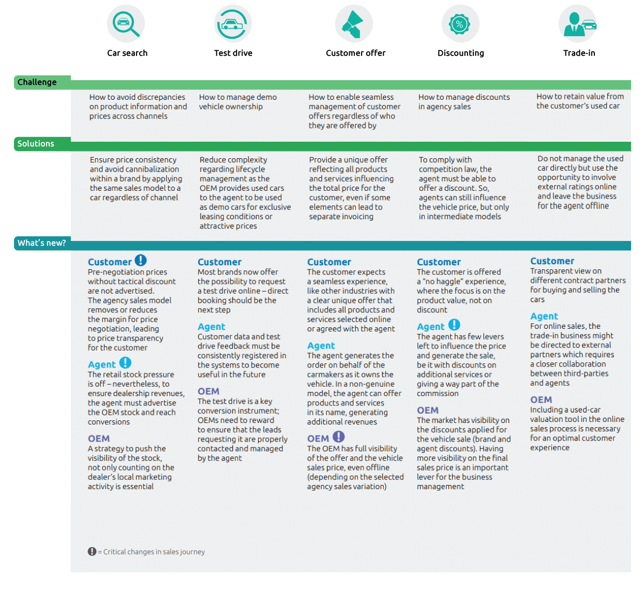
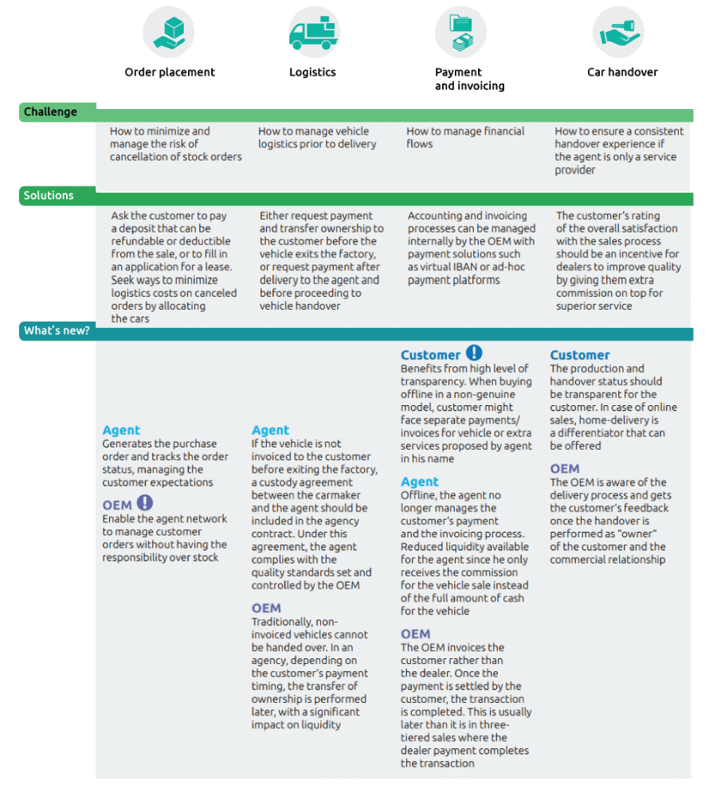
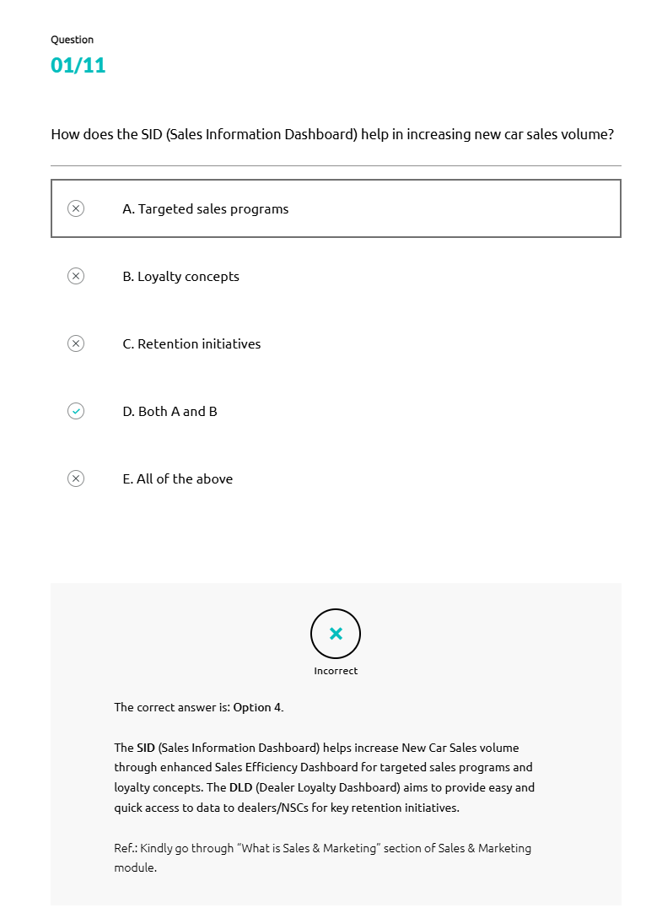
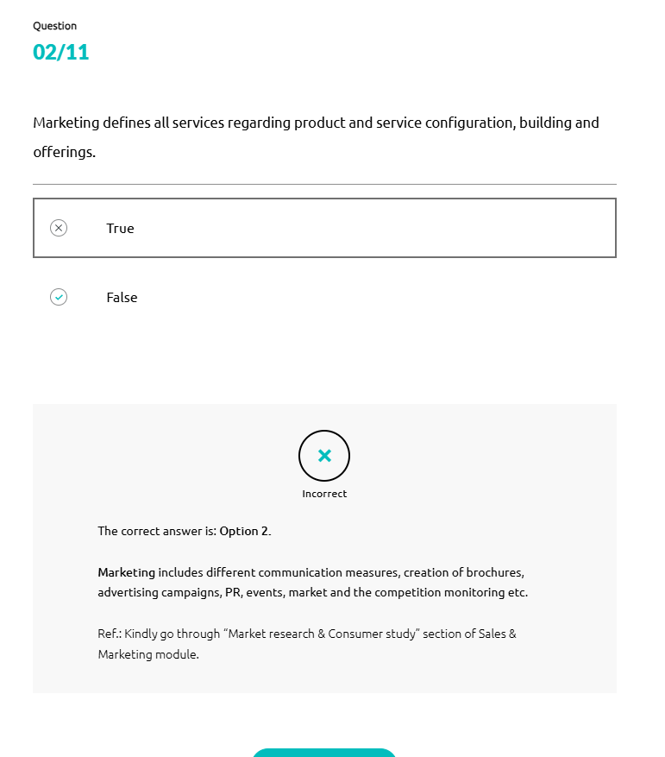
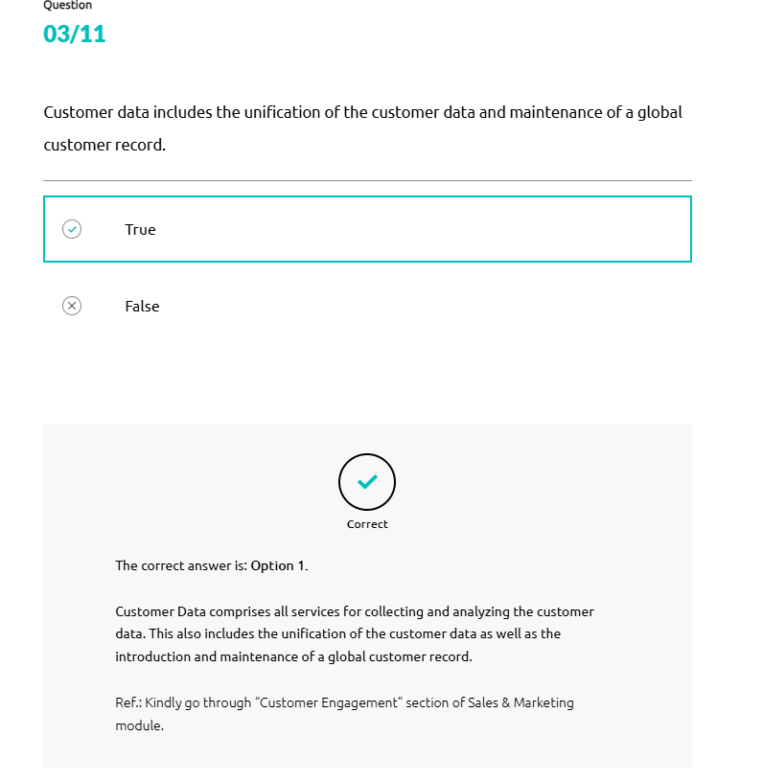
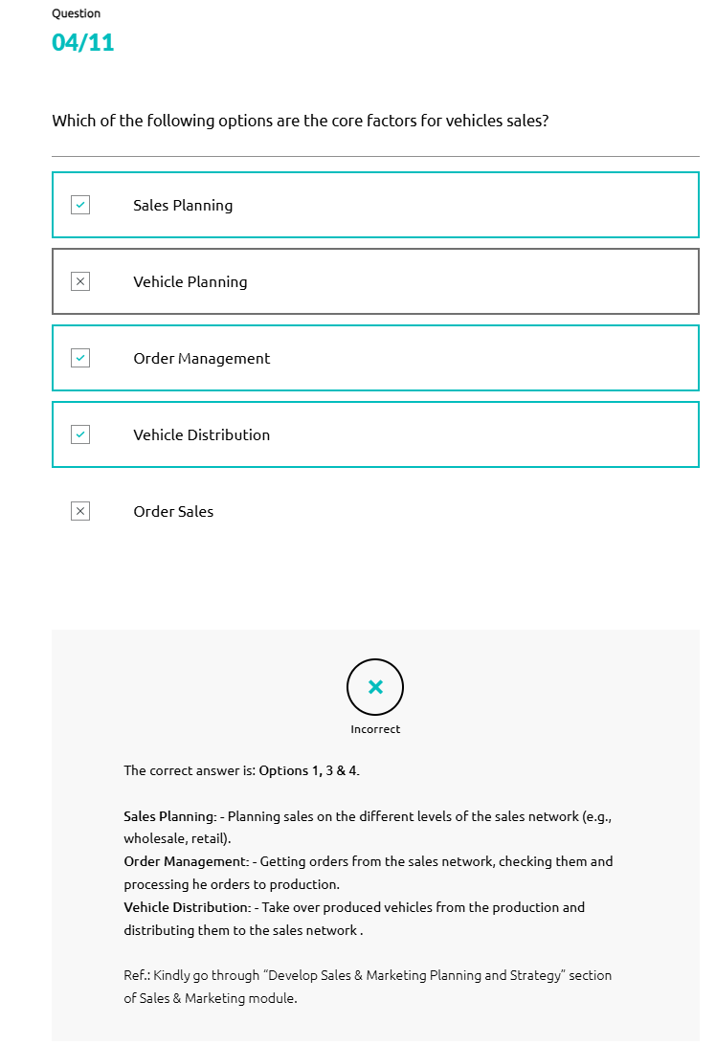
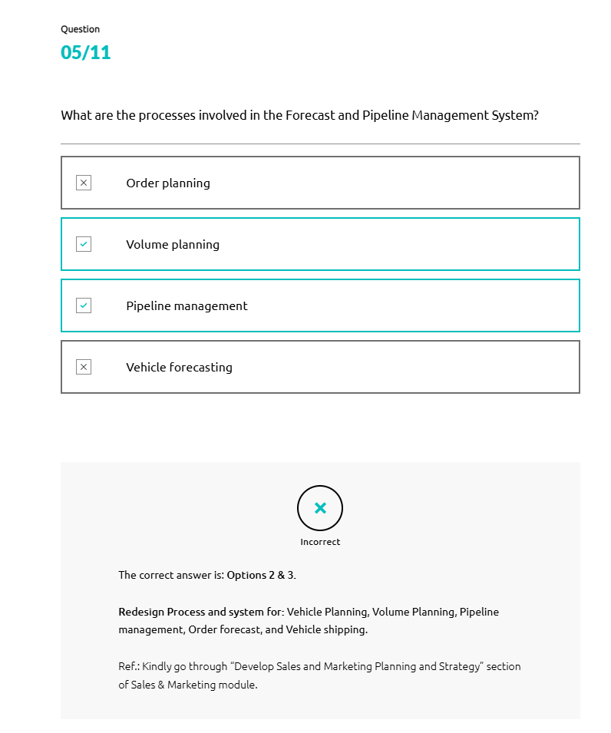
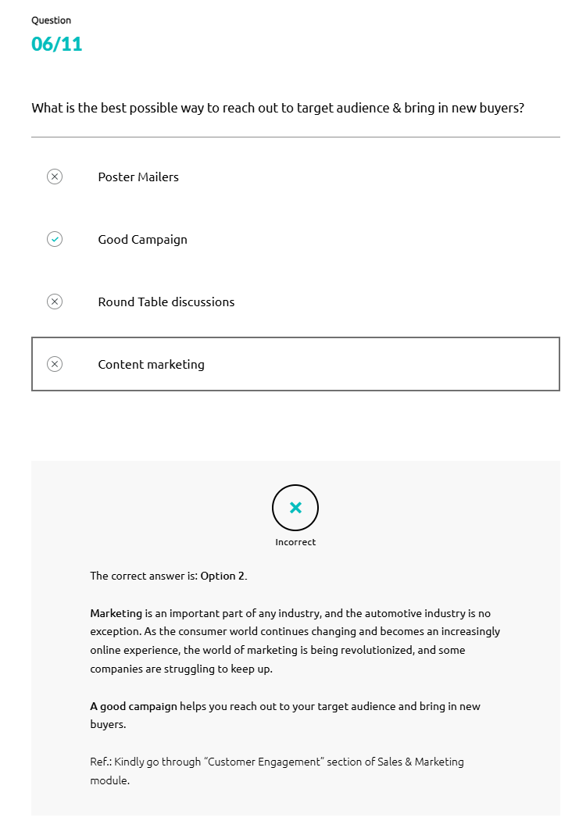
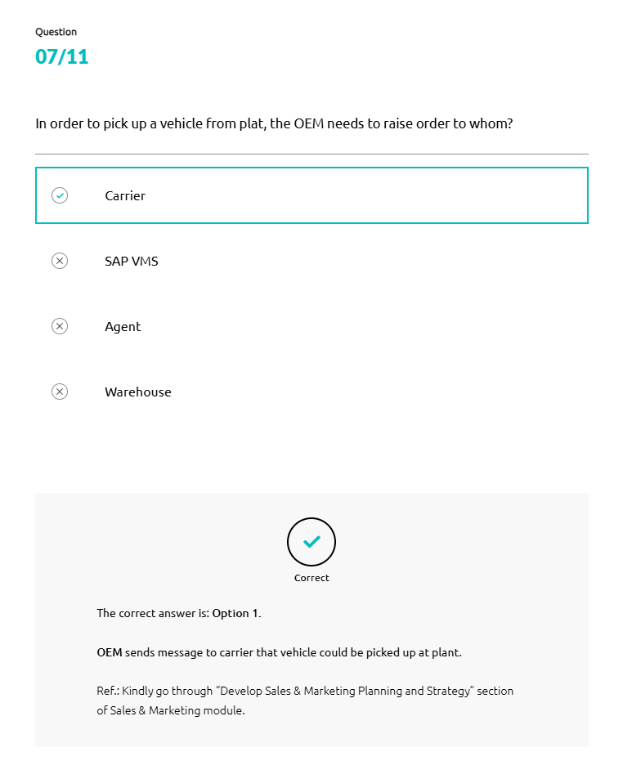
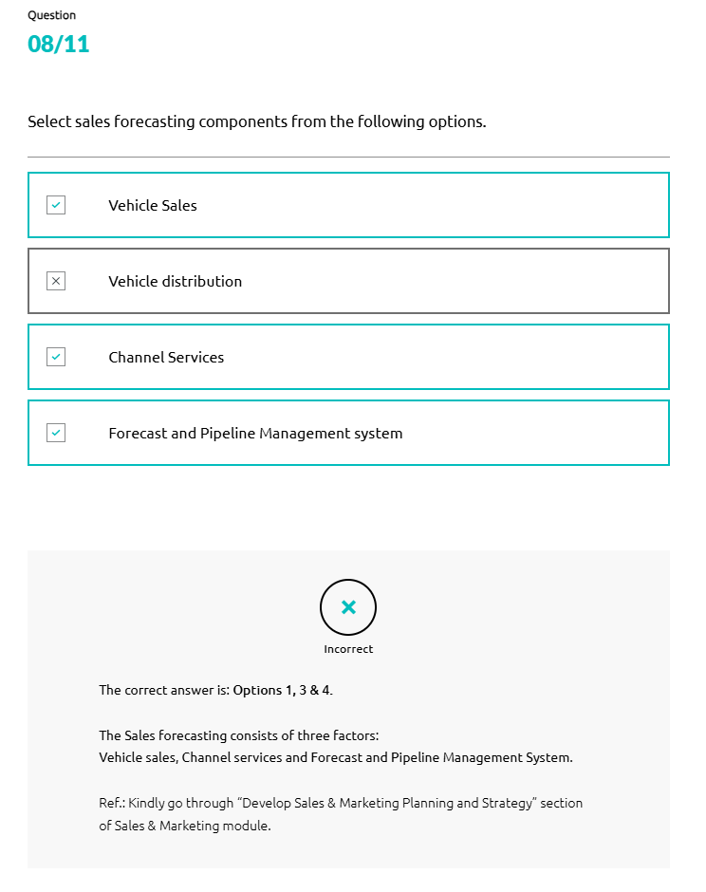
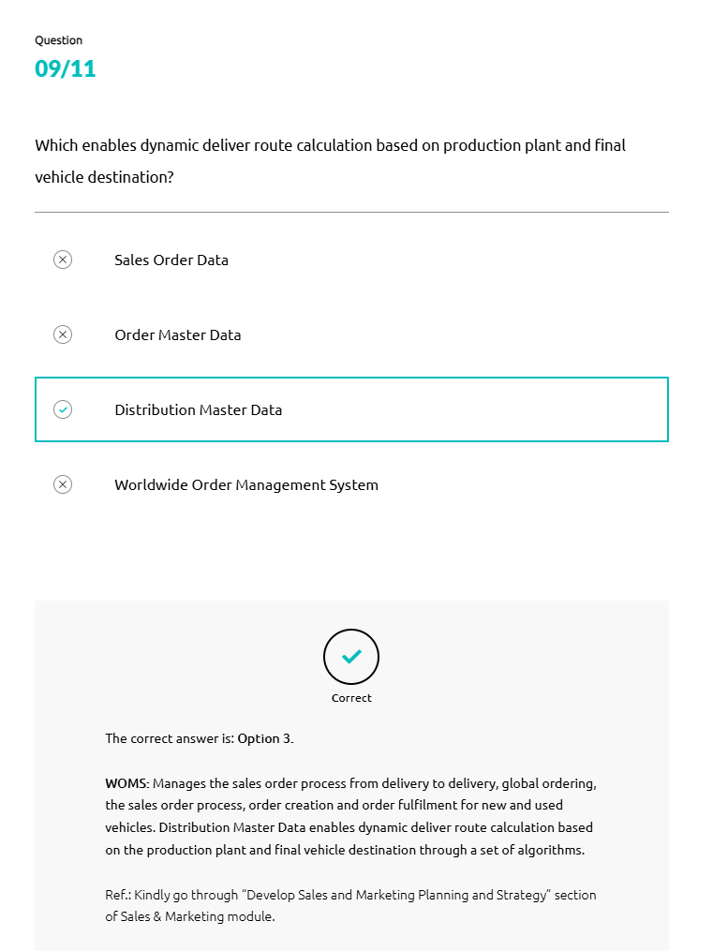
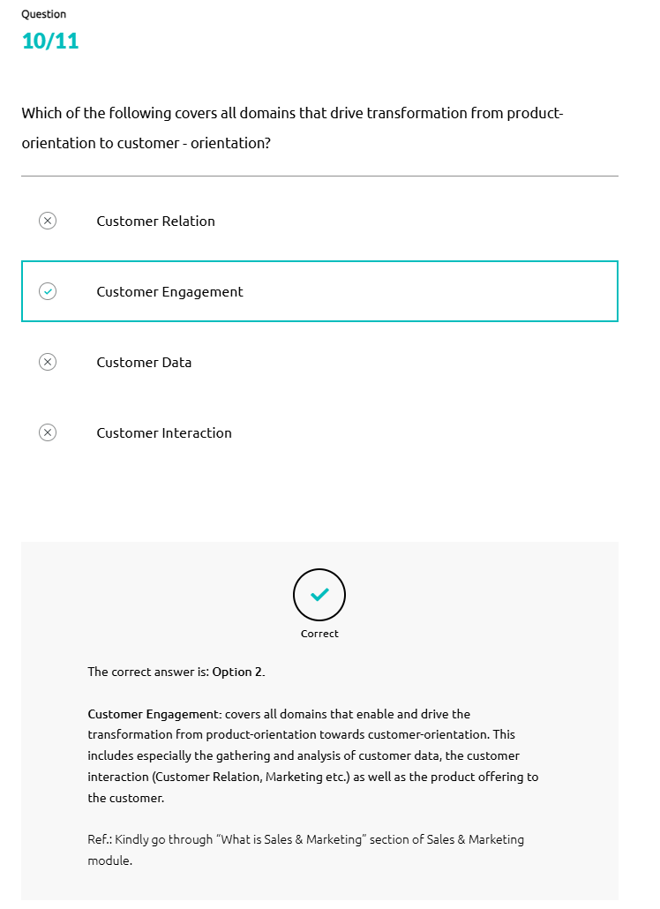
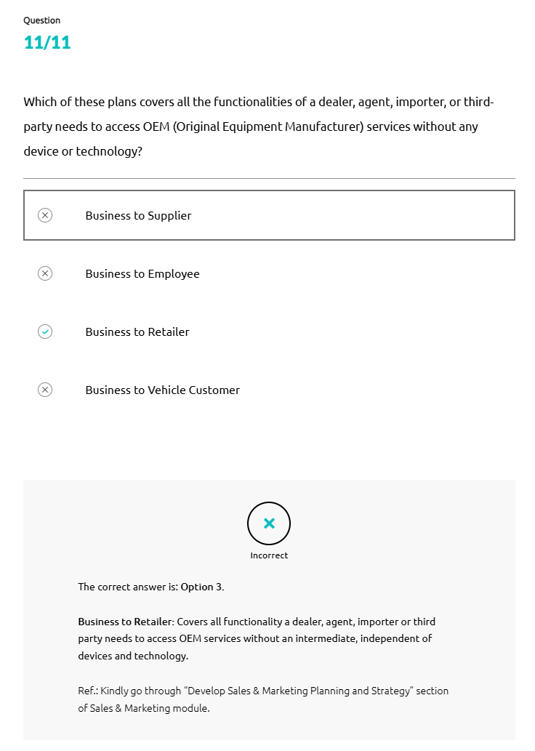
Business Process in Automotive Industry
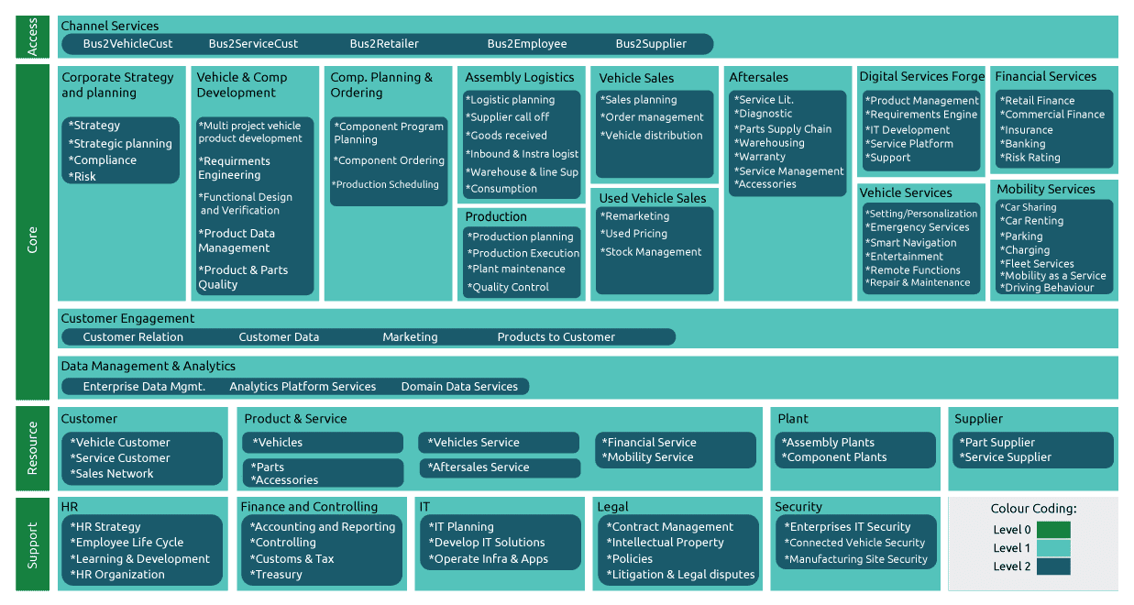
Business Process
A business process is a pattern of related and structured activities in a sequence specially designed to achieve a business goal. It is a vital part of every business, as it describes step-by-step how things are done in the best possible way and helps focus on improving business. The business processes for automotive focus on production planning, procurement, and sales.
Business Processes and Support Functions
Concept-to-Launch
Concept-to-Launch is a streamlined, integrated methodology for product development that reduces cycle time and costly design iterations.

Concept-to-Launch:
- Helps ensure clear communications, smooth transitions, and detailed documentation from one critical milestone to the next
- Provides you with the right design for your application, no matter how complex or demanding it is
- Takes responsibility for developing a total-functional solution for your application, employing a wide range of manufacturing processes
Procure-to-Pay
- Procure-to-Pay is one of the key processes closely linked with product management and production in the automotive industry. It enables the integration of purchasing and accounts payable systems for greater efficiency. It is a process of purchasing, receiving, paying for, and accounting for goods and services.
Forecast-to-Deliver
- Forecasting sales and demand over a 6 to 24 months horizon is crucial for planning the production processes of automotive and other complex product industries where typical concept-to-release times are 12 to 60 months long.

- Empirical Analysis is another evidenced-based approach that indicates that automobile sales at segment levels have a long-run equilibrium relationship with identified economic indicators.
A Vector Error Correction model or VECM of multi-segment automobile sales forecasts sales based on the impulse response functions to quantify the long-term impact of these economic indicators on sales.
Order-to-Cash
Order-to-Cash is a business process for receiving and processing customer orders and generating revenue. There are various steps involved in this process. They are:
- Customer Places an order
- Order is fulfilled
- Order is shipped
- Invoice created and sent to the customer
- Customer pays invoice
- Payment is recorded in the general ledger
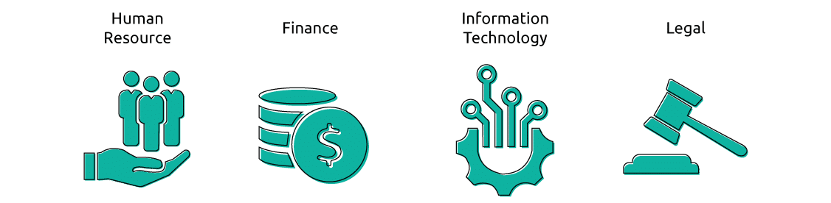
Human Resource
Human Resources or HR plays an important role to support the employee lifecycle and a provide positive employee experience.
HR supports the following in an organization:
- •
HR Strategy
- •
HR Organization
- •
Employee Life Cycle
- •
Learning and Development
Human capital management (HCM) software is used for handling many functions and processes needed for effective workforce management, saving time and money.
HCM tool enables recruiting, managing, developing, and optimizing employees to increase their value to the company. This tool streamlines and simplifies things such as recruiting, applicant tracking, Onboarding, Employee recordkeeping, workflows and approvals management, Time tracking and attendance, Payroll, Performance management, Employee self-service, Reporting, and analytics.
Finance
Finance primarily focuses on providing broad financial services to Original Equipment Manufacturer (OEM) customers, commercial partners, and its distribution network. The financial services domain is typically separated from the OEM corporation because of the complex regulatory requirements and therefore it has its own enabling and support capabilities.
There are five core types of finance. They are:
- •
Retail Finance
- •
Commercial Finance
- •
Insurance
- •
Banking
- •
Risk Rating
Information Technology
Information Technology or IT is another crucial support function of any business process. IT system improves efficiency, reduces cost, enhances customer service, and provides objective data which are integral parts of any effective business process. Therefore IT capabilities should always be aligned with the requirements of a business process to achieve business goals.
In a business process, IT supports the following:
- •
IT Planning
- •
IT Solution Development
- •
Infrastructure and Application Operation
Allocation Manager is an Enterprise Performance Management tool that helps to deliver optimized business performance and refers to the processes involved to support evidence-based decision-making through improved planning and reporting. EPM software solutions enable businesses to predict, monitor, measure and adjust performance across each operation. It’s an umbrella term for the processes and solutions a business uses to achieve the full suite of its management practices, improve operations, and enhance results.
Benefits:
- 1
Streamlined allocation process
- 2
Maximization of port accessory sales
- 3
Provides a strong to district-level managers during managing turn downs
- 4
Cleaner and stronger tracking of port capacity utilization
- 5
Auto install of
Legal
Legal support is critical to any business process, as it acts as a prevention tool and protects a business from any legal issues that can hinder business flow. It also reviews and drafts contracts, and employee policies, protects the company’s intellectual property, and represents the company in litigation and disputes.
Legal department supports the following:
- •
Contract Management: Setting up and checking contracts from a legal point of view
- •
Intellectual Property: Protecting the intellectual properties of the company
- •
Policies: Setting up policies within the company
- •
Litigation and Legal Disputes: Conducting litigation and representing the company in legal disputes
Worldwide Harmonized Light Vehicle Test Procedure (WLTP) Calc
The Worldwide harmonized Light vehicles Test Procedure (WLTP) is a series of tests required to certify that all new vehicles (ICE's, hybrids as well as EV's) on the market abide by the emissions regulations. It is a realistic measuring process for determining a car’s fuel consumption, range and emissions. The new WLTP also considers individual vehicle configurations and test results are reproducible, thereby allowing consumers to compare different car models.

Test calculator for CO₂ emissions & energy consumption by providing vehicle details/request parameters. Plus approve/validate rules, upload, and check logs.
Data Consent Management
Web service providing operations related to user data consent, to comply with data regulations.
General Data Protection Regulation (GDPR)-Ready
This enables consulting engagement with VW Financial Services to prepare for adherence to General Data Protection Regulation for the IT landscape across applicable geographies.
Approval
This is a development engagement handling type approval of all vehicles produces (homologation).
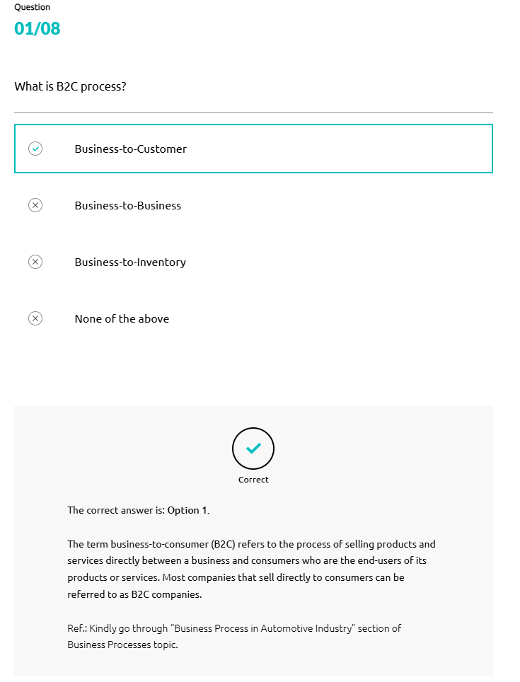
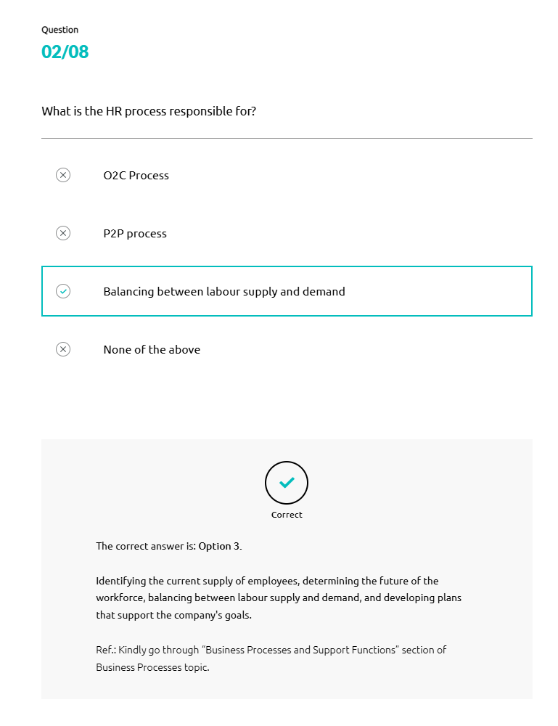
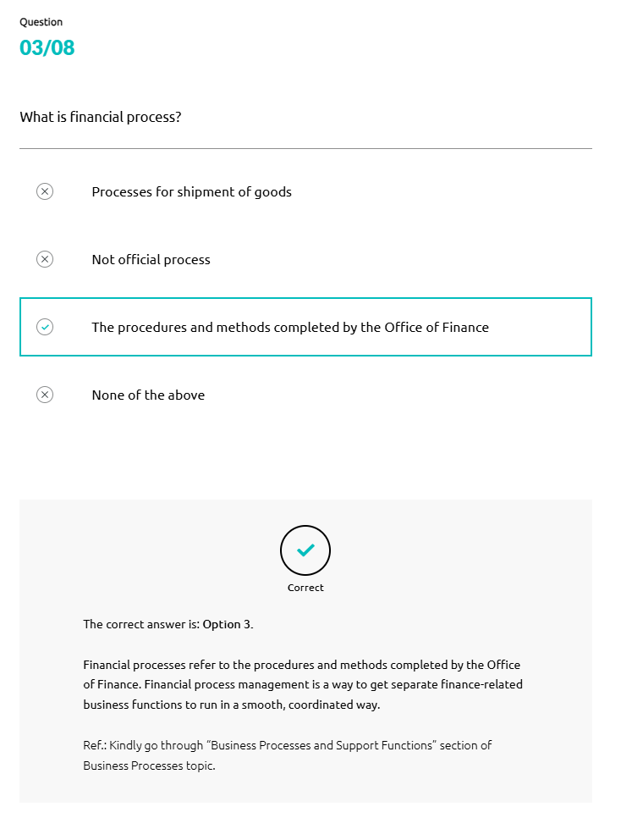
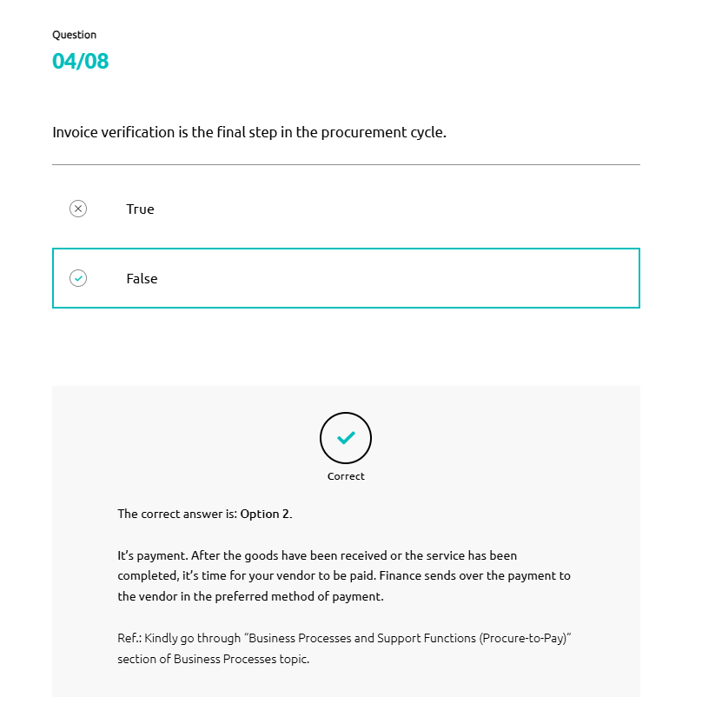

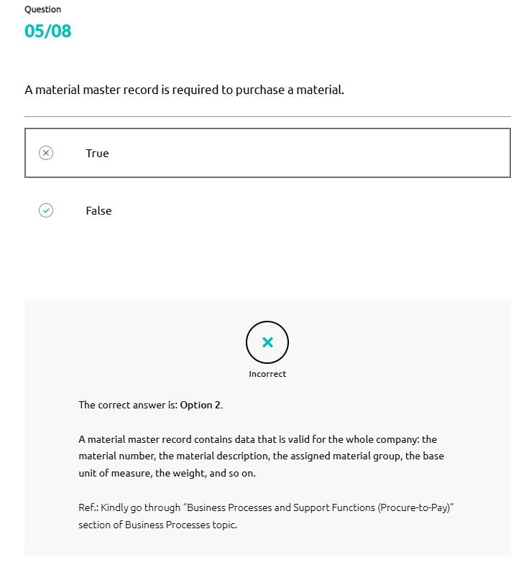
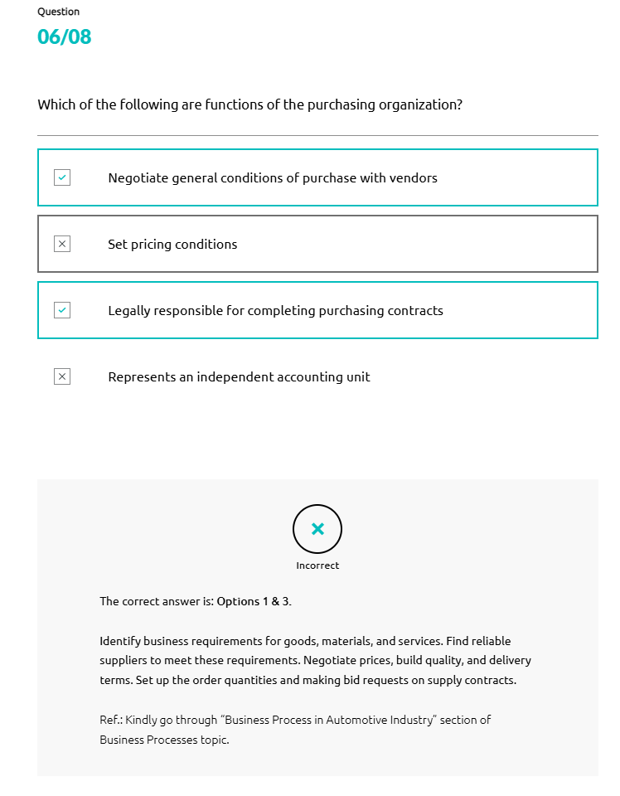
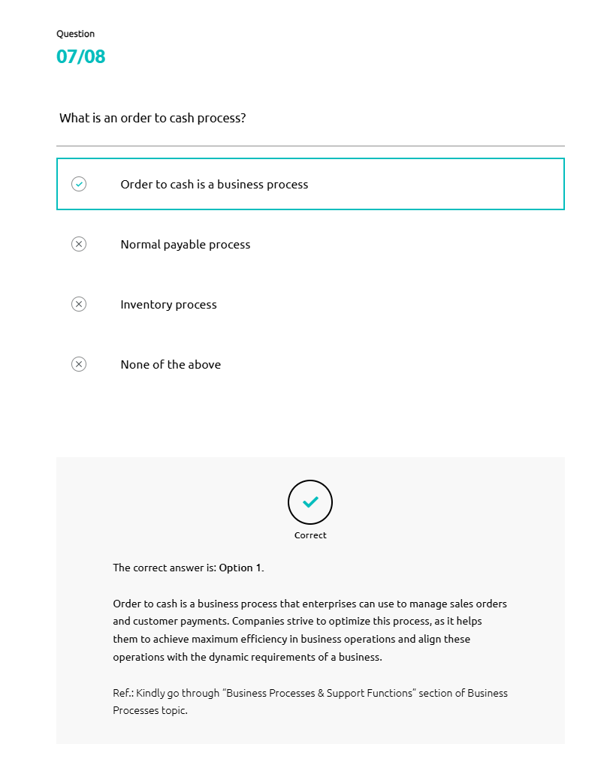
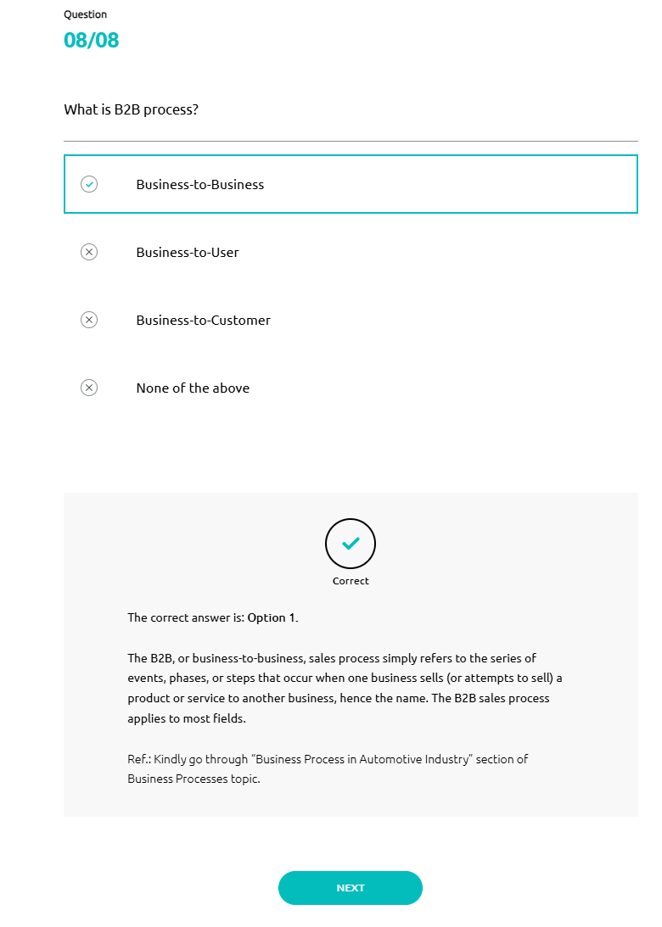
Electric Vehicles
With growing concerns about climate change and environmental degradation, sustainability has become a strategic priority for automotive organizations. Governments, consumers, and investors are now pushing automotive organizations to change their ways of working, culture, and products. Though OEMs are making substantial progress, they still need to set up their sustainability efforts, and electric vehicles are one of the outcomes of these efforts.
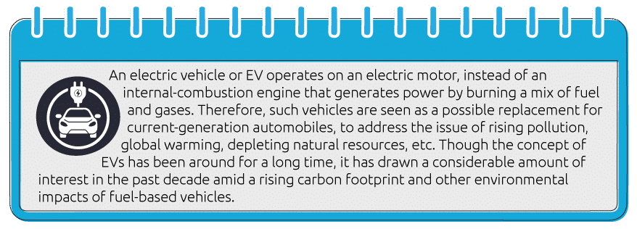
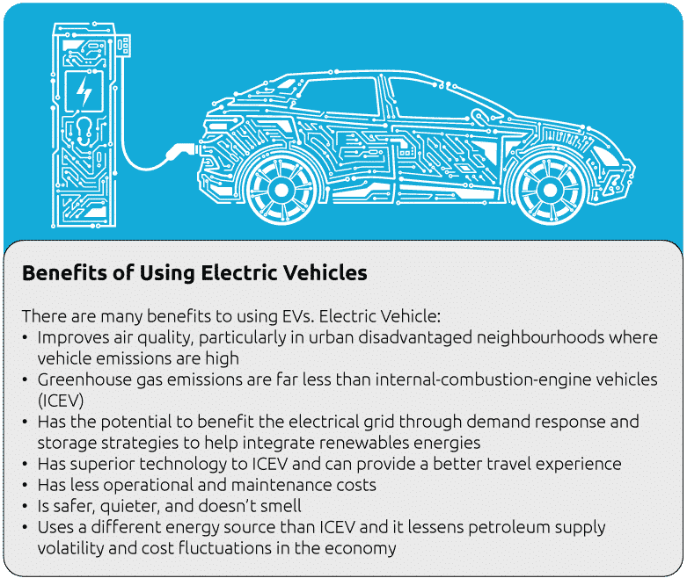
Battery Electric Vehicle
Battery Electric Vehicles are powered by an electric battery, with no gas engine parts.
Most BEVs are capable of fast charging and L2 charging, and Zero emissions.
Plug-in Hybrid Electric Vehicles
Plug-in Hybrid Electric Vehicles are similar to hybrid cars, but with a larger battery and electric motor. It has a gas tank and a charging port and can be charged by using L2 chargers.
Hybrid Electric Vehicles
Hybrid Electric Vehicles are low-emission vehicles that use an electric motor to assist gas-powered engines. The battery of an HEV can’t be charged using a charger, but it charges itself using gasoline.
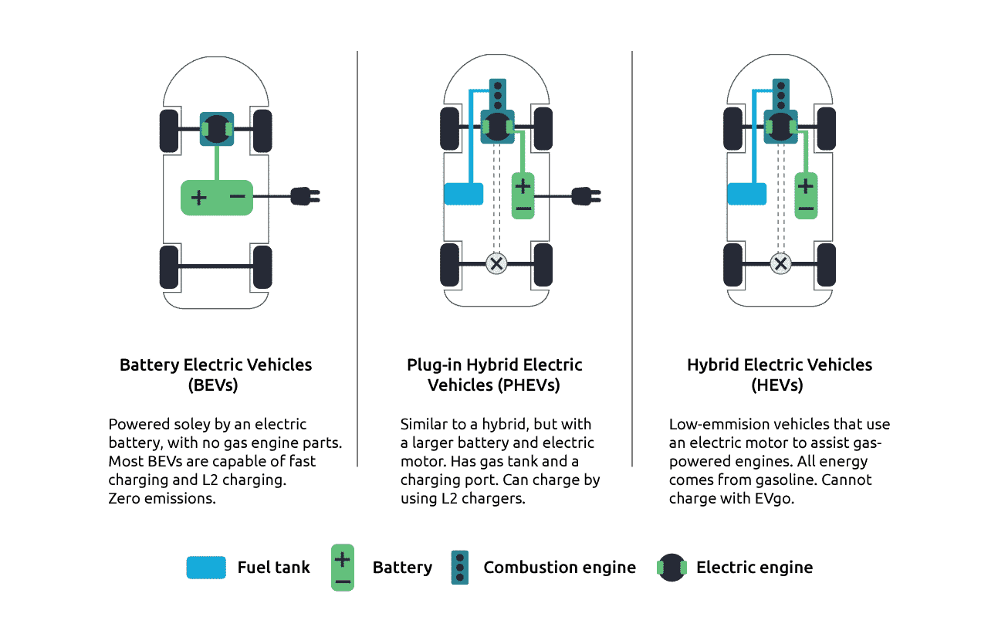
Electric Vehicle Features
There are various features available in EVs. They are:
- Torque, or pulling power, is instantly available.
- All electric cars are automatic and have the features we expect in premium cars like sat-nav, air conditioner, climate control, phone charger, Bluetooth connection, etc.
- Many electric car models have additional desirable features such as park-assist cameras, high-resolution intelligent displays, touchscreens, 30-minute rapid charging capability, automatic wipers and lights, funky design, and environmentally friendly components.
- Electric cars are quiet, comfortable, economic, and exciting. The electric motor is smaller than an internal-combustion engine translating into roomy interiors and a peaceful drive.
Charging an Electric Vehicle

There are three ways to charge an EV.

Rapid Charging
Rapid charge points are located in motorway services, fuel stations, and at key destinations.
It can be accessed via apps or a contactless charger. It supplies power at 50kWh or more. It’s not the cheapest way to charge your car but allows traveling beyond its range.

Fast Charging
This is the most cost-effective way to charge EVs. They are widely available on-street and at supermarkets, leisure facilities, and car parks. It can be installed at your home.

Trickle Charging
Trickle charging is an overnight charging solution plugging into a standard household three-pin wall socket. This is useful when you first get home with your EV and when staying away or visiting friends and family.

Advantages and Disadvantages of EVs
There are various advantages as well as disadvantages of EVs.
Advantages
- Low running cost compared to traditional vehicles
- Environment friendly as they do not emit pollutants
- Lower maintenance due to an efficient electric motor
- Better Performance

Disadvantages
- Finding a charging station is harder as there is not enough charging station
- Charging takes longer
- Covering short distance range on a full charge
- Higher initial purchase cost
- Replacing the battery is expensive
Hybrid Vehicles
In the early 1900's, Ferdinand Porsche created the Lohner-Porsche Mixte - the world's first hybrid electric car. The vehicle was powered by electricity stored in a battery and a gas engine. The first mass-produced hybrid vehicle was the Toyota Prius, launched in Japan in 1997, and followed by the Honda Insight, launched in 1999 in the United States and Japan.
- A hybrid car uses more than one means of energy, combining a petrol or diesel engine with an electric motor, and the two systems work with each other to move the vehicle. This allows the car to burn less gasoline, achieving better fuel efficiency than a traditional engine that solely uses fuel does.
- Hybrid electric vehicles are powered by an internal combustion engine and one or more electric motors, which use energy stored in batteries.
- A hybrid electric vehicle cannot be plugged in to charge the battery. Instead, the battery is charged through regenerative braking and by the internal combustion engine.
- One of the biggest advantages of a hybrid car over a gasoline-powered car is that it runs cleaner and has better gas mileage, which makes it environmental-friendly. A hybrid vehicle runs on twin powered engine (gasoline engine and electric motor) that cuts fuel consumption and conserves energy.
- The basic principle with hybrid vehicles is that the different motors work better at different speeds; the electric motor is more efficient at producing torque, or turning power, and the combustion engine is better for maintaining high speed.
- Hybrid vehicles are more efficient than traditional vehicles, but they still don't hold a candle to the efficiency of a pure, battery-only electric vehicle. All the added complexity in hybrids is stripped away in EVs, which are ingenious in their simplicity.
Parallel Hybrid
- A parallel hybrid is the most commonly found hybrid car in the market. Here the petrol engine and the electric motors are directly connected to a single transmission allowing the cars to combine both energies.
Series Hybrid
- Though a series hybrid engine contains two power sources, the gasoline engine is purely used to charge the batteries and never to power the wheels.
Plug-in Hybrid

- This is an up-gradation to conventional hybrid electric vehicles. Bigger batteries and an external electric source make this car more like an electric vehicle. You can charge the car at your office, home, or a public charging station, and you are set for a short journey.
Mild Hybrid
- A mild hybrid system offers only minimum electrical assistance to the engine, but not enough for the car to drive on electric power alone. The systems assist the engine under hard acceleration and help make its stop-start system smoother in operation.

- These systems also harvest energy when the brakes are applied, converting it into electricity that's fed to the Lithium-ion battery to provide extra assistance when needed.

Key Components of Hybrid Vehicles
Battery (Auxiliary): In an electric drive vehicle, the low-voltage auxiliary battery provides electricity to start the car before the traction battery is engaged.
DC/DC Converter: This device converts higher-voltage DC power from the traction battery pack to the lower-voltage DC power needed to run vehicle accessories and recharge the auxiliary battery.
Electric Generator: It generates electricity from the rotating wheels while braking, transferring that energy back to the traction battery pack.
Electric Traction Motor: This motor drives the vehicle's wheels using power from the traction battery pack.
Electric Exhaust System: The exhaust system channels the exhaust gases from the engine out through the tailpipe.
Fuel Filler: A nozzle from a fuel dispenser attaches to the receptacle on the vehicle to fill the tank. This tank stores gasoline on board the vehicle until it's needed by the engine.
Internal Combustion Engine (Spark-Ignited): Fuel is injected into either the intake manifold or the combustion chamber, where it is combined with air, and the air/fuel mixture is ignited by the spark from a spark plug.
Power Electronics Controller: This unit manages the flow of electrical energy delivered by the traction battery, controlling the speed of the electric traction motor and the torque it produces.
Thermal System (Cooling): This system maintains a proper operating temperature range of the engine, electric motor, power electronics, and other components.
Traction Battery Pack: It stores electricity for use by the electric traction motor.
Transmission: The transmission transfers mechanical power from the engine and/or electric traction motor to drive the wheels.
Advantages and Disadvantages of HVs
There are various advantages and disadvantages of a hybrid vehicle.

Advantages
- Eco-Friendly: Since hybrid engines house an electric motor as well as a gasoline engine, they need less fossil fuel, resulting in less CO₂ emissions. On top of that, they have more efficient gas mileage than conventional cars.
- Financial Benefits: Many governments around the world have introduced tax credits and incentives for buyers and owners of hybrid vehicles. They are also exempt from environmental charges.
- Higher Resale Value: As more and more people are getting tired of gasoline price fluctuations and care about our planet, they are becoming more willing to make the switch to hybrids. As a result, the resale value of such vehicles keeps increasing.
- Lighter Cars: Hybrid cars are manufactured with lightweight materials, which allow vehicles to run on less energy. Their smaller-sized and lightly built engines also contribute to conserving energy.
- Regenerative Braking: Hybrid vehicles use a system called “regenerative braking,” in which the battery recharges a little whenever the driver brakes. The mechanism allows the driver more time between manual recharges.
Disadvantages
- Less Power: Hybrid cars combine both an electric motor and a gasoline engine, with their gasoline engine primarily operated as the power source. Therefore, neither the gasoline engine nor the electric motor works as strongly as they do in conventional gasoline or electric cars.
- Pricey to Buy: The initial cost of hybrid vehicles is more expensive than conventional vehicles in most cases.
- Higher Running Costs: Due to their engine and continuous development in technology, it may not be easy to find a mechanic with the required expertise and they would likely charge you a little more for maintenance and repairs.
- Poor Handling: Hybrids have more machinery than conventional cars, which adds extra weight and reduces fuel efficiency.
- Electrocution Risk: The batteries in hybrid vehicles contain a high voltage, which can increase the risk of the passengers and rescuers being electrocuted in the event of an accident.
- Batteries
The Main Component of an Electric Vehicle is the Battery.

Battery Specifications of Different EV Segments
EV charging requirements depend on the specifications of EV batteries, as power is supplied to the battery at the accurate voltage and current levels to permit charging.
- •
All EVs are powered by an electric motor. This motor gets its power from a stack of batteries. From the batteries, the energy goes to the pre-charge circuit, and from there to the motor.
- •
Nowadays, most electric cars will use lithium-ion batteries. In EVs, most electric cars, the batteries are usually found positioned low down in the car. For example, In the Tesla, the battery runs along the floor. The weight of the batteries helps to regulate the car’s center of gravity.
- •
Electric cars usually feature an auxiliary battery that is used to power the car’s non-powertrain electrics, much like the battery found in a conventional fuel-powered vehicle.
Light Electric Vehicles (LEVs)
- In India, transport electrification over the next decade is expected to be driven by light electric vehicles (LEVs), comprising two-wheelers (scooters, motorcycles) and three-wheelers (passenger and cargo)
- Electric 2 Wheelers and Electric 3 Wheelers are powered by low-voltage batteries.
The first generation of e-cars is also powered by low-voltage batteries
- 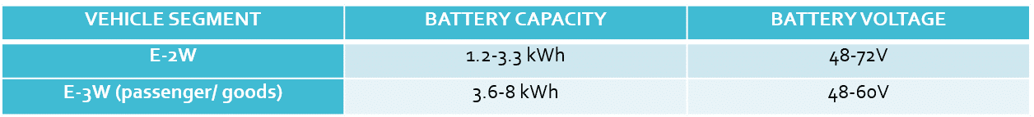
Light Commercial Vehicles (LCVs)
- Cars and light commercial vehicles (LCVs) are the other key vehicle segments being electrified
- EV charging requirements depend on the specifications of EV batteries, as power must be supplied to the battery at the right voltage and current levels to permit charging
- Electric LCVs will comprise of both low-voltage and high-voltage vehicles, depending on their load-carrying capacity
- The first generation of e-cars is also powered by low voltage batteries. However, these are likely to be phased out in the future, even if they continue in specific use cases such as taxis
- The second generation of e-cars, as seen in the upcoming e-car models, is powered by high-voltage batteries. Electric LCVs will comprise of both low-voltage and high-voltage vehicles, depending on their load-carrying capacity
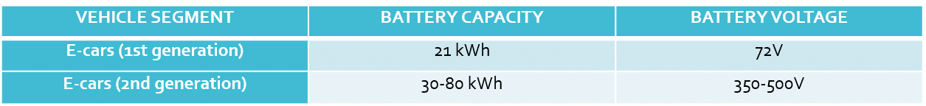
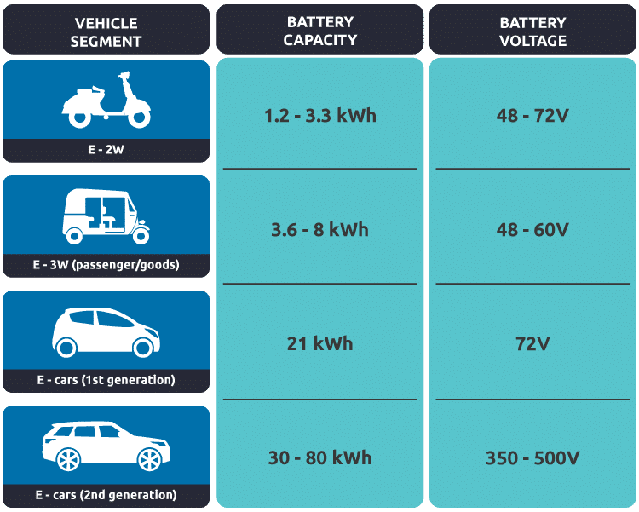
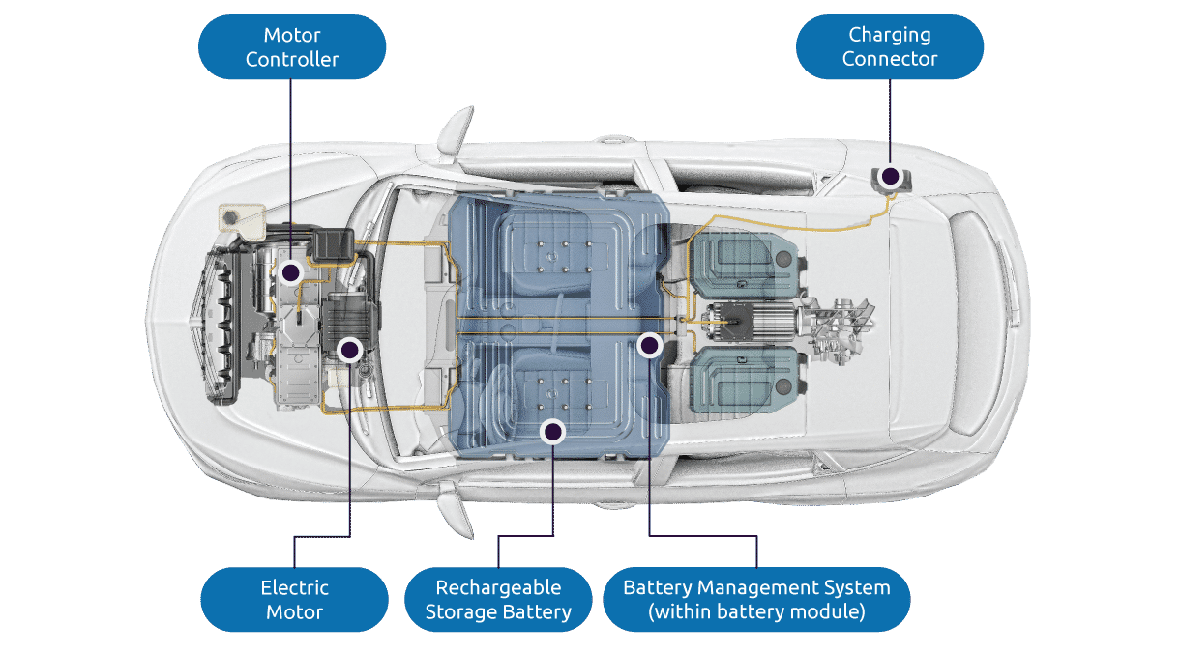

Existing Battery Ecosystem
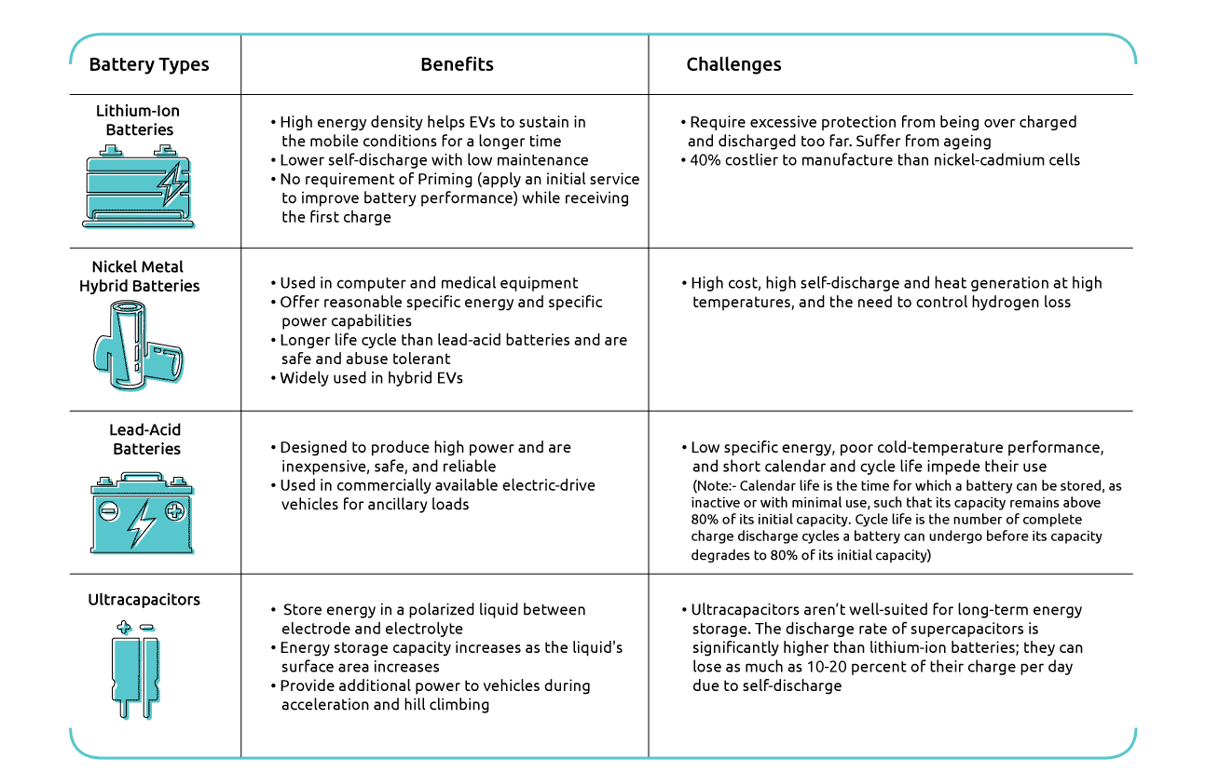
Advanced Technology - Cost Reduction of Batteries
Technology advances are delivering substantial cost reductions of batteries.
Solid State Batteries
- The solid and dry material is more efficient and less likely to catch fire than lithium-ion batteries
- Solid-state batteries safely and quickly draw power from the batteries and enable fast charging
- Further, these batteries require less space than lithium-ion batteries for temperature control. More space enables companies to squeeze more battery cells into the same size package

Wireless Charging
- Engineers at Witricity Think are identifying a possible solution for charging batteries wirelessly all around the place
- The technology was invented at MIT, using magnetic resonance to charge batteries over distances and even through different materials
- The technology will help vehicle drivers gain access to the charging infrastructure

Global Market Overview
In 2011, around 55,000 electric vehicles (EVs) were sold around the world. With many countries getting plugged into electrification, the global EV market has seen exponential growth over the last decade close to 7 million EVs.
USA Electric Vehicle Sales
- •
USA electric car sales mostly benefited from the launch and first deliveries of electric pick-up trucks in 2022 (greater interest in large vehicles).
- •
The US charging infrastructure is getting built out fast, and Tesla’s opening up the supercharger network. Electric car adoption in the US is happening at a faster pace than predicted.
- •
California has the highest EV demand in the USA with 1 million plug-in electric cars sold.
- •
In 2021 electric car sales in the USA grew more than 2x from the previous year.
The US now accounts for 10% of global EV sales.
Electric Car Sales in USA
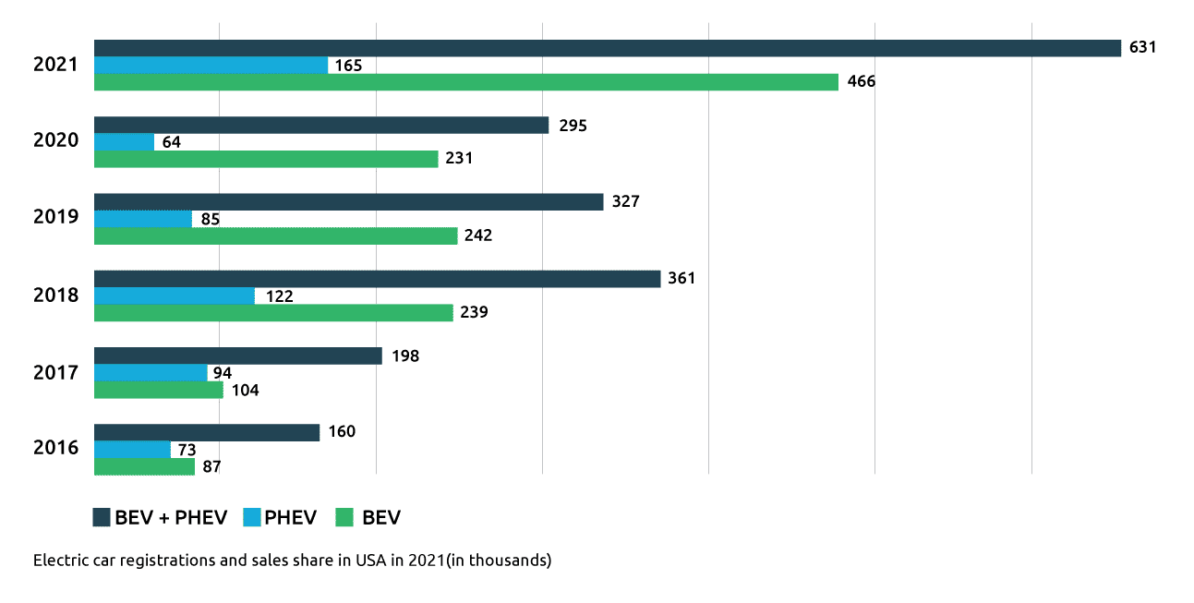
US Electric Vehicle Market Share
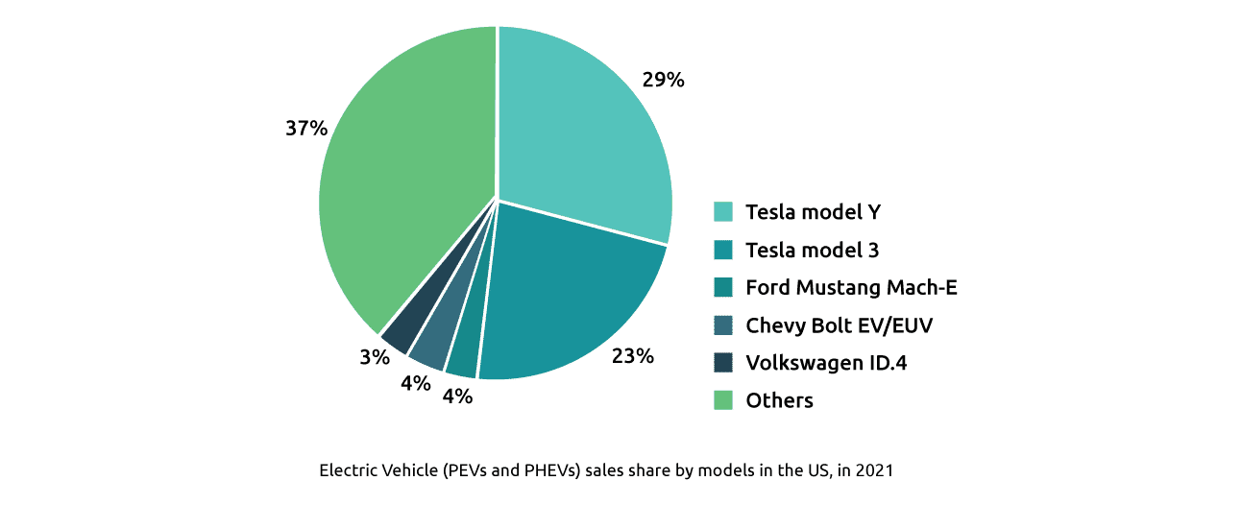
Europe Electric Vehicle Sales
- The trend in Europe is in favor of BEVs and it will probably continue.
- •
Europe, worth noting that the market share of EV in the Nordics is very high.
- •
Germany is the leading European country with 1.38 million plug-in cars registered since 2010. In fact, there are no cheap electric vehicles in Europe.
- •
German automakers (VW, Audi, BMW, Mercedes) are pretty behind with 10% sales share each due to the love for diesel and gasoline-powered vehicles.
- •
The Netherlands has the highest density of EV charging stations in Europe. Almost every parking lot in a big city has a charging point. In fact, there are many chargers available.
- •
European union countries are bounded by a agreement / legislation to abandon ICE vehicles by 2035.
Electric Car Sales in Europe
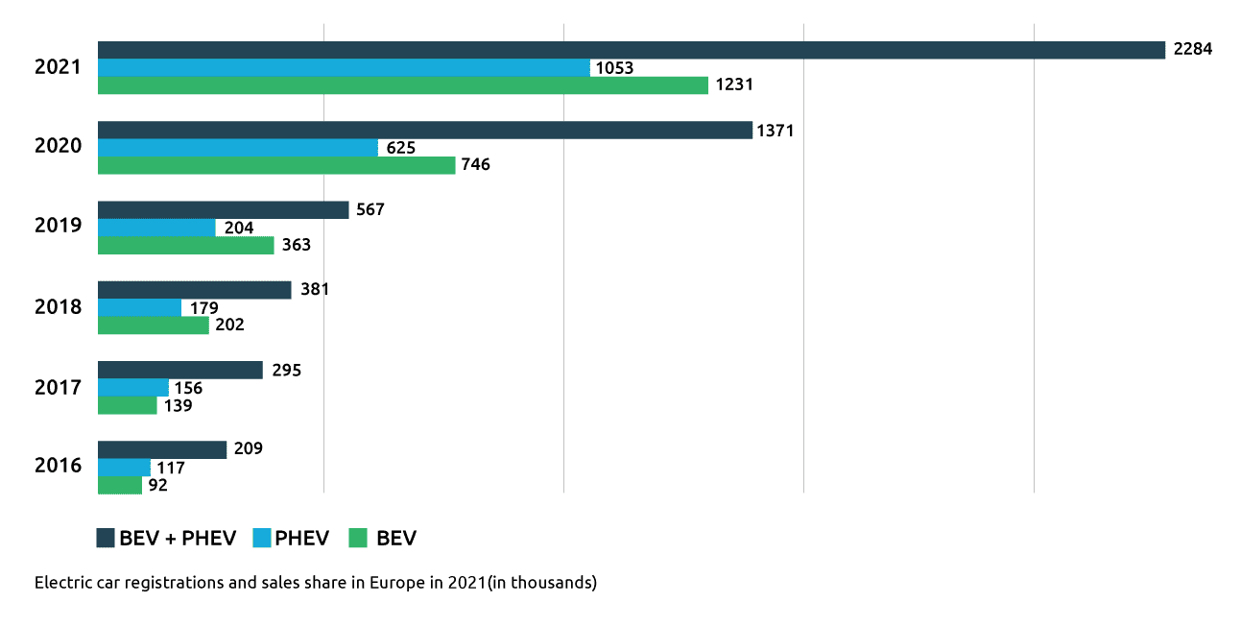
Europe Electric Vehicle Market Share
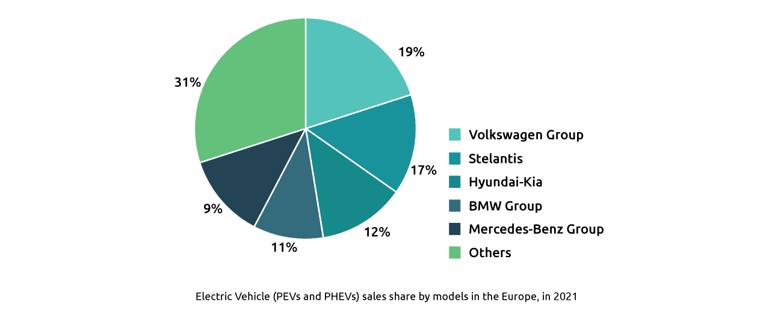
China Electric Vehicle Sales
- •
China’s auto industry is showing signs of recovery from supply chain and lockdown challenges, with car companies accelerating production.
- •
Also, the Chinese government is offering tax benefits for using electric cars. However, these electric cars are tiny, but given the price and value, it’s understandable that people buy them.
- •
With this momentum and strong consumer demand, electric sales should top 5 million by the end of this year.
- •
China sold over 3.3 million electric cars in 2021. Electric car sales in China doubled from the previous year, and it is now, by far, with 118% year-on-year growth, the biggest EV market.
- •
57% of all global EV sales happened in China, and even more brands and models keep hitting the market.
Electric Car Sales in China
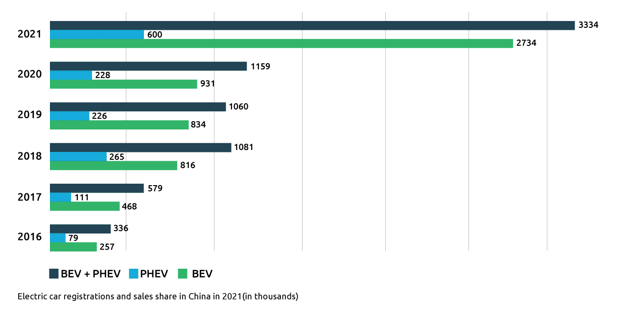
China Electric Vehicle Market Share
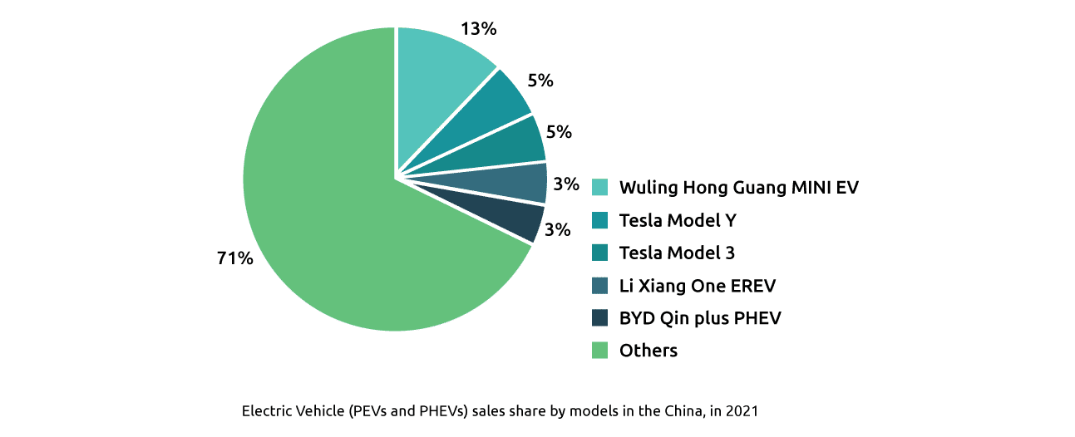
Best Selling Electric Cars
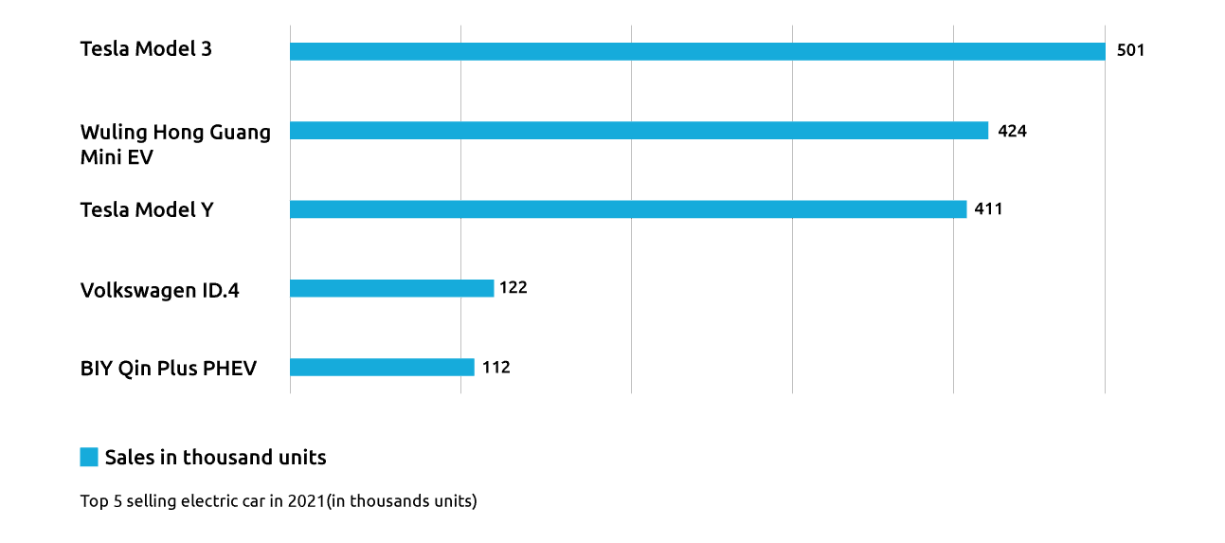
Best Electric Car Manufacturers
Below are listed bigger electric car manufacturers that play a significant role in the electric car market. These electric car manufacturers have extraordinary power and are achieving high numbers in sales of electric cars.
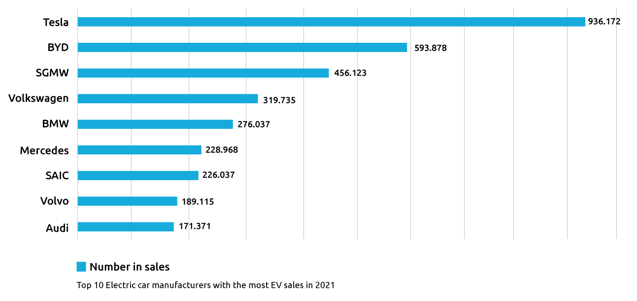
The Future of Electric Cars
- The future of electric cars and EV industry predictions show that we’ve only just started with the EV revolution
- As soon as consumers are satisfied with the availability of suitable electric car models and sufficient charging infrastructure, adoption levels can be expected to pick up speed
- Even more, innovative ways for e-mobility services such as car-sharing, ride-sharing, and ride-hailing will also raise consumer EV awareness
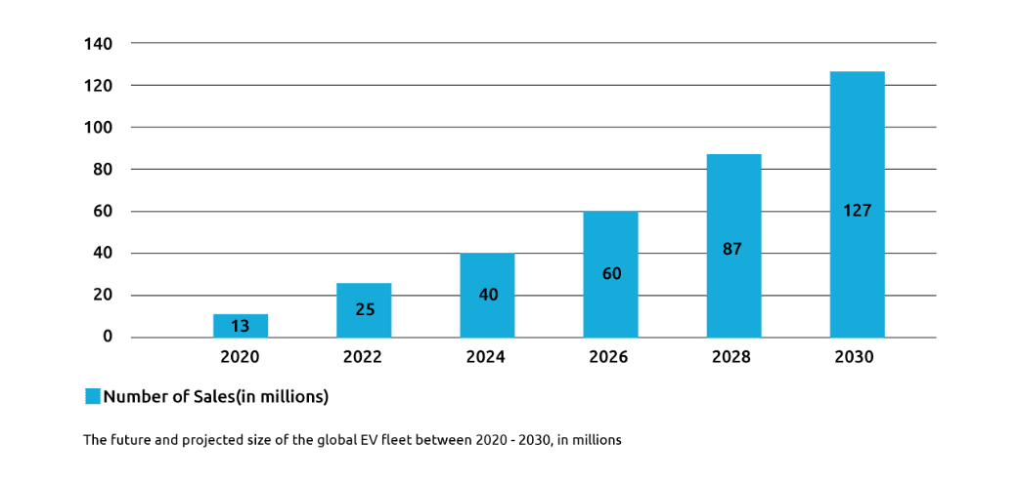
Business Around Battery Driven Electric Vehicles-India
- The India Electric Vehicle Market was valued at USD 5 billion in 2020 and predicts to grow to USD 47 billion by 2026, with a CAGR (Compound Annual Growth Rate) of more than 44% during the forecast period (2021 - 2026)
- E-commerce businesses (such as Amazon) are starting efforts to deploy e-Mobility for last-mile delivery to lower their carbon footprint
- India is experimenting with e-Mobility for public transportation and has already deployed electric intercity buses in many major cities
- Furthermore, state governments are proactively implementing legislation
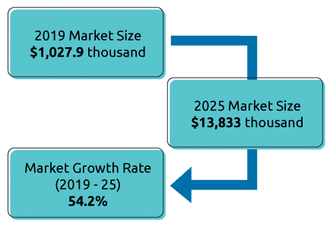
Key Players of EVs in India
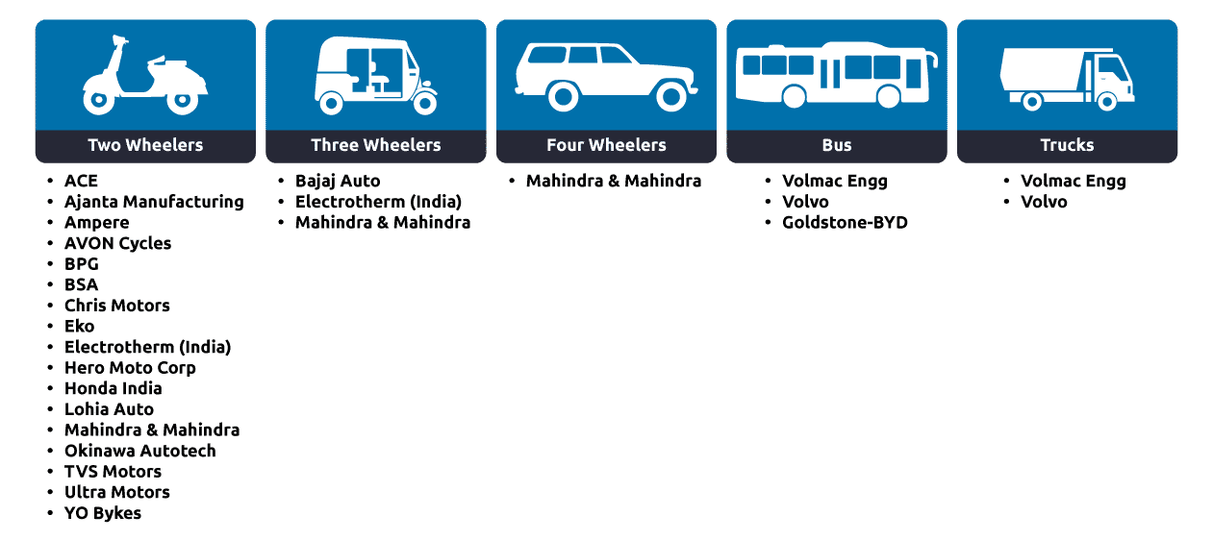
EVs Sale in India (FY 16 to FY 20)
Following the launch of the FAME India program, which aims to transition towards e-mobility in the light of expanding international policy commitments and environmental difficulties, the EV market in India has gained substantial traction.
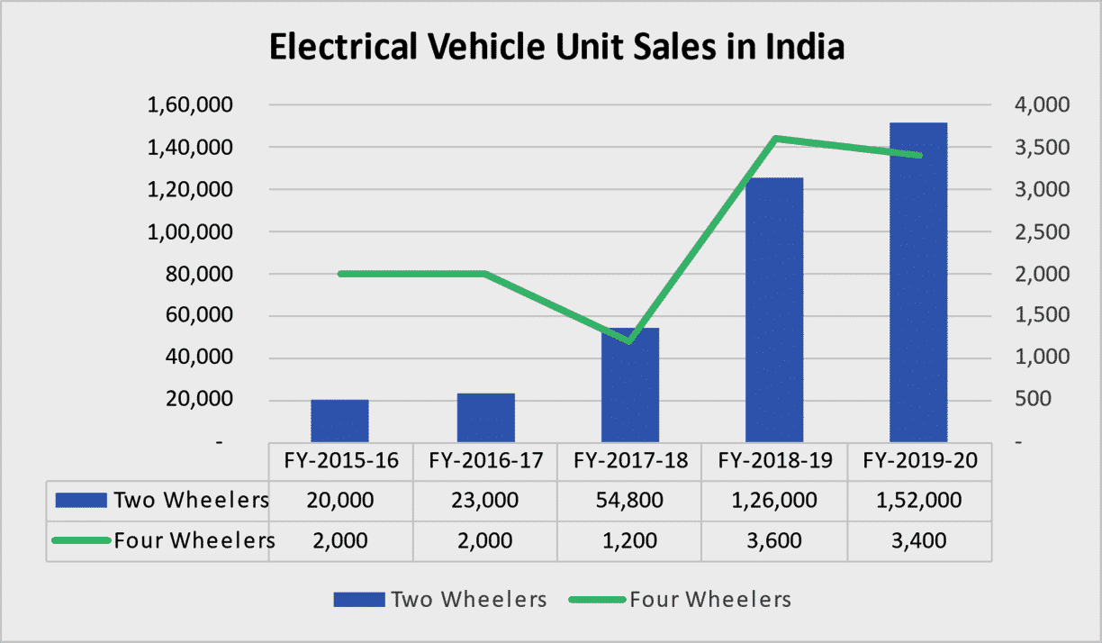
India’s Standing in World Position in Using EVs
As of 2019, the world had 7.2 million electric cars, a 40% jump over 2018. While 1.6% of cars in China are EVs, electric cars comprise just 0.07% of the cars in India. Moreover, Norway, Iceland, Netherlands, and Sweden have an even higher percentage.
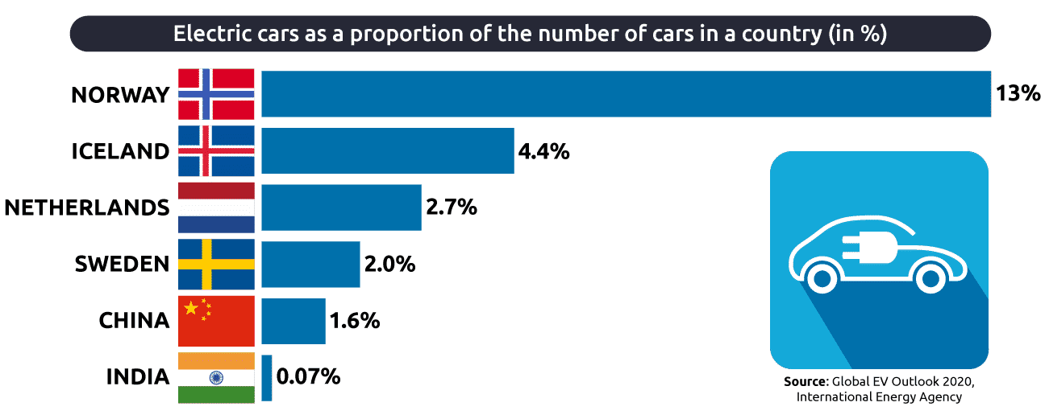
EV Market Key Players in India: Manufacturers
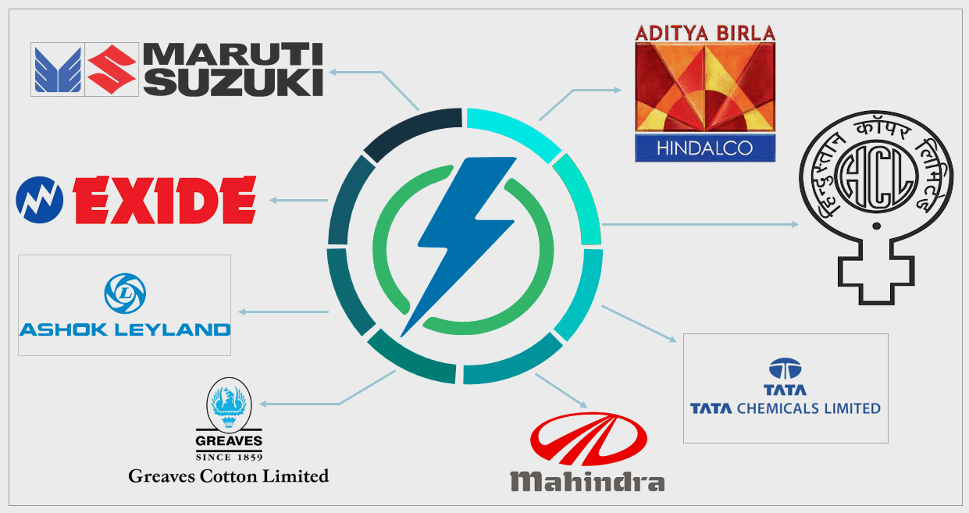
Zero Emission
Many countries promote Zero Emission Vehicles (ZEVs) and Near Zero Emission Vehicles (NZEVs) as a key element in reducing green house gas and pollutant emissions from transportation.
ZEVs and NZEVs have been advancing at a rapid pace over the last decade.
Technology
The majority of ZEVs and NZEVs on the roads today are battery electric vehicles (BEVs) and plug-in hybrid electric vehicles (PHEVs).
Lower cost
Costs of battery, have come down considerably. These have then led to significant growth in ZEV population, especially electric vehicles (EVs).
Fuel cell electric vehicles (FCEVs) which are also zero emission vehicles are commercially available but haven’t been adopted as widely as BEVs and PHEVs.
Types of ZERO EMISSION and NEAR-ZERO EMISSION Vehicles
There are multiple types of ZEVs and NZEVs. Most of them are EVs like, BEV, FCEV, and PHEV. People are more familiar with EVs, especially in the light-duty sector (e.g., Tesla Model 3, Nissan LEAF, Chevy Volt). It may be less known that non-EVs have near-zero emissions as well.
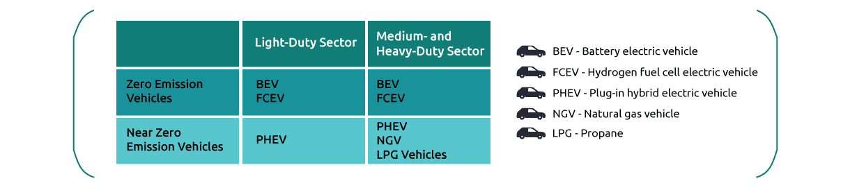
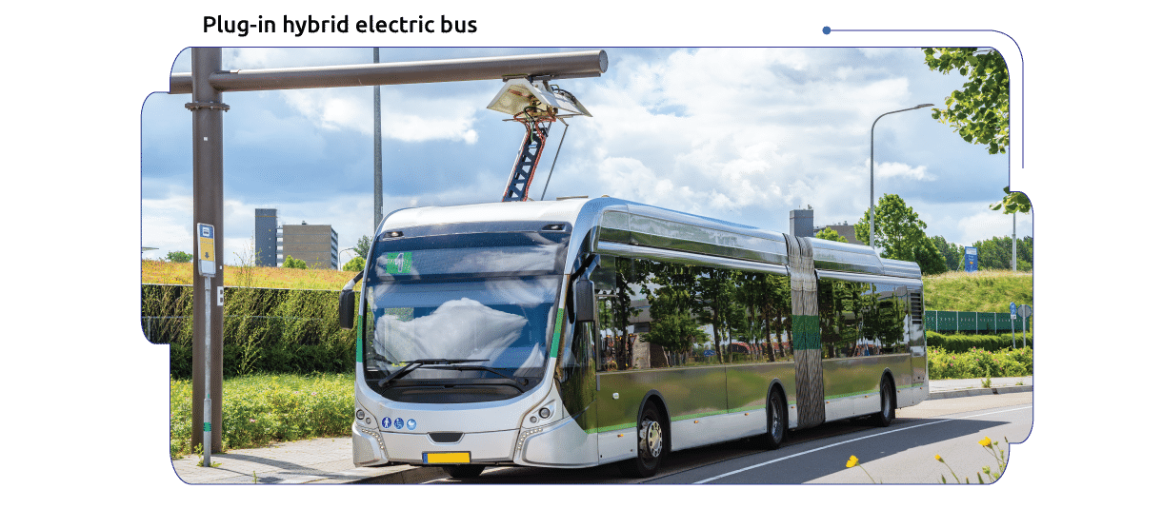

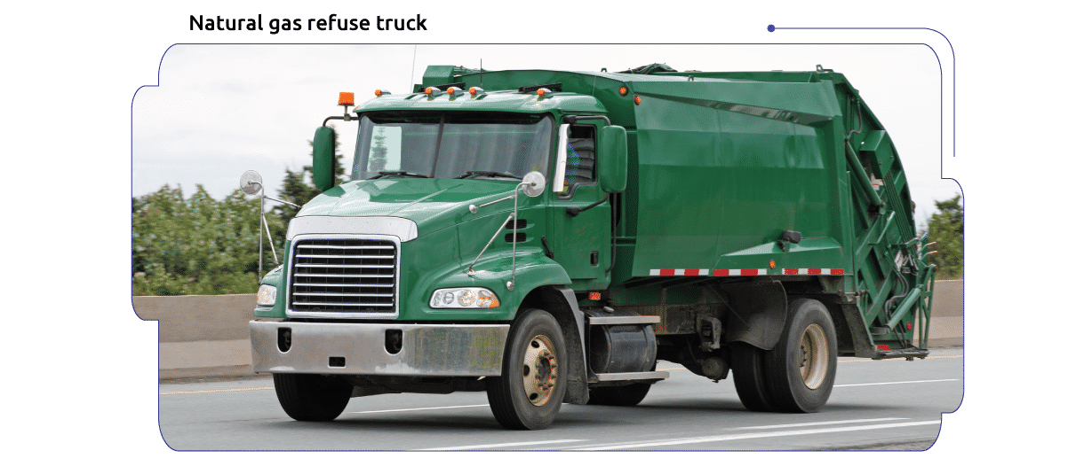
Low Emissions Zones
A low-emission zone (LEZ) is a defined area where access by some polluting vehicles is restricted or deterred with the aim of improving air quality. The intent of LEZs is generally to improve air quality within cities and larger towns. This intent is indeed achieved, with diesel particulates dropping in most LEZs. Low Emission Zones are geographical areas where the most polluting vehicles are regulated. Usually, this means that vehicles with higher emissions cannot enter the area. In some Low Emission Zones, the more polluting vehicles have to pay a higher fee/toll if they enter the low emission zone. London is the oldest LEZ Zone and the European Federation for Transport and Environment is of the opinion that LEZs should be gradually turned into zero-emission mobility zones and complement policies promoting a switch to clean alternatives, including walking and cycling, among others.
LEZs Around the World
- Europe- 250 LEZs as of 2019
- Asia-Tokyo, Japan; Seoul, South Korea; Beijing, China, Hong Kong, Singapore
- America- Bogota, Columbia; Mexico City, Mexico

Current LEZs Vary Greatly By, e.g.
- Area coverage
- Vehicle types restricted
- Required emission standards
- Time/day/month LEZ is in effect
- Entry fee and fine
- Enforcement
Zero Emission Regulatory Rules and Incentives
- Zero emission vehicle (ZEV) mandates and strict regulations related to fuel economy are boosting the demand for EV. For instance, the fleet average CO₂ emission targets in Europe will require at least 10% of market share to be captured by PHEVs and BEVs by 2025.
- Financial incentives provided by local governments are providing traction to EV demand. Various local governments are providing subsidies, VAT and vehicles registration tax exemptions on purchase of EV and EV chargers to incentivize EV buyers. These incentives are making EV to complete the ICE vehicles on pricing.
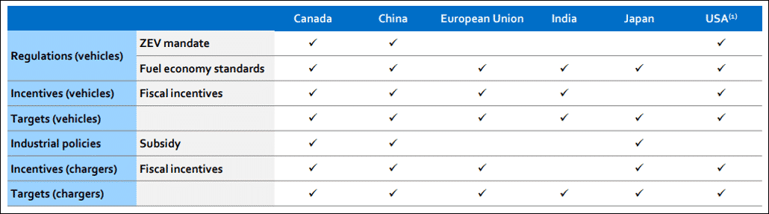
Sustaining the Future With Nature
Impact of the Automotive Industry on the Environment
- Transportation accounted for a quarter of the world’s global CO₂ emissions in 2016, with road transportation alone accounting for 18%
- China mines most of the natural graphite used in electric vehicles. Increased demand with lax environmental regulations has led to crop failures, soil pollution, water contamination, and large-scale environmental degradation
- Non-biodegradable waste from end-of-life usage and manufacturing waste have resulted landfills, land toxification, and water pollution
- Between January 2017 and June 2017, the US, Europe, and Japan exported 3.1 million tons of plastic waste to developing countries, mostly in Asia
- The automotive industry uses 5.2 billion liters of water and produces 1 million tons of CO₂ from UK by manufacturing of cars and components alone
A More Sustainable Growth Model
- •
With the growing concerns about climate change and environmental degradation, sustainability has become a strategic priority for automotive organizations.
- •
Governments, consumers, and investors are now pushing automotive organizations to change their ways of working, culture, and products, for the industry, which while making substantial progress, still requires to step up its sustainability efforts.
- •
Business leaders understand that considerable change is necessary for the future of the automotive industry, and that is why they’re shifting gears. Attitudes toward sustainability are maturing, and manufacturers are now leading the way in terms of sustainable change.
- •
According to a recent survey by SAP and Oxford Economics, the results show that manufacturing executives outshine other industries when it comes to taking action to increase sustainability.
What do we Mean by Sustainability in the Automotive Industry?
Sustainability in the automotive industry involves a comprehensive view of planet-and human- friendly operations, processes, products, and services.
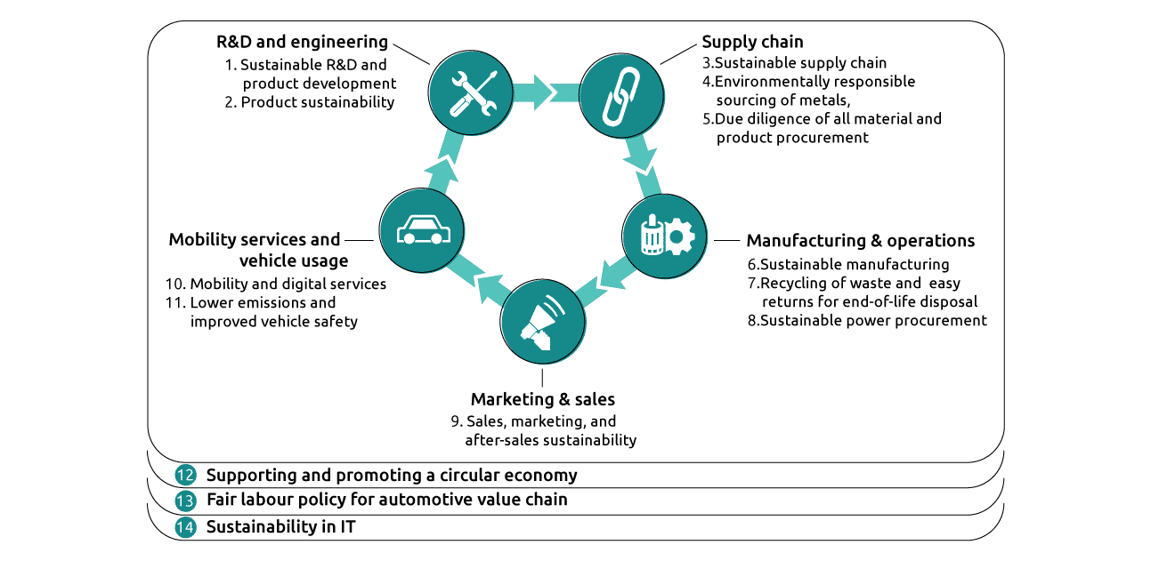
How Can Automotive Firms Accelerate Sustainability?
The maturity framework enables the assessment of the maturity of automotive organizations sustainability programs.
Below are the Pillars of the Maturity Framework
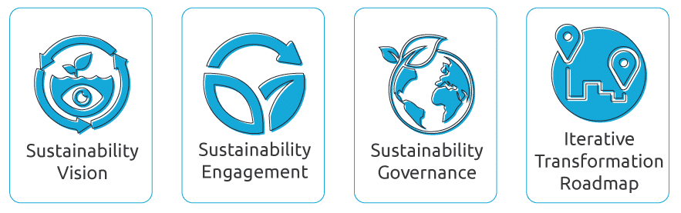
Sustainability Best Practices for the Automotive Industry
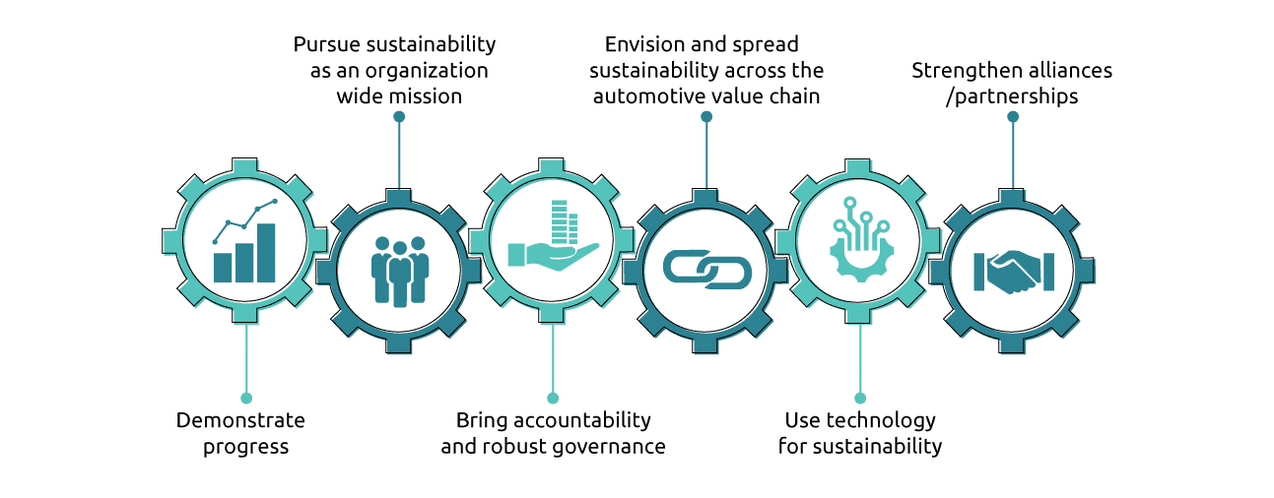
Conclusion
The EV strategy needs to be supported by the ecosystem of renewable charging infrastructure and circular economy to be truly sustainable. These initiatives will drive a great impact, yet the industry needs a structured approach to sustainability in the long run.
- •
The EV producers are taking investment decisions in mass manufacturing of EVs based on various factors such as design, functionality and price of vehicle batteries.
- •
Though challenging, automotive organizations have made sustainability a strategic priority. While this is a good start, ground-level action is required across the automotive value chain.
- •
Governance, measurement, and monitoring need to be build-up.
- •
Sustainability investments need to ramp-up in R&D and EV manufacturing.
- •
Automotive organizations must prudently assess the maturity of their sustainability strategy, learn from sustainability leaders, and make sustainability an organization-wide mission.

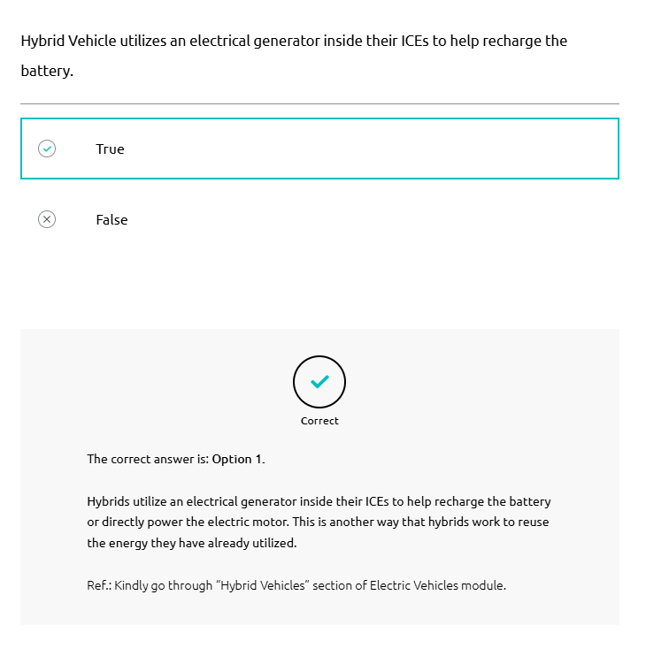
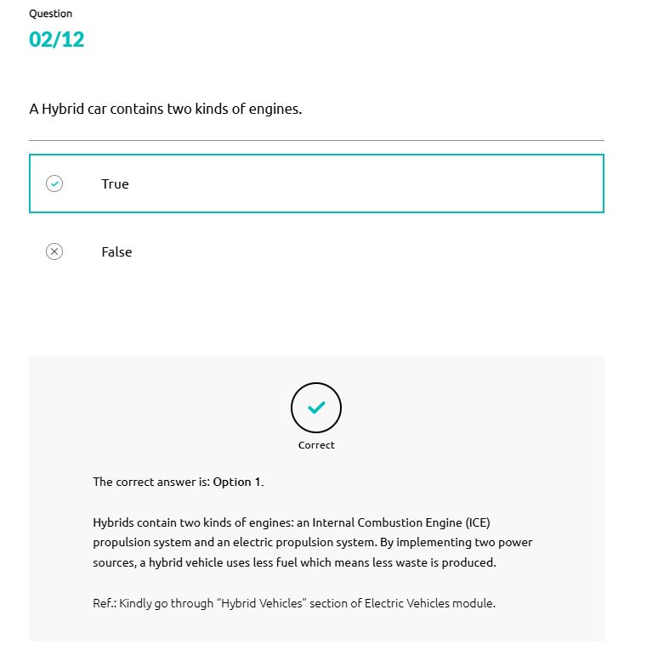
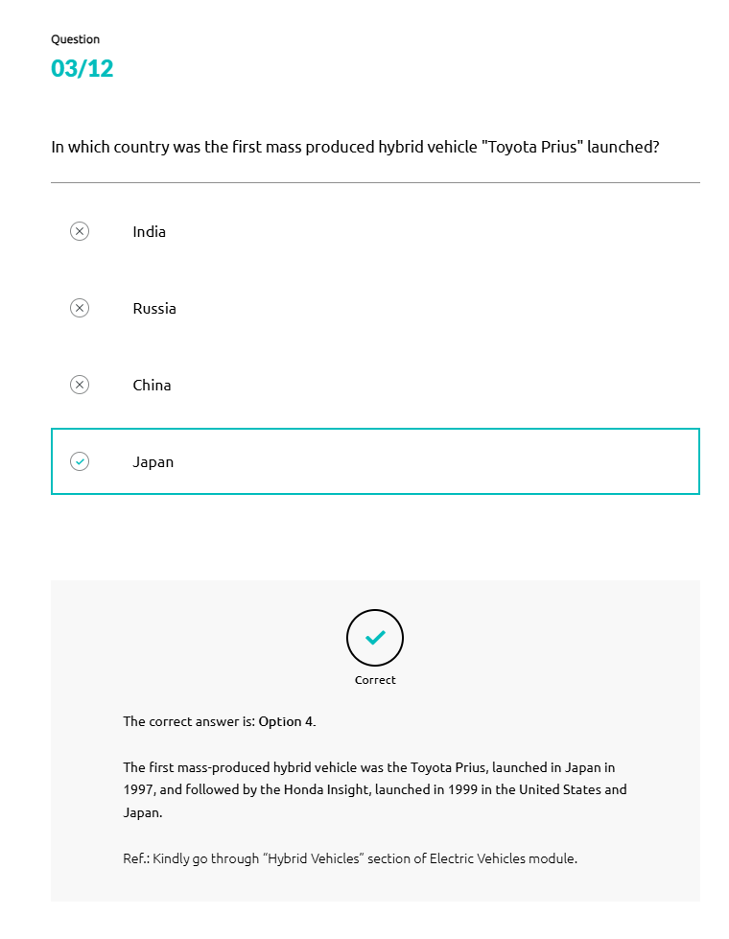
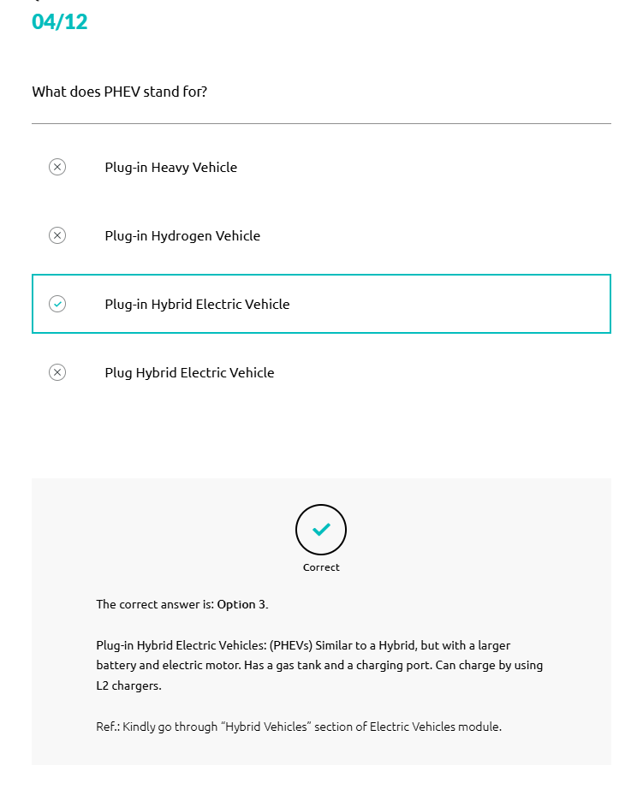
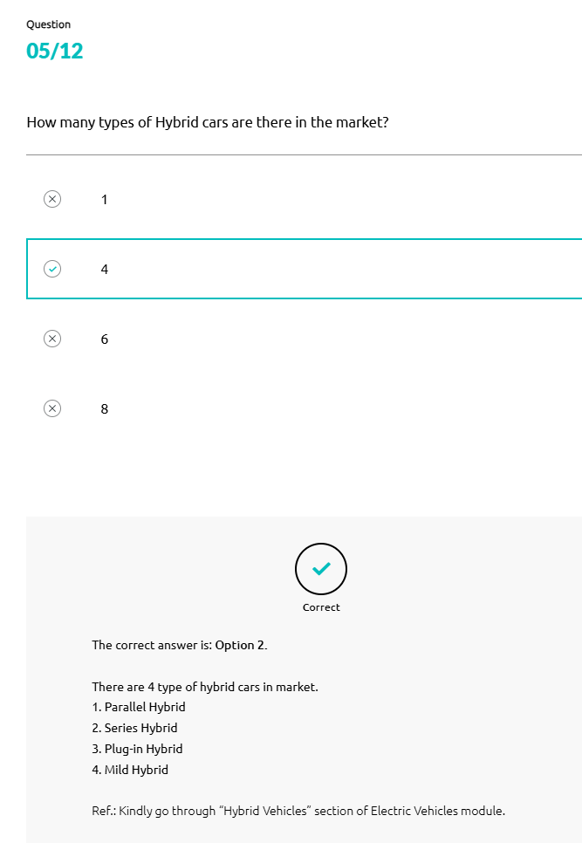
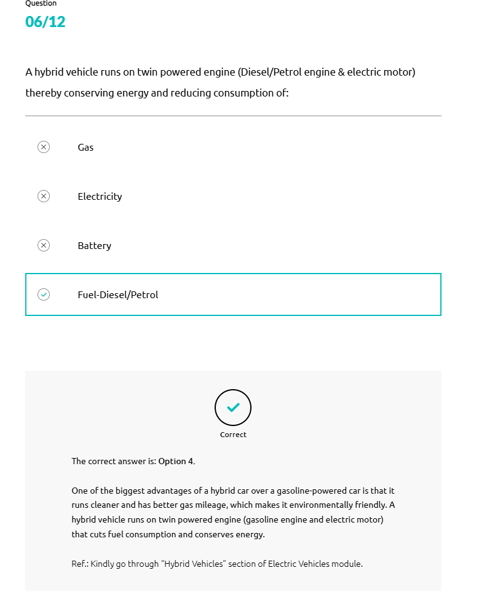
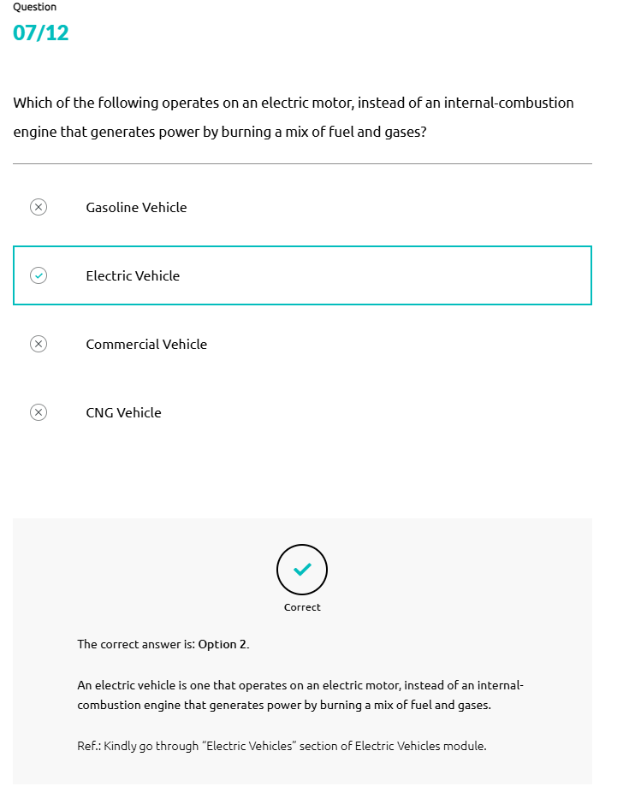
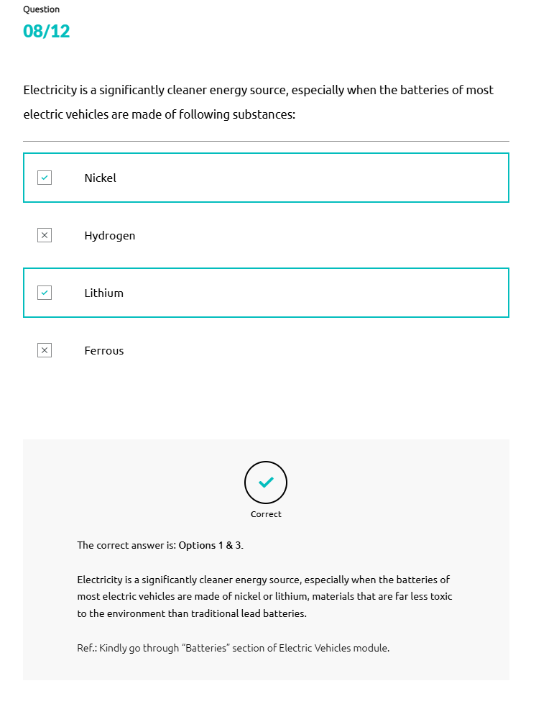
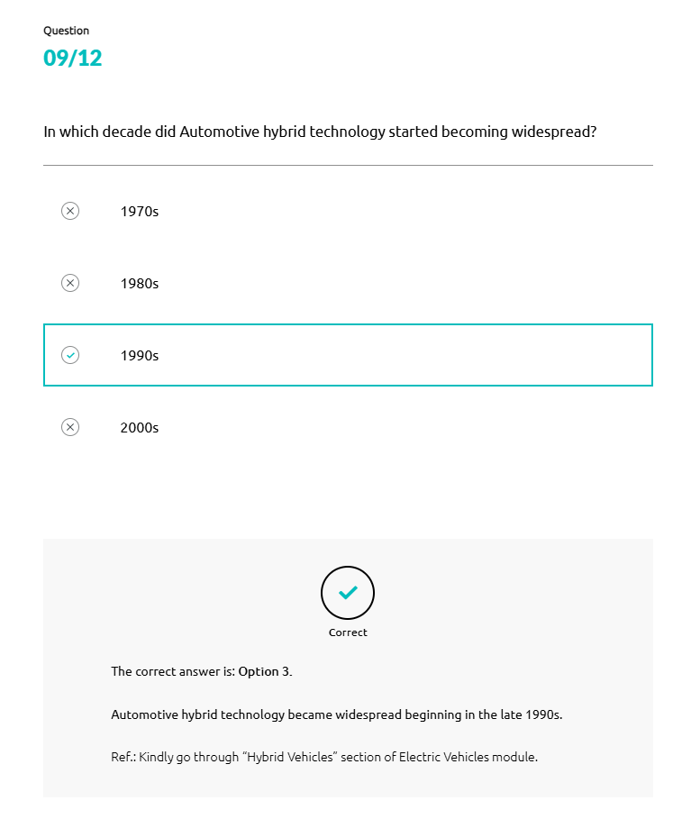
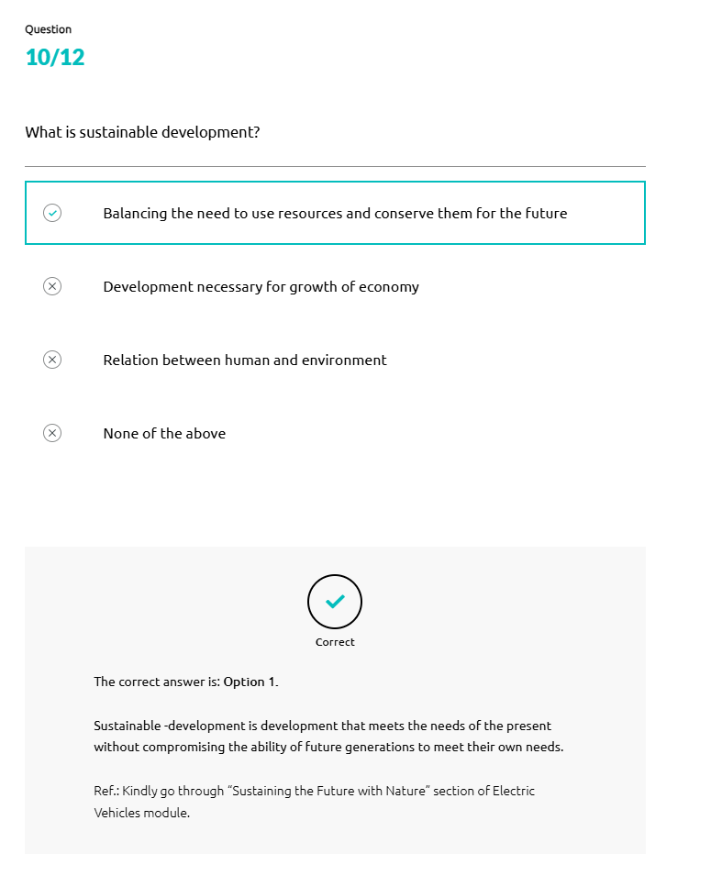

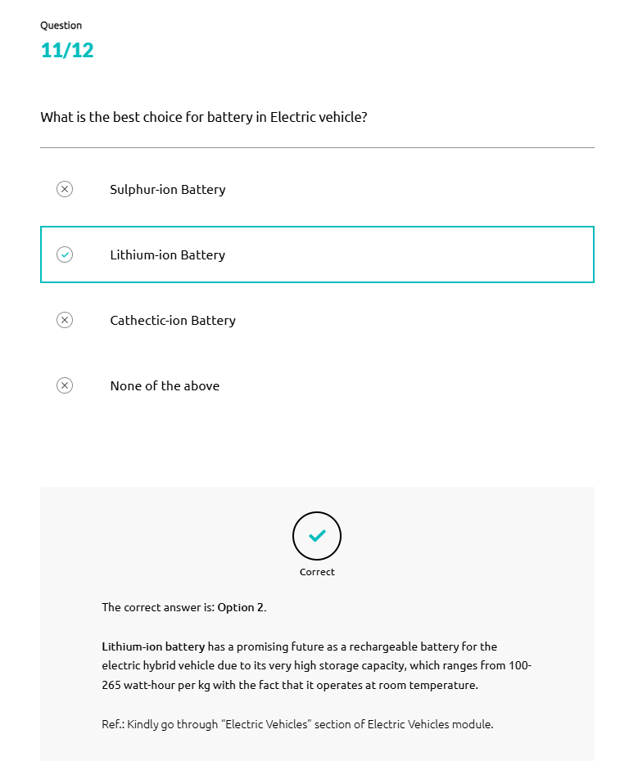
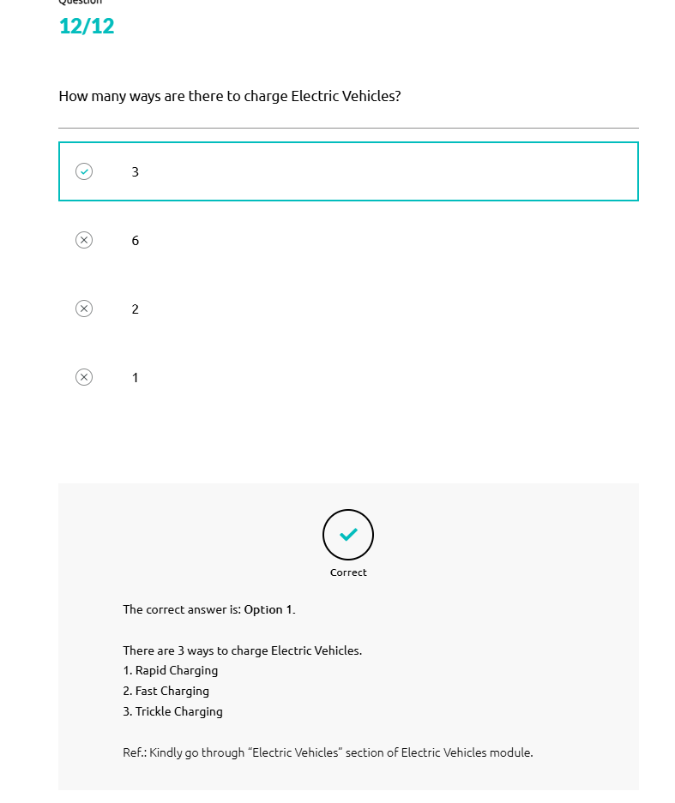
Driverless Cars
Introduction to Driverless Cars
A driverless car is a vehicle capable of sensing its environment and navigating without human input.
In other words, these vehicles fulfill the main capabilities of a regular car on their own.
These cars can detect their surroundings using various techniques, including lidar, radar, GPS, and computer vision.
History of Driverless Cars
- 1
General Motors introduced the first driverless car in 1939.
- 2
In 1925, Haudina's lab invented a radio-controlled driverless car.
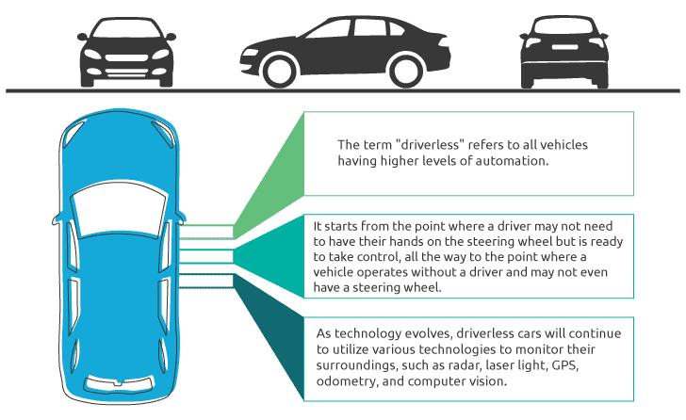
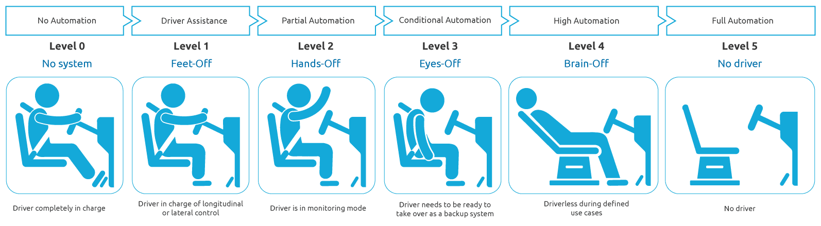
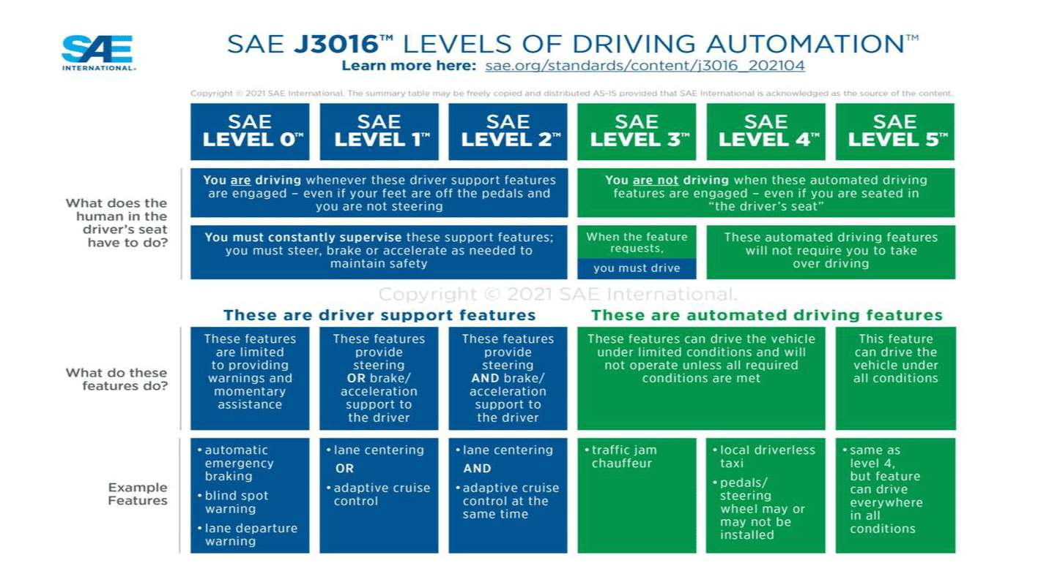
Advantages of Driverless Cars
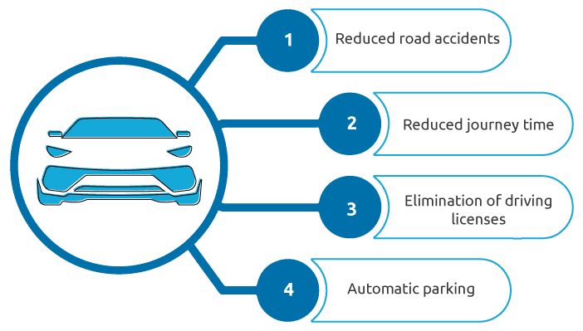
5G
The Meaning of 5G For IoT
Let us understand the meaning of 5G, the fifth generation of mobile network technology, for the Internet of Things (IoT).
- The International Telecommunications Union (ITU) established minimum recommendations for a new technology, which was later defined and standardized by the 3rd Generation Partnership Project (3GPP), leading to the introduction of 5G.
- The launch of 5G allows for faster, more stable, and more secure connectivity. This advancement benefits various sectors, including self-driving vehicles, smart grids for renewable energy, and AI-enabled robots on factory floors.
- 5G unleashes a vast ecosystem for the Internet of Things (IoT), where networks can effectively cater to billions of connected devices, striking a balance between speed, latency, and cost.
- The advent of 5G and IoT (the Internet of Things) will significantly impact revenues, innovation, and expense frameworks of several industry verticals, including automotive.
- 5G will reshape the automotive industry in several transformative ways with new models offering exciting or innovative features, better production processes, new business models, etc.
- By the end of May 2022, the GSA had identified 493 operators across 150 countries and territories engaging in 5G development. These activities included trials, license acquisition, planning, network deployment, and launches.
The Impact of 5G and IoT on the Auto Industry
Let's Discuss the Impact of 5G and IoT on the Auto Industry
- •
Although the widespread deployment of autonomous cars (and other vehicles, such as trucks) might take several more years, connected cars are very much with us.
- •
The modern automobile is rapidly becoming a sensor-laden mobile Internet of Things. It possesses significant computing power and a dedicated communication system for three primary purposes: telematics, which involves vehicle location, driver behavior, engine diagnostics, and vehicle activity; vehicle-to-everything (V2X) communication, which focuses on the surrounding environment; and infotainment, which pertains to the vehicle's occupants.
- •
While 5G networks have been a work in progress for mobile operators, the pace of deployment and launches is picking up.
Connected Car & Connected Fleet
Overview of Connected Car
A connected car refers to any vehicle or car that has internet connectivity.
These vehicles connect to the internet via WLAN (Wireless Local Area Network).
A connected vehicle can also share the internet with devices inside and outside the car.
At Present, Automobile Companies Utilize Two Types of Systems in Connected Cars:

- 1
Embedded System: An embedded vehicle is equipped with a chipset and a built-in antenna
- 2
Tethered System: This system includes hardware that connects to the driver's smartphone
Connected Services
There are five ways a vehicle can be connected to its surroundings and communicate with them.
- Vehicle to Infrastructure (V2I)
- Vehicle to Vehicle (V2V)
- Vehicle to Cloud (V2C)
- Vehicle to Pedestrian (V2P)
- Vehicle to Everything (V2X)
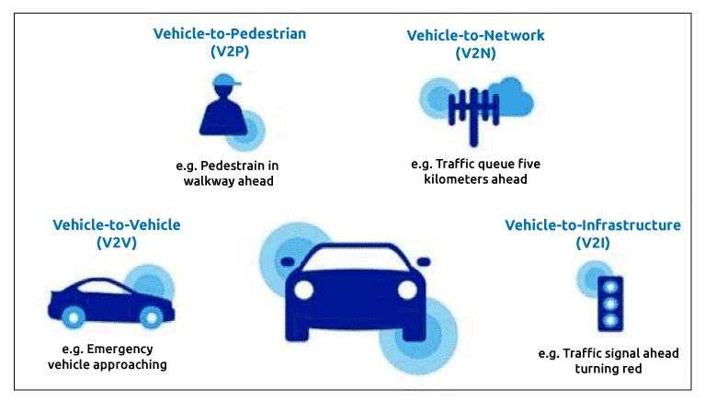
Features of Connected Vehicles
A connected car remains constantly connected to the internet via an embedded chipset or SIM card, enabling it to access the internet via stable wireless network coverage.
Remote parking is useful in small parking spaces and when you lack confidence in parking your car in congested areas.
- Front of card
No image alternative text
Click to flip
Back of card
A connected vehicle allows you to connect to a host of pre-loaded entertainment services and applications. Additionally, it enables you to connect your smartphone to the car's infotainment system via apps, allowing remote control of the audio/video.
Car manufacturers currently provide a dedicated smartphone application that establishes a wireless connection with the vehicle. The app allows users to remotely control various car functions, including locking or unlocking doors, starting or stopping the engine, and even locating the car using the onboard GPS.
Connected vehicles come equipped with essential security features, such as real-time location sharing and tracking, emergency SOS calls in case of an accident, roadside assistance in case of vehicle breakdown, and offering additional functionalities.
Connected Fleet & Its Uses
A group of cars or vehicles operating under the same ownership is called a fleet.
Connected Fleet is a technology that enables interconnected vehicles to predict their movements, thereby avoiding accidents by alerting drivers about dangerous driving, overtaking, etc.
Connected Fleet Technology Can Be Used For the Following Purposes:

- 1
Vehicle tracking to pinpoint the precise location of vehicles, including geofencing and proximity search
- 2
Monitoring driver behavior, which includes watching out for troubling driving patterns, logging mileage, managing expenses, identifying drivers, and tracking working time
- 3
Remote diagnostics and maintenance alerts
- 4
Promotion of eco-driving
- 5
Order management, which includes order entry, dispatch, providing order status information, and offering electronic proof of delivery
- 6
Reduction of expenses related to fuel and idling
- 7
Tracking and recovery of stolen vehicles
- 8
Prevention of unauthorized use of assets during and after work hours
Software Driven Vehicles
The Meaning of a Software-Defined Vehicle
The software-defined vehicle relies mainly on software to enable its features and functions.
It is a result of the ongoing transformation of the automobile from a hardware-based product to a software-centric electronic device on wheels.
Premium vehicles today can already contain up to 150 million lines of software code distributed among as many as 100 electronic control units (ECU's) and a growing array of sensors, cameras, radar, and light detection and ranging (lidar) devices.
Software-defined vehicles (SDV's) offer significant safety and convenience features, enabling new in-vehicle experiences and functions through the software while delivering updates and services over-the-air (OTA).
Benefits of the Software - Defined Vehicle
- 1
Customers can benefit from an SDV (software - defined vehicle) by receiving
over-the-air (OTA) updates. These updates encompass:
  - Security patches
  - Infotainment improvements
  - Monitoring and tuning of the vehicle's core functional capabilities, such as powertrain and vehicle dynamics
- 2
The electronic control units (ECU's) will facilitate the data exchange with sensors and actuators. This data flow allows vehicle manufacturers to gain insights into various aspects of the vehicle, its performance, and its place in the connected ecosystem.
- 3
In the future, the software-defined vehicle will provide:
  - Improved safety and security features
  - Increased levels of autonomy
  - The capability of receiving daily updates on both functional and safety-related features
- 4
It will have a software platform for connected services, including infotainment.
ADAS - Advanced Features
Introduction to ADAS
Advanced driver assistance systems (ADAS) are designed to increase car safety and road safety more generally. Basically, advanced driver assistance systems (ADAS) help the driver in the driving process and enable safe, relaxed driving. Purchasing a new car with driver-assist features at a fair price is a sensible choice. These features help you drive easily and safely in everyday use.
Now, let's discuss various applications of the ADAS features.
Automatic Emergency Braking (AEB)
Automatic Emergency Braking system (AEB) uses sensors to detect when a collision is imminent and automatically applies the Brakes to avoid or mitigate the impact. AEB is a collision avoidance system that engages the main braking system in automobiles when it detects an imminent collision.
The World Forum for Harmonization of Vehicle Regulations defines AEBS (in some jurisdictions).
UN ECE regulation 131 requires a system that can automatically detect a potential forward collision and activate the vehicle braking system to decelerate a vehicle to avoid or mitigate a collision. UN ECE regulation 152 says deceleration can be 5 meters per second squared.
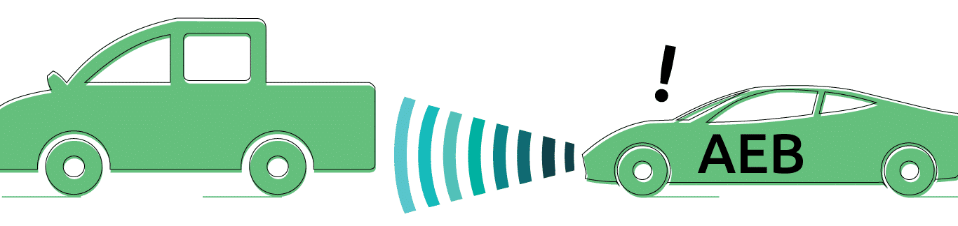
Adaptive Cruise Control
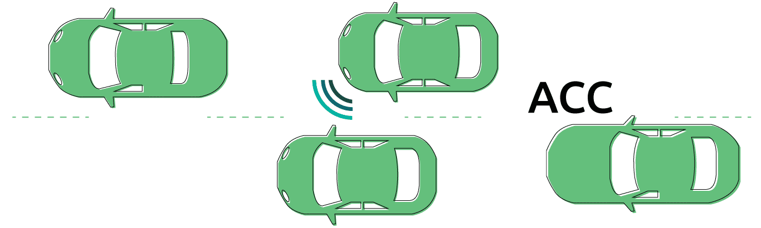
Adaptive Cruise Control (ACC) uses forward-looking radar and maintains a safe distance from the car ahead. In order to prevent accidents, it keeps your car a safe distance from the traffic in front of you.
It makes sense to get your new car with an adaptive cruise control system as the price drops and you drive more highway miles (for longer trips).
Blind Spot Detection
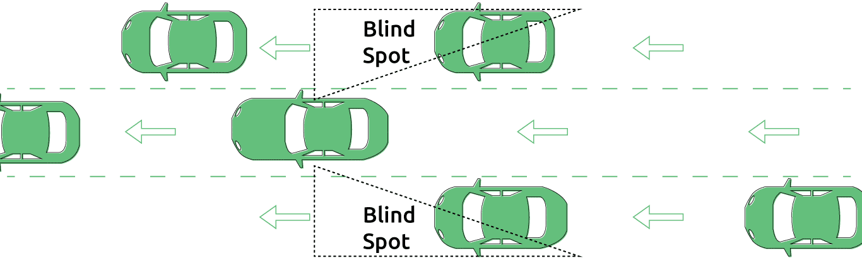
A blind spot monitor detects other vehicles located in the blind spot areas, such as the side and rear, but it also detects other areas.
Blind spot areas are challenging to detect when you are driving at night. If a bicyclist stops in one of these blind spot areas, it becomes difficult to detect the bicyclist.
Also, the system provides audible and visual signs to back out of a parking space when traffic is approaching from other sides.
Driver Drowsiness Detection
Various technologies can be utilized to detect driver drowsiness.
Driver's eye or face monitoring
It requires one of the cameras to watch the driver's face.
Physiological measurement
It requires body sensors to measure parameters, including brain activity, heart rate, skin conductance, and muscle activity.
Steering pattern monitoring
Primarily, it uses the steering input from an electric power steering system to detect the vehicle is drifting away from the lane due to the driver's inattention.
Vehicle position in lane monitoring
It uses the lane monitoring camera to detect the vehicle is drifting away from the lane due to the driver's inattention.
Traffic Sign Recognition
Traffic sign recognition (TSR) system detects road signs such as schools, turns ahead, speed limits, etc.
It also notifies or warns the driver by displaying them on a color screen.
The first traffic sign recognition system first appeared on the BMW 7 Series in late 2008, and then other cars introduced the TSR system, such as the Mercedes S Class, Audi A8, BMW 5 Series, and Volvo's XC60, XC70, V60, etc.

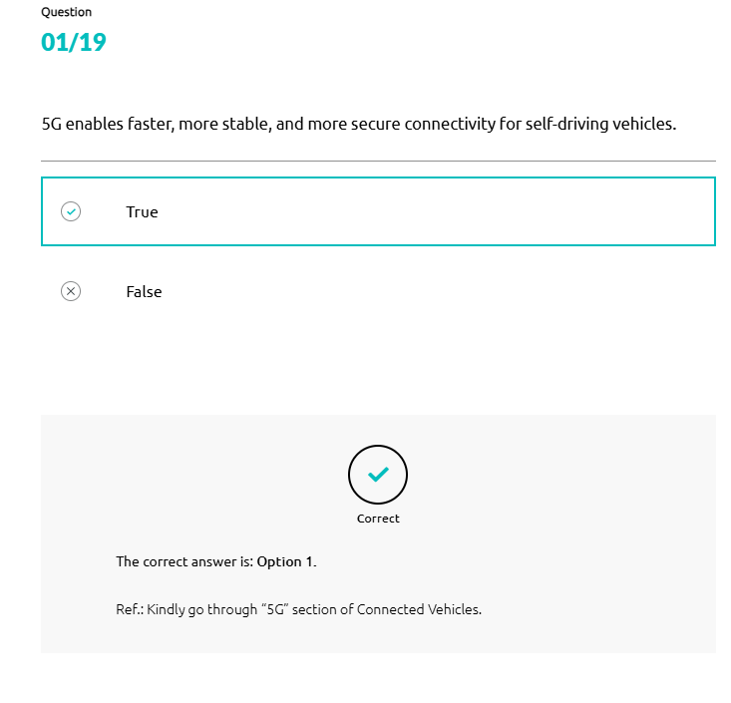
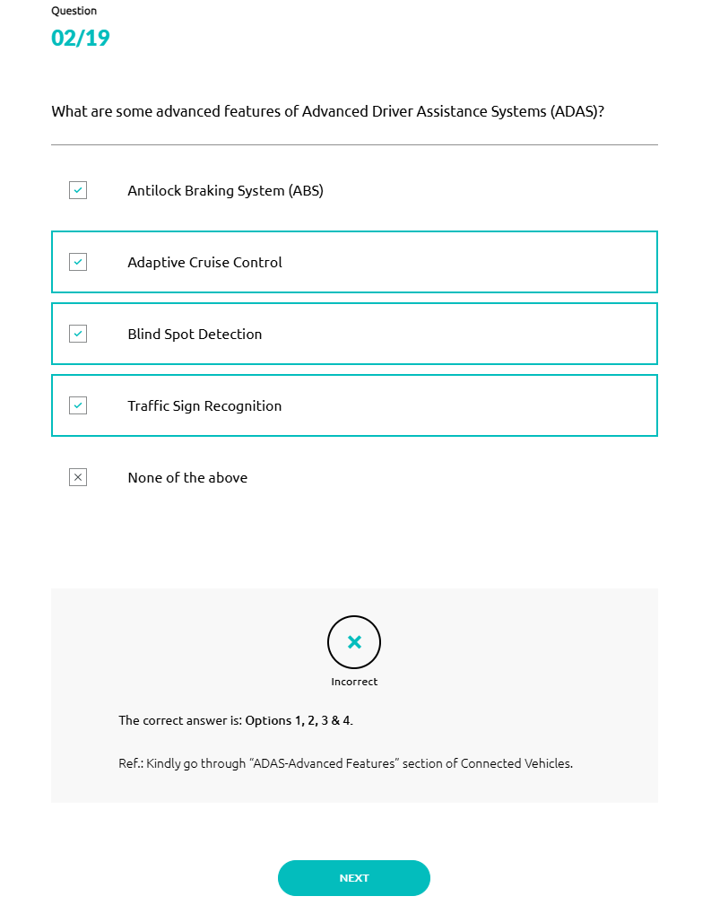
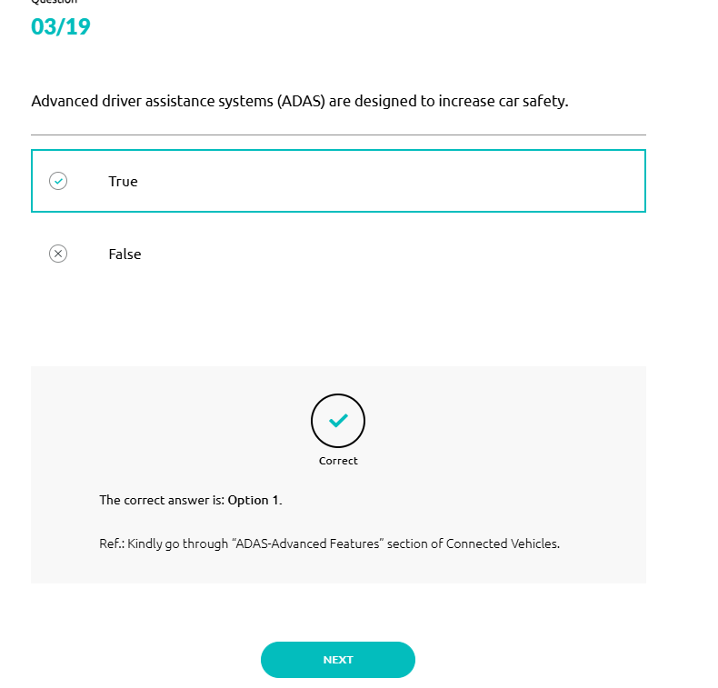

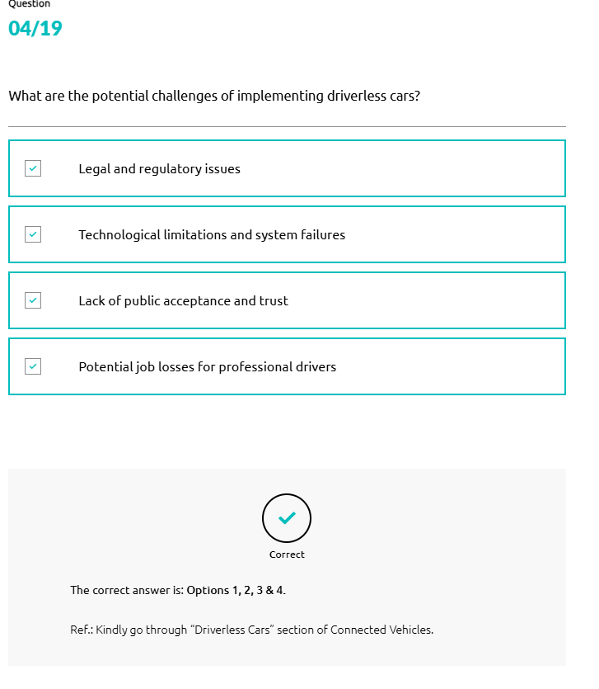
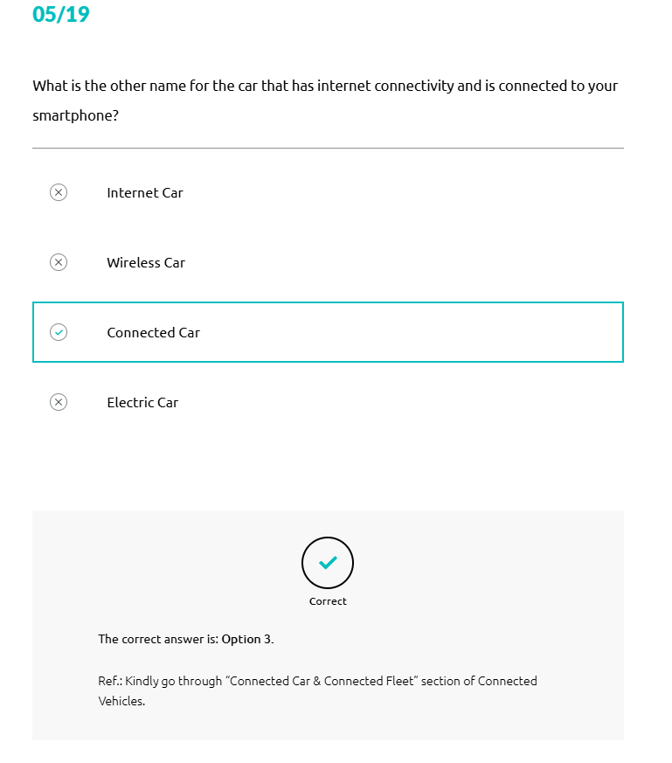
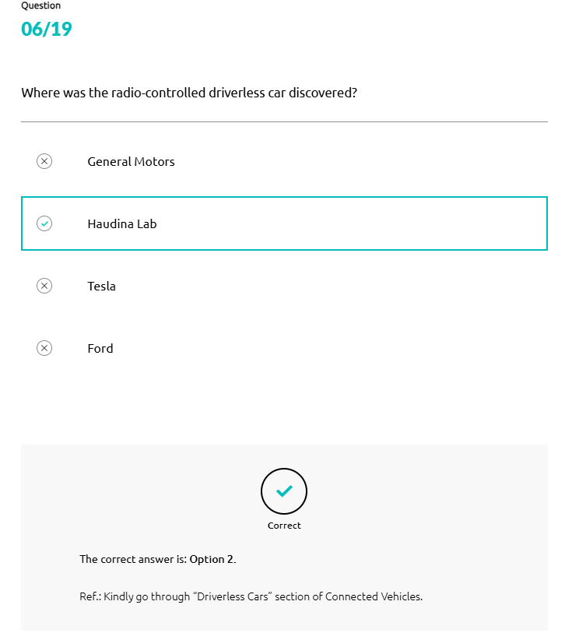
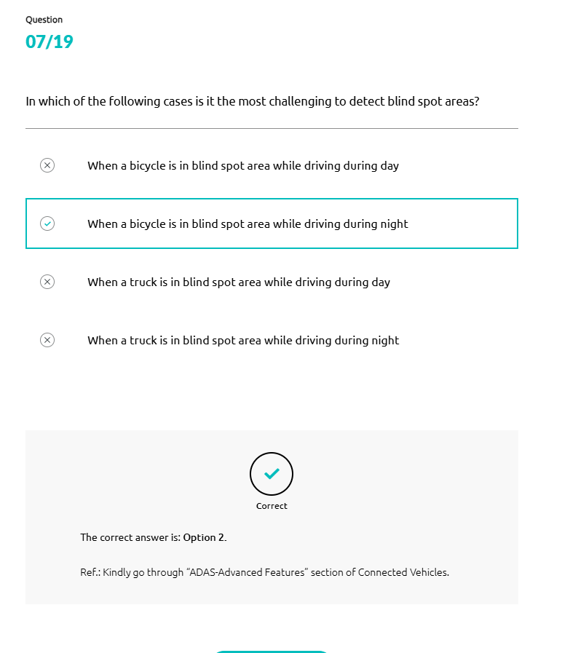
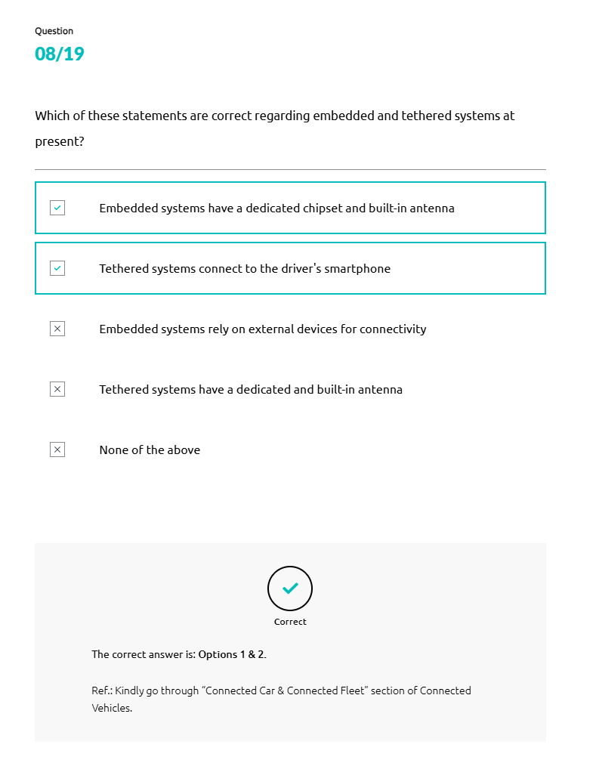
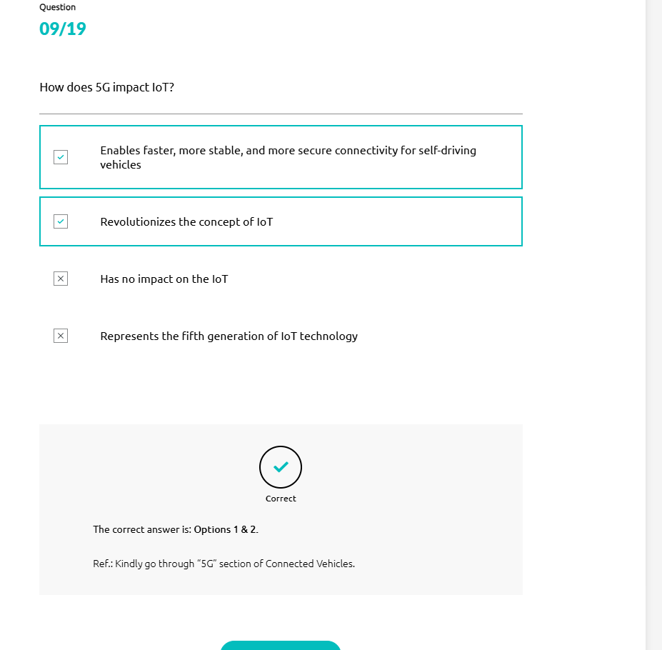

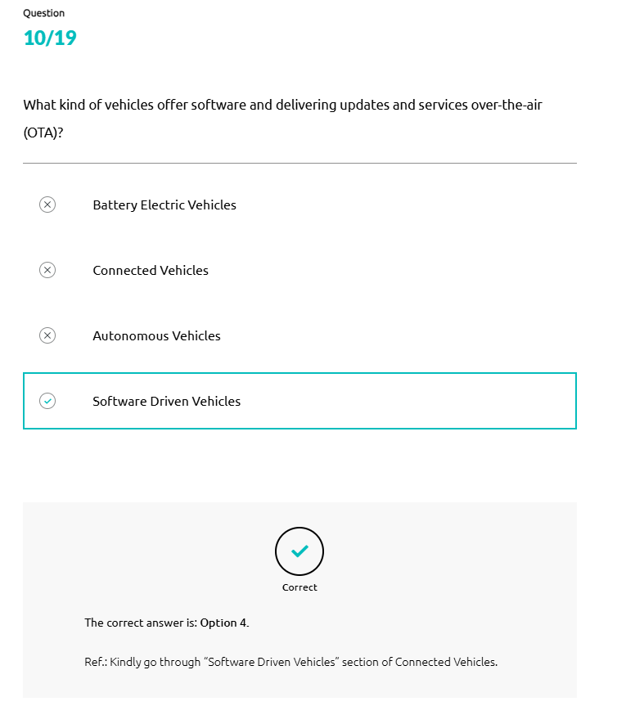
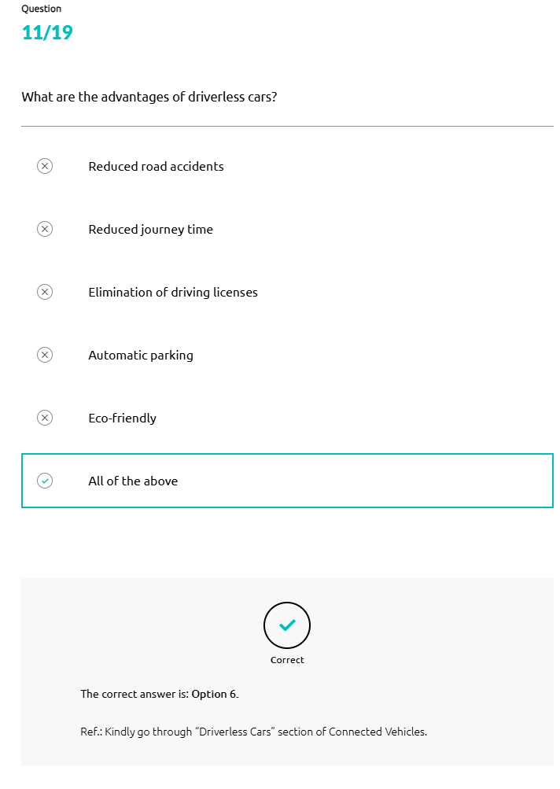
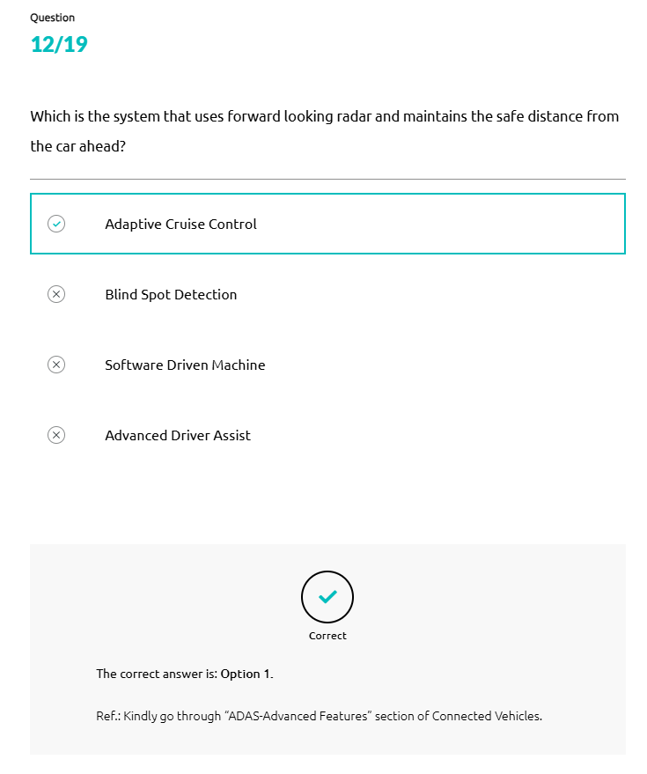
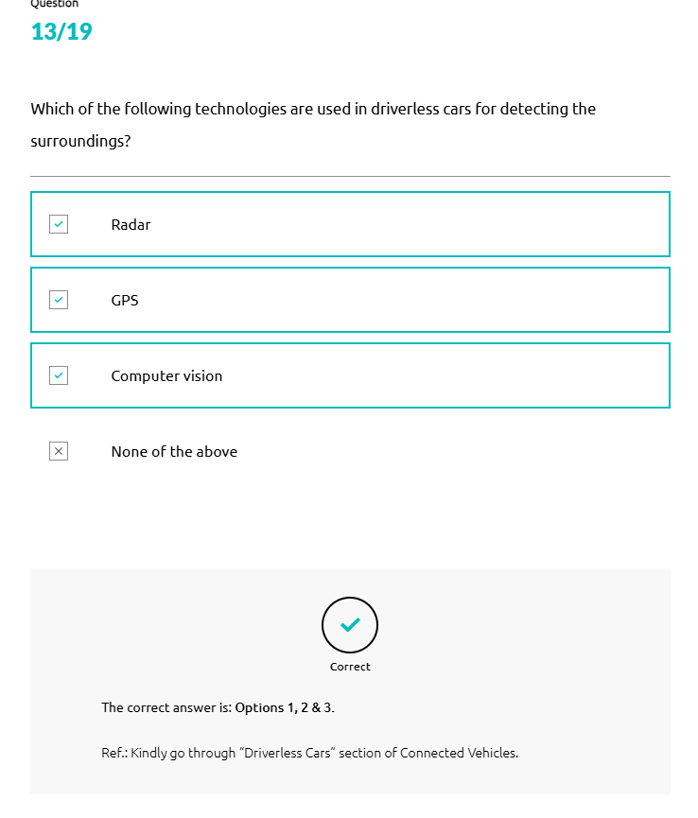
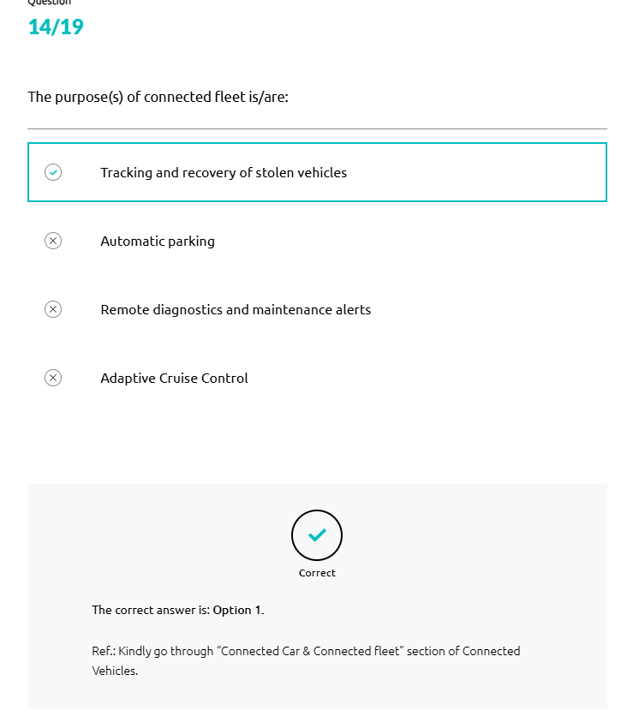
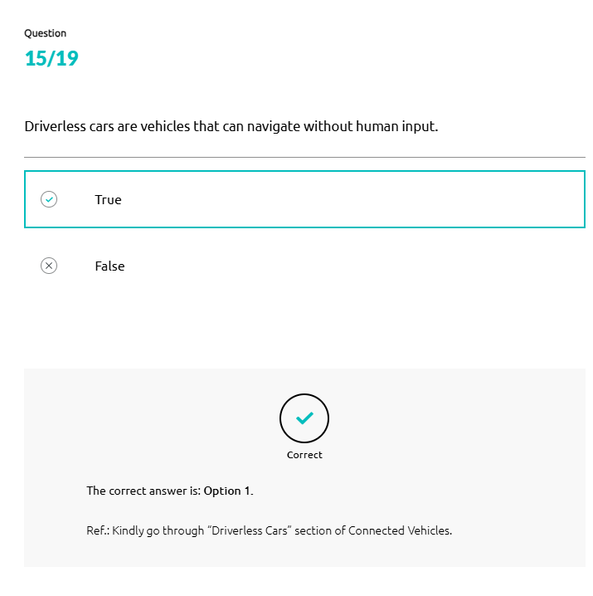
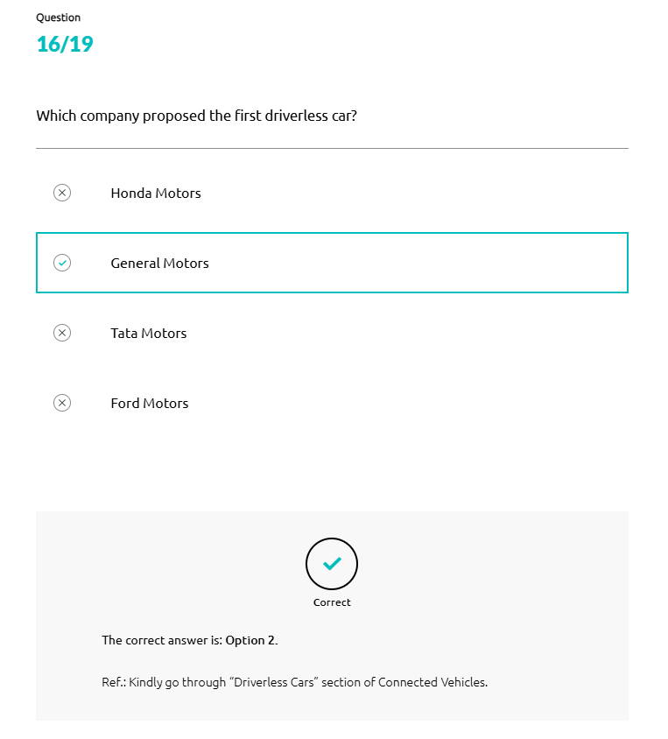
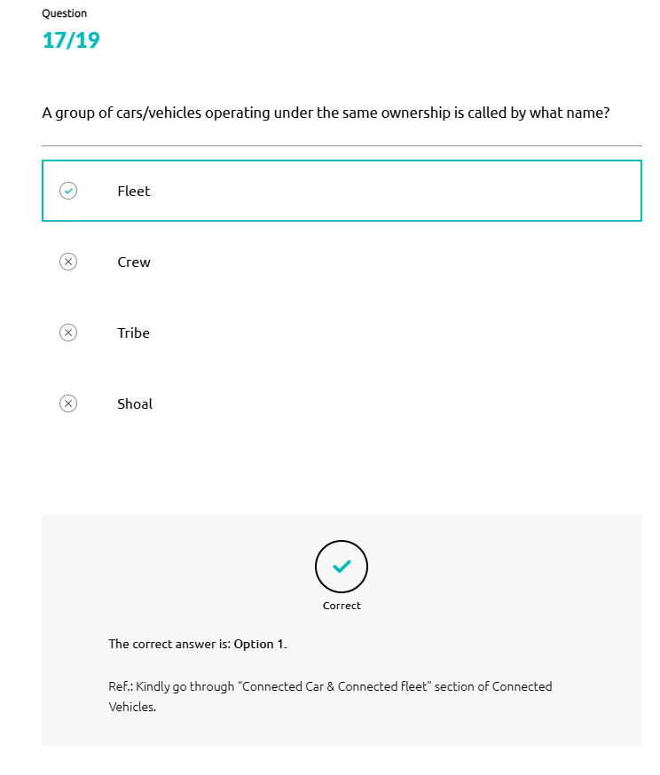
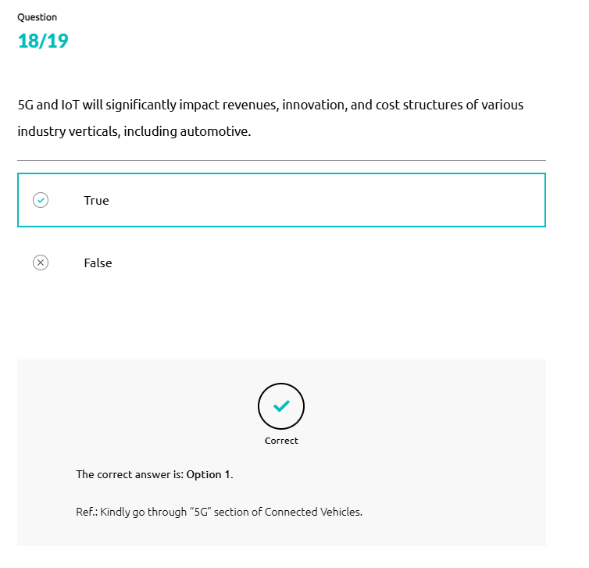
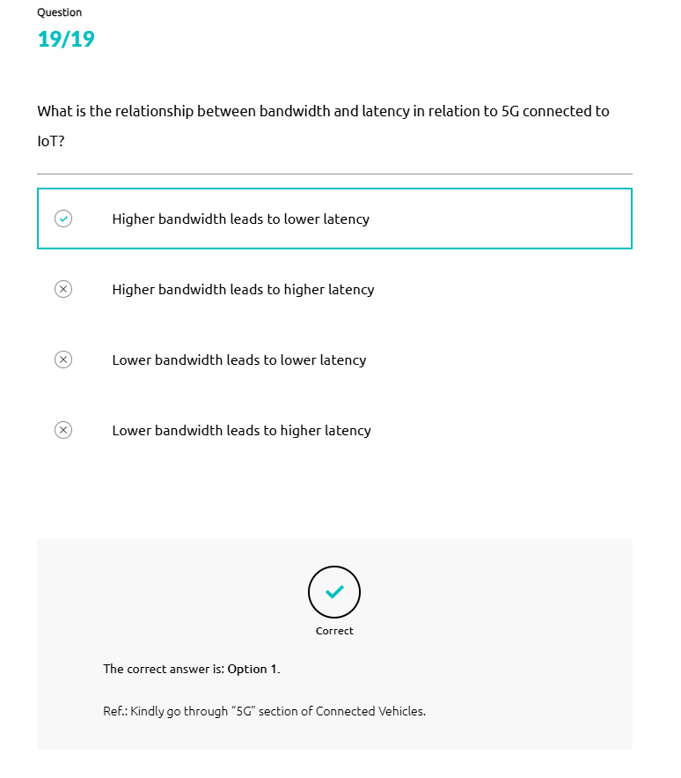
Automotive – Industry 4.0
The term industry 4.0 refers to a further developmental stage in the organization and management of the entire value chain process involved in the automotive manufacturing industry. Another term for this process is the fourth industrial revolution.
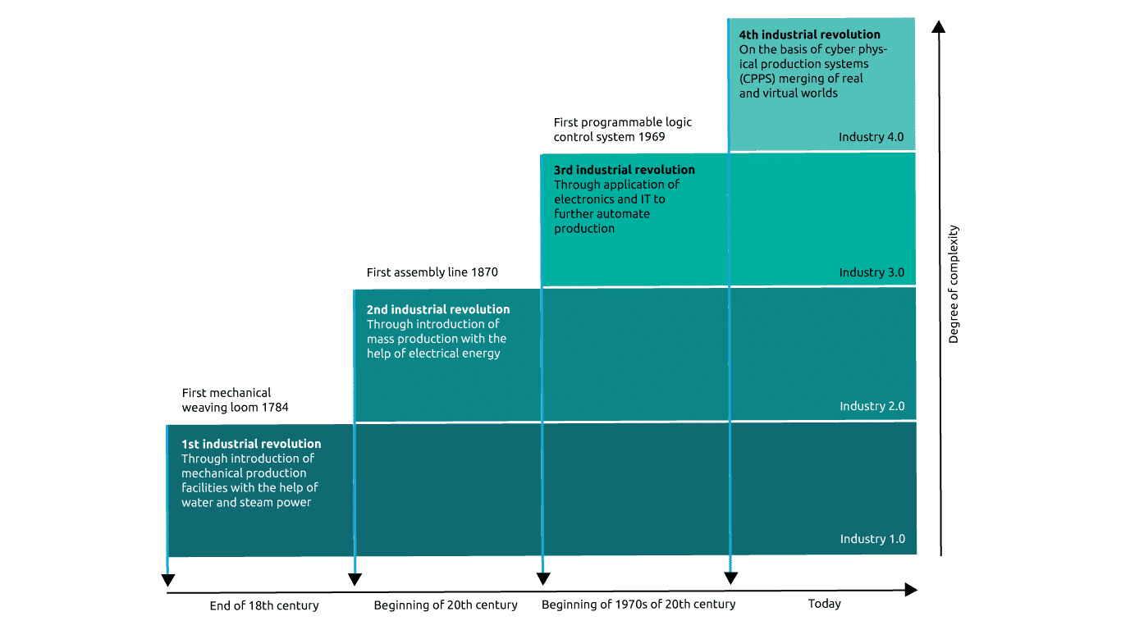
Technology Driven Industry 4.0
- Smart machines continually share information about current stock levels, problems, or faults, and changes in orders or demand levels. Processes and deadlines are coordinated with the aim of boosting efficiency and optimizing throughput times, capacity utilization and quality in development, production, marketing and purchasing.
- CPPSs not only network machines with each other, they also create a smart network of machines, properties, ICT systems, smart products and individuals across the entire value chain and the full product life cycle. Sensors and control elements enable machines to be linked to plants, fleets, networks and human beings.
- Smart networks of this kind are the bedrock of smart factories, which themselves underpin industry 4.0
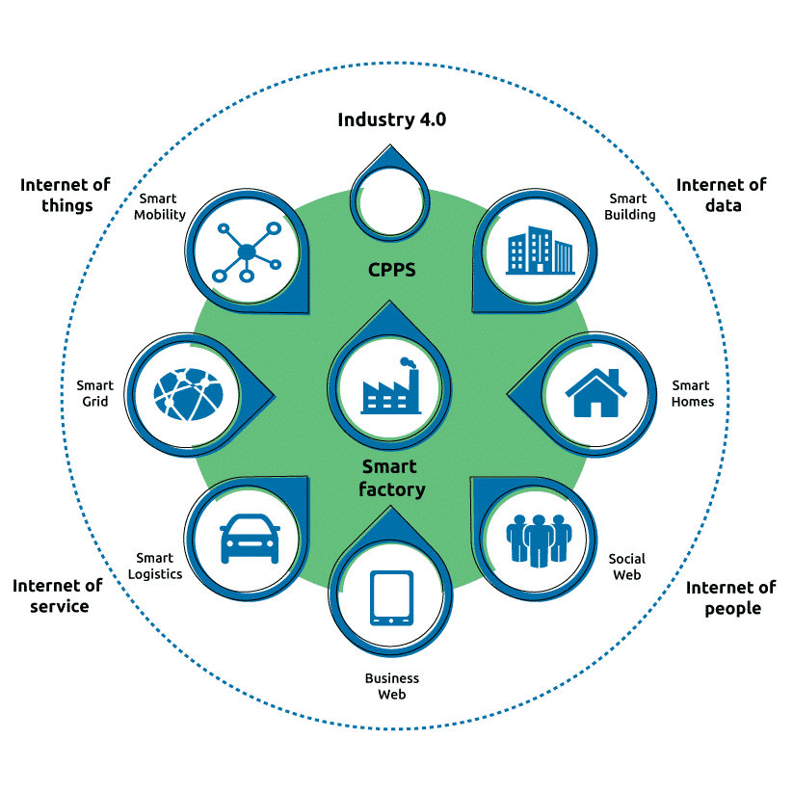
Benefits of Industry 4.0
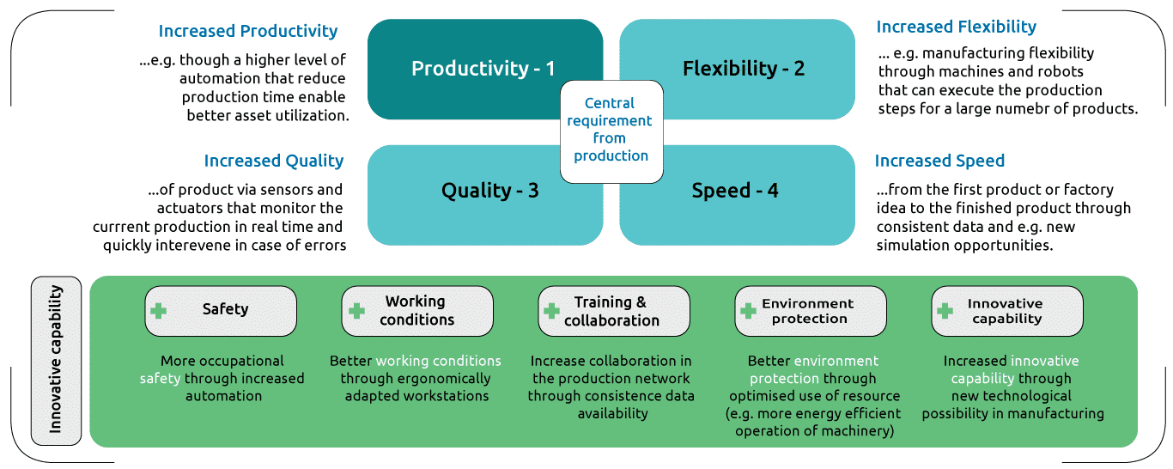
The Impact of Industry 4.0 on the Automotive Industry
Industry 4.0 refers to the integration of advanced digital technologies and automation into various aspects of automotive manufacturing and operations. It involves the use of technologies such as the Internet of Things (IoT), Artificial Intelligence (AI), robotics, big data analytics, additive manufacturing, and Augmented Reality (AR) to drive innovation, improve efficiency, and transform traditional automotive processes.
Industry 4.0 in the automotive sector entails the digitization and connectivity of vehicles, production systems, supply chains, and customer experiences. It encompasses the use of sensors, connectivity, and data analytics to enable real-time monitoring, predictive maintenance, and optimization of manufacturing processes. It also includes the application of AI algorithms to enhance quality control, demand forecasting, and personalized customer experiences.
Industry 4.0 in the automotive industry involves the adoption of additive manufacturing (3D printing) for rapid prototyping, customization, and on-demand production. It utilizes AR and Virtual Reality (VR) technologies for design visualization, virtual testing, training, and customer engagement. Cybersecurity measures are crucial to protect connected vehicles, manufacturing systems, and customer data in the era of Industry 4.0.
Digital Twin & Digital Thread
Digital twins and digital threads are the foundations behind a digital transformation. They both enable new ways to assess practices, processes, and product concepts in a virtual environment. Both can potentially have huge benefits for operating models, revenue streams and relationships in the future.
Let's go through each of them one by one.
Digital Twin
Simply stated, the digital twin is the current representation of a product or system, mimicking a company’s machines, controls, workflows, and systems.
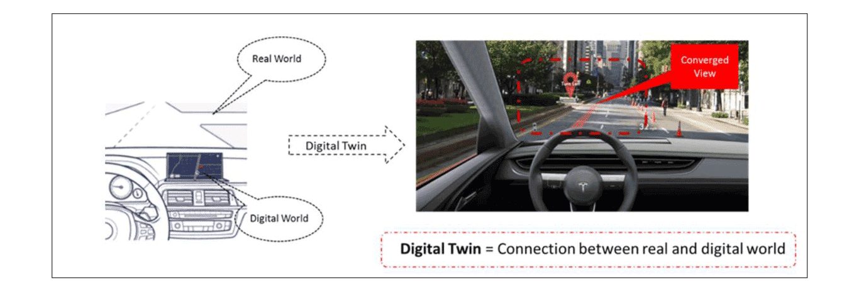
Digital Twin: Steering the Auto Industry towards Data Maturity
Benefits of Digital Twin
- 1
In the automotive sector, digital twin enables the ability to assess the current and future capabilities of a system throughout its entire lifecycle.
- 2
The early detection of system performance deficiencies by simulating results before physical processes and product development is indeed a benefit of digital twin technology in the automotive sector.
- 3
Leveraging models and simulations throughout the entire lifecycle of each vehicle, the automotive sector can achieve optimization in terms of operability, manufacturability, inspect ability, and sustainability.
- 4
The automotive sector continually improves designs and models by leveraging captured data that can be readily cross-referenced with design specifications.

Digital Threads

The digital thread meanwhile is a record of a product or systems lifetime, from its creation to its removal.
Benefits of Digital Threads
- 1
Digital threads aim is to signify the digitization and traceability throughout a product’s lifespan. They link all digital twin’s capabilities such as the designs, performance data, product data, supply chain data, and software going into creating the product in automotive sector.
- 2
The digital thread, in combination with digital twins, enable design requirements, records, and all the data that need to be used. While proving to be useful in the creation and optimization of both physical and digital processes across the product value chain, digital twins and threads are being expanded into the digital market.
- 3
By adopting the digital thread and embracing digitalization, engineers and manufacturing experts in the automotive sector can experience significant advantages, particularly through the elimination of traditional paper-based processes.
Digital Transformation
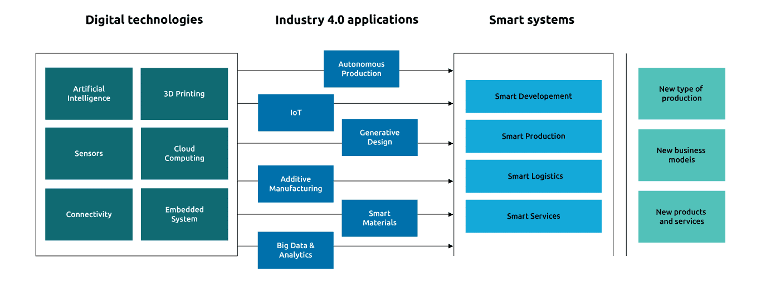
Evolution of Products
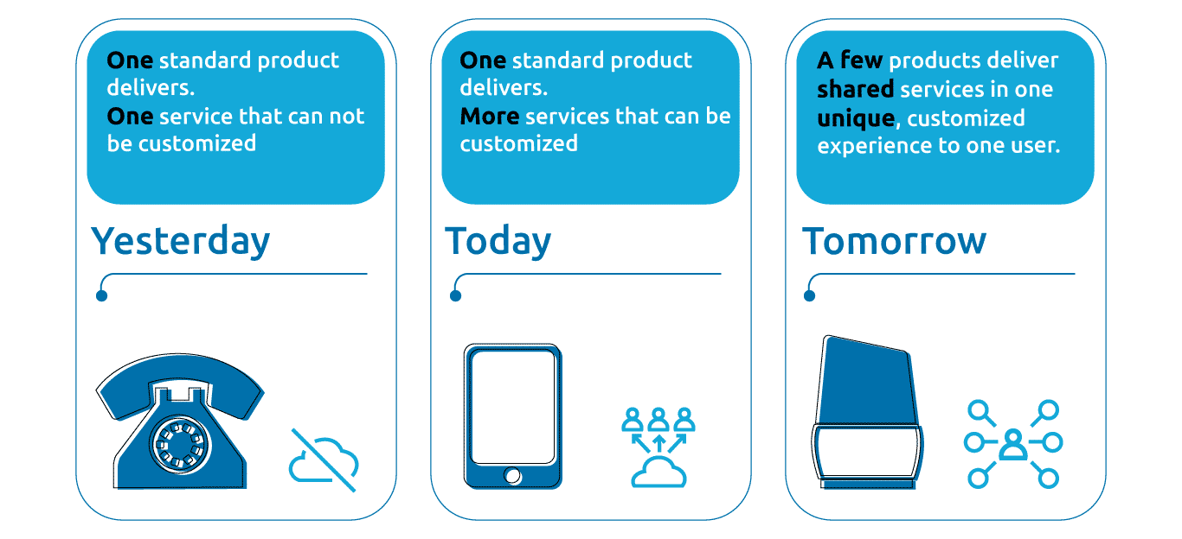
Industrial IOT
The Industrial Internet of Things (IIoT), also known as the Industrial Internet, brings together critical assets, advanced predictive and prescriptive analytics, and modern industrial workers. It is the network of a multitude of industrial devices connected by communications technologies that results in systems that can monitor, collect, exchange, analyse, and deliver valuable new insights like never before. These insights can then help drive smarter, faster business decision-making for industrial companies.
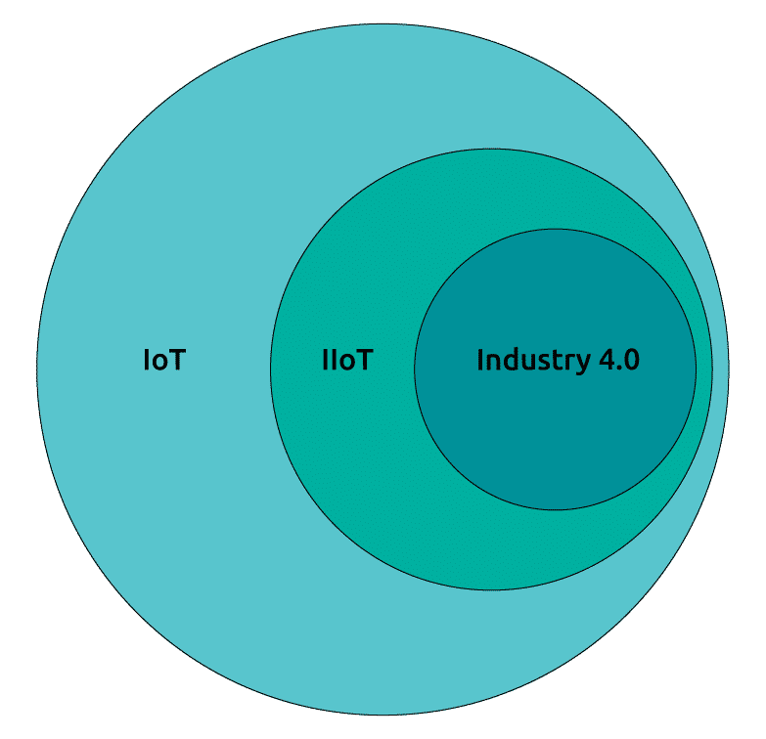
The Industrial Internet of Things (IIoT) is a branch of the Internet of Things (IoT) that is primarily concerned with manufacturing and agriculture.
Let's learn more about the distinctions between IOT and IIOT.
Difference between IOT & IIOT
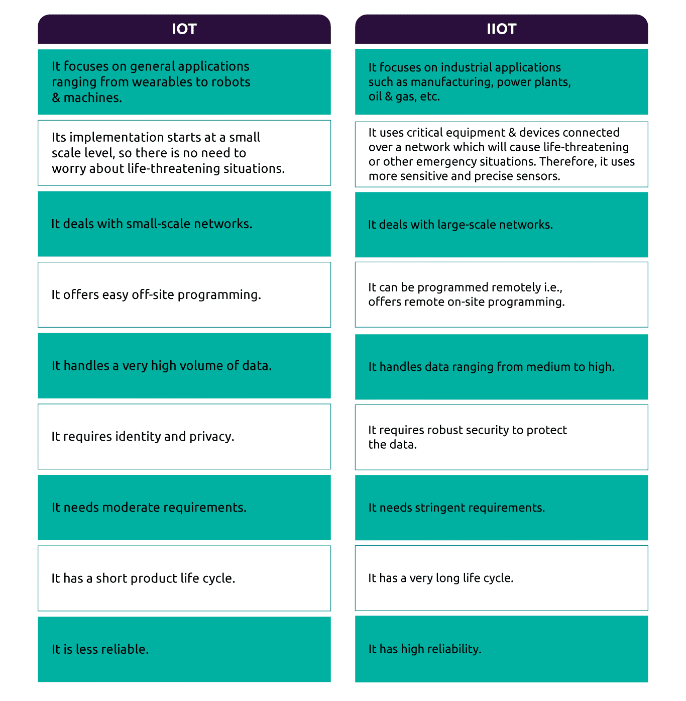
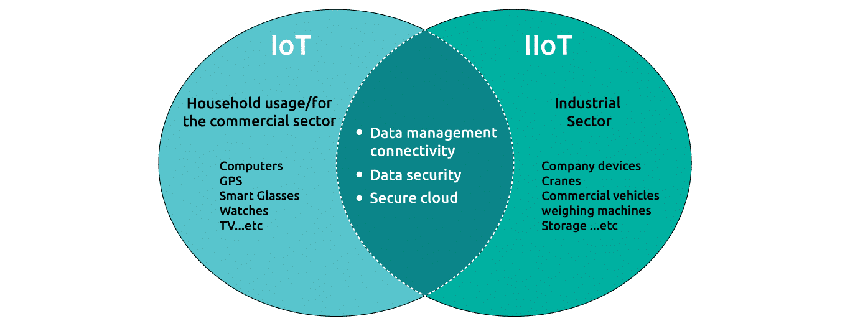
Industrial internet of things applications in Automotive Sector comprise the following
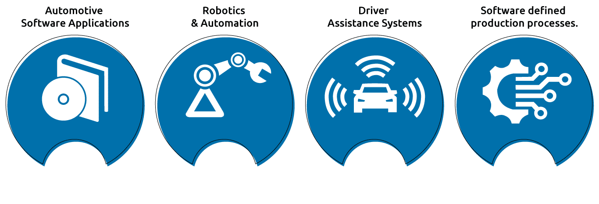
Key Element to Successful IIOT Functionality
- Front of card
No image alternative text
Click to flip
Back of card
In the automotive industry, leveraging the capabilities of Industrial Internet of Things (IIoT) technologies optimizes and automates manufacturing processes. IIoT facilitates the integration of devices, machines, sensors, and systems in the manufacturing environment, forming a connected ecosystem that enhances efficiency, productivity, and decision-making.
In the automotive manufacturing sector, data analytics can cultivate industrial performance through connectivity of machines, equipment, radio-frequency identification (RFID), barcodes, market performance and profit.
In the automotive industry, internet-enabled devices such as PLCs, IPCs, embedded HMIs, robots, vision cameras, and sensors utilize internet connectivity for communication, while connected devices can access the internet through various services like 4G, cellular networks, or Wi-Fi.
Three Layers of IIOT Challenges
When it comes to data consolidation in the automobile business, there are three levels of IIOT challenges.
Data Collection at Operational Level
- Heterogeneous Data Models: In automotive Industry, devices and sensors in IIoT use diverse data models and protocols, making it complex and time-consuming to integrate data into a unified format for consolidation.
- Network Security: IIoT devices in automobile industry are connected to networks, increasing the risk of security threats. Ensuring data integrity and protection against unauthorized access or cyberattacks is crucial during data collection.
- Latency: Real-time data collection is vital for automobile industrial processes, but network latency can delay data transmission, affecting the ability to consolidate and analyse information promptly.
Data Consolidation at Plant Level
- Heterogeneity of Data Sources: Automobile industrial plants have diverse systems and equipment from different manufacturers, generating data in various formats. This makes it difficult to consolidate and standardize data from different sources.
- Network Security: In automotive sector, Consolidating data from different operational areas increases security risks during data transfer and storage. It is vital to implement strong security measures to ensure data integrity and confidentiality.
- Latency: Timely consolidation of data across multiple systems within a plant in automotive Industry can be hindered by latency issues. This can impact real-time decision-making and overall operational efficiency.
Data Monitoring at Corporate Level
- Heterogeneity of Data Sources: In automotive sector, consolidating data at the corporate level involves integrating information from multiple plants or sites, each with its own data models and formats. This complexity requires additional effort for normalization and standardization.
- Network Security: Data consolidation in automobile industry at the corporate level necessitates robust measures to ensure the security and privacy of sensitive information. This includes encryption, access control, and secure data transfer protocols to prevent unauthorized access or breaches.
- Latency: Real-time data monitoring at the corporate level is challenging due to the time needed to consolidate data from multiple plants or sites in automotive Industry. Delayed or outdated data can impact decision-making and hinder prompt responses to operational issues.

Big Data
Big Data for Automotive Industry
In the automobile manufacturing industry, big data analytics enables the collection and integration of information from various functional units and supply chain partners. With the advent of the Internet of Things (IoT) and machine-to-machine (M2M) communication, the automotive industry is aligning itself with the readiness of Industry 4.0. The manufacturing floor now incorporates sensors, RFIDs, barcode readers, and robots as standard equipment, significantly amplifying the number of data generation points.

Big data analytics has transformed the consumer electronics industry, shifting it from a push market to a pull market strategy. By analyzing consumer behaviour patterns, the industry can better understand demand and plan production accordingly. The automotive sector has also benefited from this shift, as IoT advancements and electronic components are now essential parts of vehicles.

Furthermore, big data analytics have helped automobile manufacturers boost their efficiency in terms of sales and marketing. It has also improved its operations by aiding in the incorporation of utilities like predictive maintenance and service schedule. It has also aided automotive vendors in streamlining the procurement process, making it more cost-efficient by analysing the data for demand prediction.

Different domains in which data analytics can be used to improve quality.

Applying advanced analytics across the automobile manufacturing value chain will generate exponential value. Analytics is a powerful tool. However, applying analytics effectively requires knowledge beyond statistics, operations, or information technology.
In order to fully benefit from analytics, it requires a comprehensive set of capabilities that intersect and integrates with multiple functions and teams across the organization. We can improve insights across each component of the value chain.
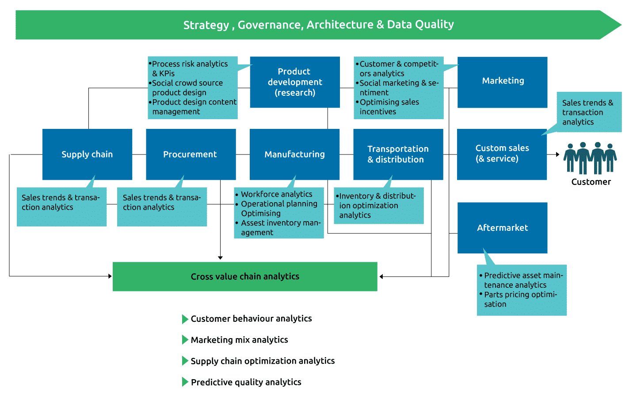
Customer Behavior Analytics
Customers have come to expect a consistent, personalized experience across their access channels. The power of digital is revolutionizing the way in which customers research, purchase and manage the upkeep of their vehicles.
Potential for Analytics
Analytics and information management present a significant opportunity for automakers to use quantitative techniques to support the planning of interventions across the customer lifecycle, including but not limited to:
- Understanding the potential value of different customer segments. Using that knowledge to strategically target new customers whilst maintaining the loyalty of existing customers.
Improving customer experience to drive retention
This could lead, for example, to the formulation of a new innovative retail model such as a pop-up store to drive awareness and/or more targeted campaigns of special service bundles beyond normal warranty to reduce customer leakage and aid retention.
Marketing Mix Analytics
Potential for Analytics
Marketing mix analytics in the automotive industry involves analyzing data to refine product, price, promotion, and distribution strategies. By examining customer behavior, market trends, and competition, automotive companies gain insights to enhance marketing decisions, optimize pricing, target customers, evaluate product features, and improve distribution channels. Applying marketing mix analytics strengthens initiatives, improving customer acquisition, brand awareness, and overall performance.
Use cases for Marketing Mix Analytics Implementation in Automotive sector
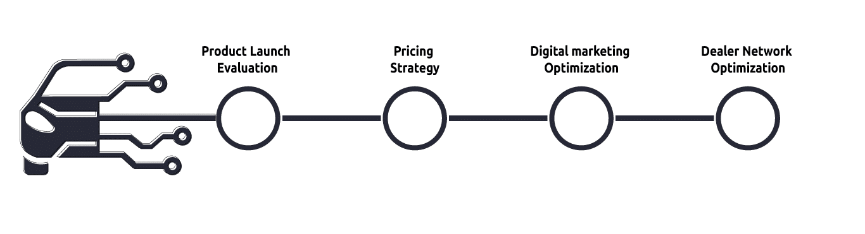
Product Launch Evaluation
Evaluating the influence of marketing initiatives during new vehicle launches. By analysing the impact of advertising, promotions, and public relations efforts on sales and brand awareness, automotive companies can enhance their launch strategies for future products.
Pricing Strategy
Analyzing the effects of various pricing strategies on sales volume, market share, and profitability. By evaluating price elasticity and demand response to price changes, automotive companies can determine the most effective pricing for their vehicles, options, and services.
Digital marketing optimization
Evaluating the effectiveness of various digital marketing campaigns, including SEM, social media ads, email marketing, and website optimization. This analysis enables automotive companies to gain insights into customer behaviour, engagement levels, and conversion rates. By leveraging these insights, companies can refine their digital marketing strategies for better results.
Dealer Network Optimization
Analyzing the performance of various dealerships and their impact on sales and customer satisfaction. This analysis helps automotive companies identify underperforming dealerships, optimize the dealer network, and implement strategies to enhance sales and improve customer experience.
Global Supply Chain Management
(Using data analytics to manage risk and drive growth)
Potential for Analytics
Advanced supply chain analytics represents an operational shift away from reactive management models. Emerging capabilities in this area introduce a proactive management model, equipping automakers with the ability to continually sense and respond as the industry changes around them. Moreover, advanced supply chain analytics can help automakers analyze increasingly larger sets of data using proven analytical and mathematical techniques, including regression analysis, stochastic modelling, and linear and nonlinear optimization.
Supply chain management in the automotive industry can effectively utilize data analytics for managing risk and driving growth through various use cases:
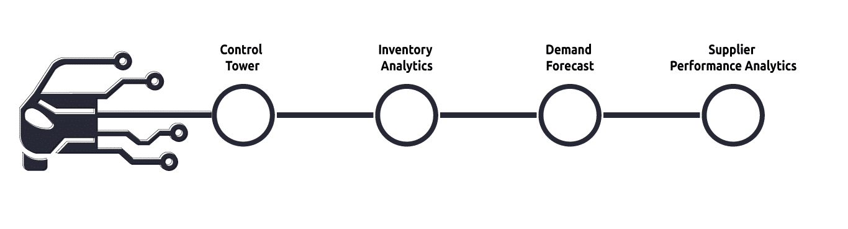
Control Tower
A data analytics-powered Control Tower gives complete oversight and command over the global supply chain, offering real-time insights on suppliers, production, logistics, and distribution. It enables proactive risk management, operational optimization, and data-driven decision-making for automotive companies' growth.
Inventory Analytics
Data analytics improves inventory management by analyzing sales data, trends, and demand patterns. It optimizes stock levels, lowers costs, and enhances customer satisfaction for automotive companies.
Demand Forecast
Data analytics techniques enable automotive companies to forecast demand accurately. By analyzing historical sales data, market trends, customer behaviour, and external factors, companies can predict future demand patterns. This enables them to align production, procurement, and distribution activities, reducing supply chain risks and capitalizing on growth opportunities.
Supplier Performance Analytics
Data analytics empowers automotive companies to evaluate and control supplier performance efficiently. By examining supplier capabilities, delivery reliability, quality metrics, and cost performance, companies can make informed choices for selecting, evaluating, and optimizing their supplier network. This reduces supply chain risks, enhances operational excellence, and promotes growth.
Predictive Quality Analysis
Potential for Analytics
Predictive Quality Analytics in the automotive industry enables the early identification of quality and safety risks in vehicles, allowing prompt and focused actions to be taken. To begin, various external and internal data sources are prioritized, consolidated, and correlated. Through comprehensive data analysis and iterative processes, predictive models are developed, employing diverse evaluation techniques. These models have the capability to forecast not only immediate defects but also long-term issues that may result in warranty claims. This approach aids in ensuring vehicle quality and reducing safety concerns for both short-term and extended periods of ownership.
Use cases for predictive quality analysis implementation in automotive sector
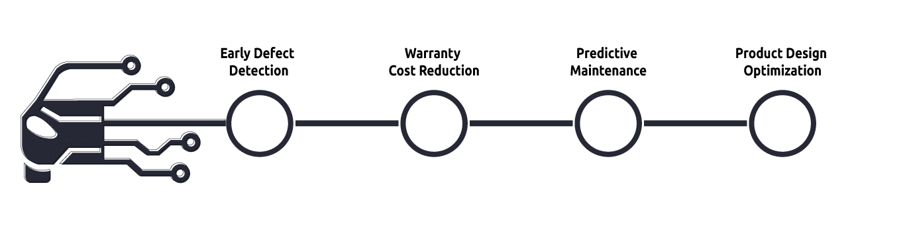
Early Defect Detection
By analyzing historical data and real-time sensor readings from vehicles on the production line, predictive quality analysis can identify patterns and indicators of potential defects in the vehicle. This enables manufacturers to detect quality issues early in the manufacturing process, allowing for timely corrective actions and reducing the number of defective vehicles reaching customers.
Warranty Cost Reduction
Predictive quality analysis can help automotive manufacturers identify the factors that contribute to warranty claims and repairs. By analyzing warranty data, sensor data, and other relevant information, patterns can be identified to predict potential failures or malfunctions in vehicles. This helps manufacturers proactively address these issues during the design and production stages, reducing warranty costs and improving customer satisfaction.
Predictive Maintenance
Automotive manufacturers can leverage predictive quality analysis to implement predictive maintenance programs. By analyzing data from vehicle sensors, historical maintenance records, and other relevant data sources, manufacturers can predict when a component or system is likely to fail. This allows for proactive maintenance interventions, minimizing vehicle downtime, improving safety, and reducing maintenance costs.
Product Design Optimization
Predictive quality analysis can be used during the product design phase to predict the impact of design choices on product quality. By simulating different design scenarios and analyzing historical data, manufacturers can identify potential quality issues early in the design process. This enables them to make design modifications that improve product quality, reduce recalls, and enhance customer satisfaction.
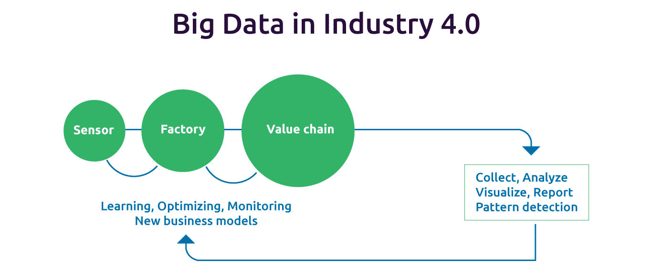
Big Data Use Case
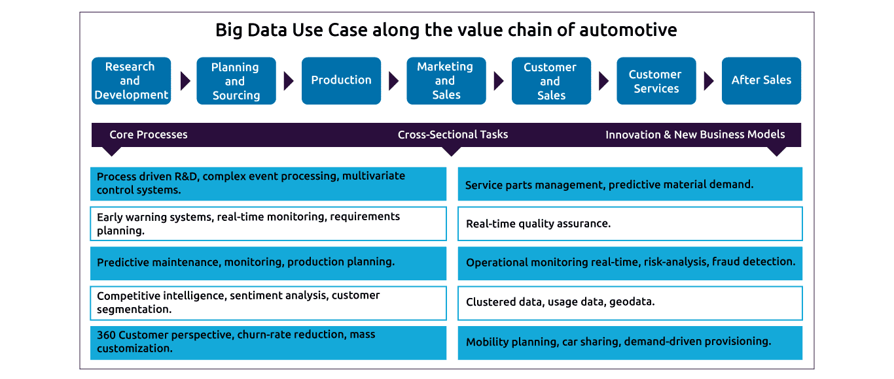
The applicability of Big Data also lies in the business strategies directly involved in manufacturing, resulting in systems such as:
- •
Enterprise Resource Planning
- •
Supplier Relationship Management Systems
- •
Product Life Cycle Management Systems
- •
More Environmentally Responsible Systems
Cloud Platform
Cloud Platform for Automotive Sector
By harnessing the power of cloud platforms, the automotive industry can achieve greater connectivity, data-driven insights, operational efficiencies, and accelerated innovation, ultimately transforming the way vehicles are designed, manufactured, operated, and serviced.
Overall, cloud platforms have a profound impact on the automotive industry, offering benefits in connectivity, data analytics, cost efficiency, customer experiences, supply chain management, sustainability, regulatory compliance, and more. By embracing cloud technologies, automotive companies can unlock new opportunities for innovation, growth, and competitive advantage in the rapidly evolving automotive landscape.
Ways the cloud is impacting the automotive sector
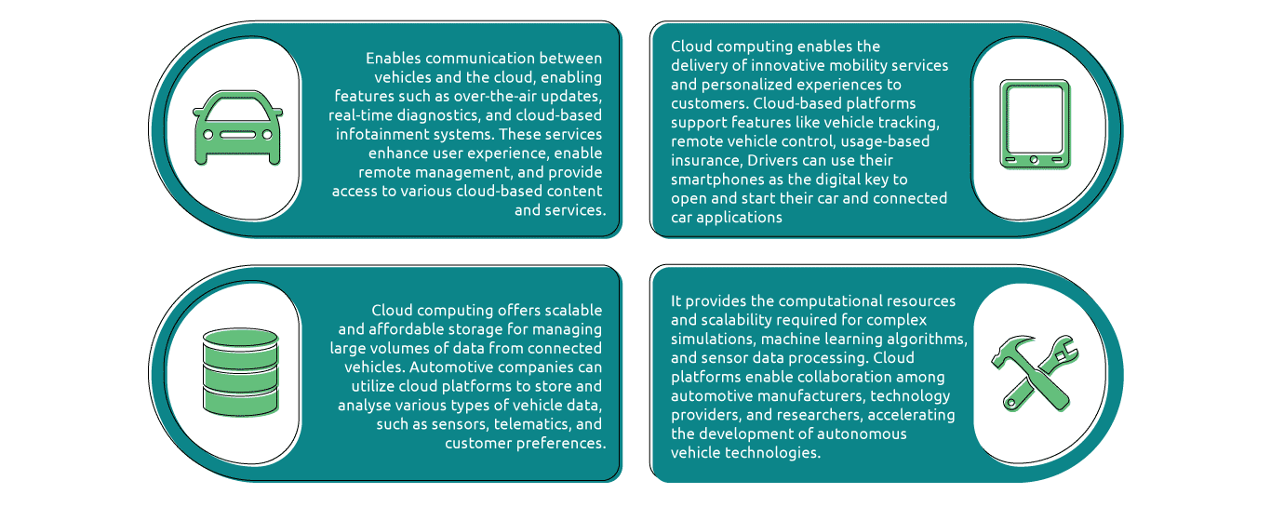
Reduction in Costs
- Infrastructure Cost: Many automobile manufacturers have had to rely on the existence of on-site infrastructure for their daily operations, and this has translated to huge overheads for hardware, software licensing, space, power, cooling systems, hiring and training of staff, and much more.
- Maintenance and Updates: Cloud providers manage maintenance and updates, relieving automotive companies from hardware maintenance and costly software updates.
- Scalability: Cloud services enable automotive companies to efficiently adjust their computing resources according to their needs, minimizing costs by paying only for utilized resources and avoiding excessive provisioning.
Security and Risk Reduction
- Data Security: Like in any other sector, when manufacturers run their own on-premise infrastructure, they are responsible for safeguarding their sensitive data and keeping their systems safe from unauthorized access by attackers.
- Threat Detection and Response: With the cloud, manufacturers can transfer the burden of protecting their systems to cloud providers. Besides protecting the systems from the malicious activities of hackers, the cloud also helps to reduce the risk of data damage and errors.
Cabin System
- Entertainment & Infotainment: Cloud computing empowers automotive companies to provide advanced entertainment and infotainment systems in vehicles, allowing passengers to access a variety of media, streaming content, real-time information, and personalized experiences during their travels.
- Voice Assistance: Cloud-based voice recognition and natural language processing services enable intelligent voice assistants in vehicles, allowing passengers to interact with them for controlling cabin features, accessing information, making reservations, and more.
Protection from Natural Disasters
- Data backup and Recovery: Cloud computing ensures automatic data backup and replication across multiple data centers, protecting against data loss caused by natural disasters by storing data securely in redundant cloud environments.
- Geographics Redundancy: Cloud providers maintain data centers in different regions, which automotive companies can use to ensure uninterrupted operations and reduce the effects of natural disasters on their business.
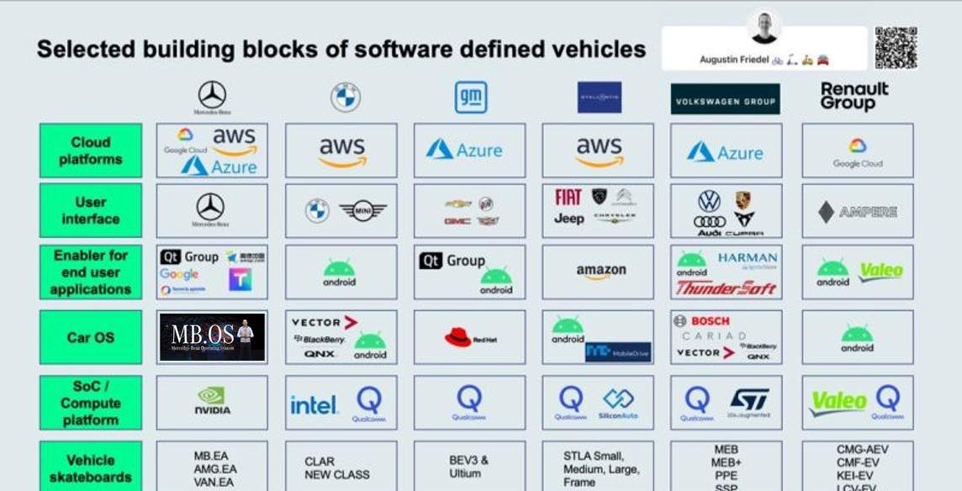
AI/ML & AR/VR to Achieve Business Drivers
Artificial Intelligence (AI) and Machine Learning (ML) algorithms are employed in the automotive sector for various applications. This includes autonomous driving, predictive maintenance, intelligent manufacturing, natural language processing, and customer experience personalization.
Artificial Intelligence (AI) in Automotive Industry
Evolution of AI in Automotive Industry
In the automotive industry, the implementation of artificial intelligence is at a lower rate compared to Financial Services, ICT, Retail, and Healthcare sectors. In terms of AI technology adoption and implementation – the automotive industry can be categorized as ‘new adopters'.
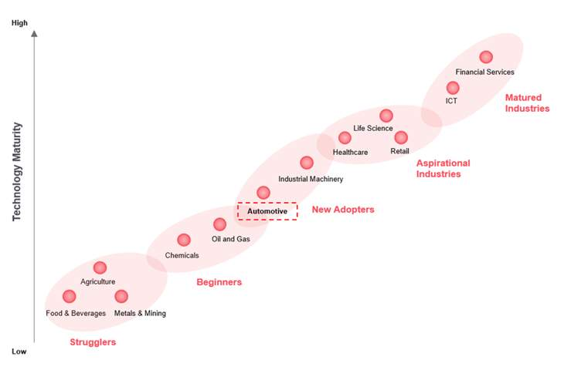
Role of AI in the Automotive Value Chain
Currently, AI is being implemented in automotive manufacturing, including design, supply chain, production, and post-production. In addition, AI is being implemented in ‘driver assistance’ and ‘driver risk assessment’ systems, which is transforming the transportation sector. Aftermarket services such as predictive maintenance and insurance are also transforming through the usage of AI.
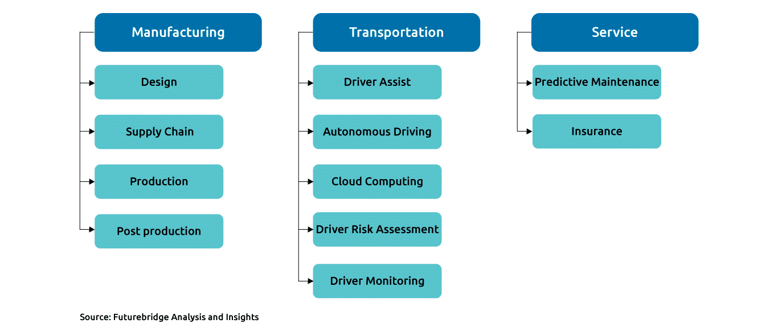
Robots are simultaneously working with human and learning automotive manufacturing skills (design, part manufacturing, and assembly) with the help of AI. Currently, AI helps humans to develop cars using Exoskeletons; in the future, the entire plant can be operated by these AI-powered robots.
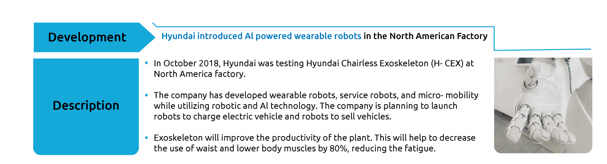
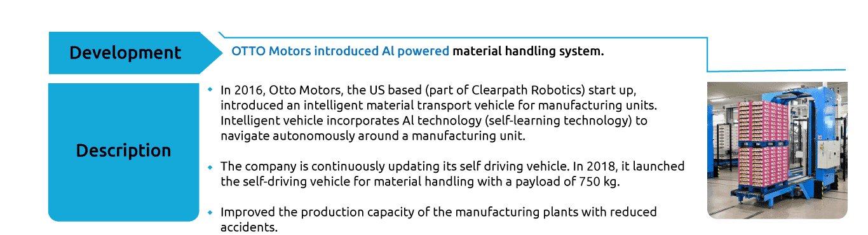
AI is revolutionizing the transportation sector. Currently, AI is playing a vital role in driver assistance technology, and it is being used widely in modern vehicles. Currently, Tesla is offering level 2 autonomous cars, and the company has been planning to launch level 4/5 autonomous vehicles. AI can be used to monitor the driver’s eye – whether one is sleeping/tired or not.
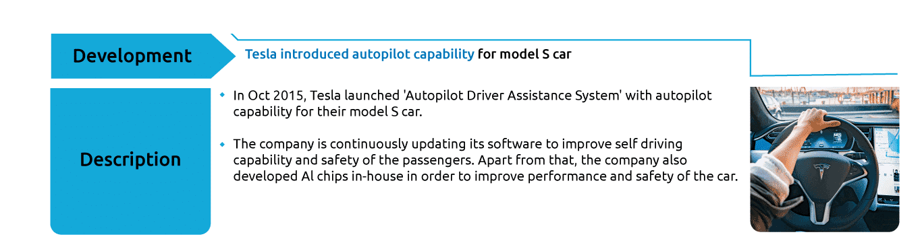
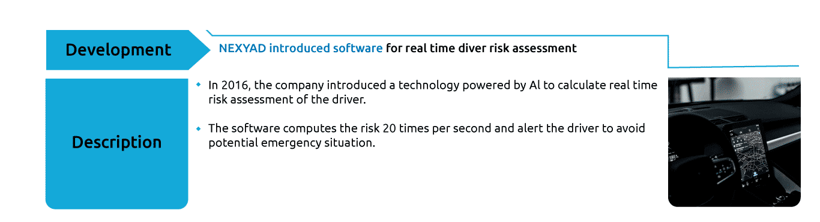

AI can play a significant role in aftermarket service. Currently, many AI applications predict the problems related to engine performance, battery performance, etc. that may occur in the future. In addition, there are many AI-powered insurance providers who offer quick services i.e., in availing insurance and claim settlements, to customers.
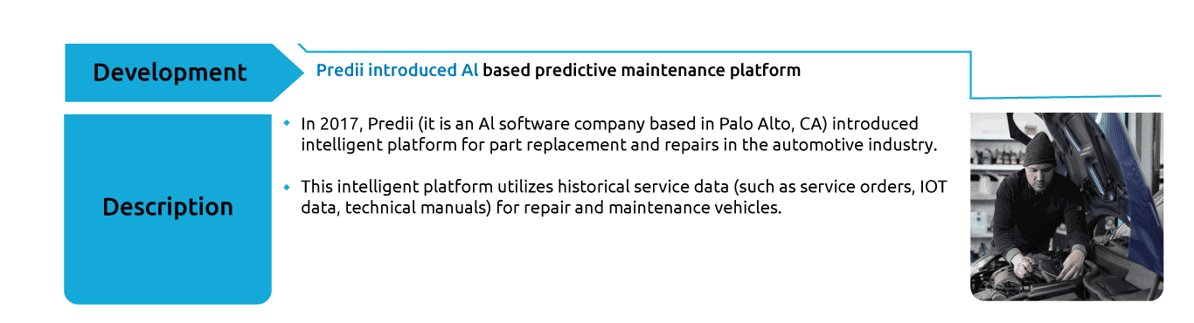
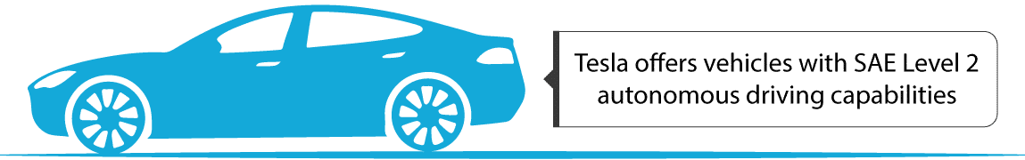
Machine Learning (ML) in Automotive Industry
Self-Driving/Automated Cars:
With recent advancements in technology and modern-day Artificial Intelligence becoming more and more advanced, Automated/Self-driving cars are no longer things of the past. Ranging from Tesla’s sophisticated autopilot, to its base form of sensing objects, autonomous cars are here to stay, and this is a result of machine learning. Aspects of machine learning that can be applied to autonomous cars include lane detection, image processing, object detection, object classification, object identification, etc.
Smart Manufacturing:
With intelligent systems in the automotive industry, managers can collect data on every aspect of their operations, such as product retrieval, energy usage and time to completion for existing models. AI-powered software will then help them to glean insights from this information, namely tips for improving efficiency, reducing unforeseen errors and improving workplace safety.
Augmented Reality (AR)
Augmented Reality (AR) is an interactive experience of a real-world environment where the objects that reside in the real world are enhanced by computer-generated perceptual information, sometimes across multiple sensory modalities, including visual, auditory, haptic, somatosensory and olfactory.
Heads Up Display:- Since the late 1980s, some makers have included a HUD option similar to those found in aircraft, displaying operating data like velocity, engine speed, fuel consumption, and similar items. Projecting this information onto the windshield in front of the driver overlaid onto the driver’s actual view of the road created an augmented reality. These have grown into GPS navigation, lane departure guides for exiting the freeway and blind spot cameras. Enhanced backing assistance displays a graphic of the “danger zone” directly behind the vehicle.
AR in Automobile Sales
- 1
Using AR in the showroom. Salespeople can use their smartphone camera to view the car with overlaid information about every option, financing and weight, performance or mileage.
- 2
This empowers sales personnel to provide instant answers to buyers hungry for knowledge.
- 3
This technology allows consumers to view the car where it sits, with the ability to walk around it, displaying different colors, options and trim in real-time.
- 4
With many brands offering dozens of models, this concept will save space for the maker and time for the consumer.
VR in Automotive Industry
The automotive industry continually seeks methods to improve vehicle quality, manage costs, and decrease time to market. Consequently, it is unsurprising that an increasing number of automotive companies are adopting Virtual Reality (VR) technology in various aspects of their product and sales processes to enhance efficiency. Whether it is applied to design, research, manufacturing, sales, or marketing, VR is being leveraged to achieve higher levels of effectiveness in the automotive sector.
VR in automobile sales enhances the overall customer experience, offering convenience and enabling customers to visualize and engage with vehicles in innovative ways. Automotive dealerships can leverage VR technology to create immersive and unforgettable experiences, resulting in improved customer satisfaction and increased sales in a dynamic and competitive market.
Use Case
Accelerated Adoption of Industry 4.0 involves:
- 1
Autonomous vehicles
- 2
Internet of Things = connected cars
- 3
Digitization is disrupting automotive manufacturing
- 4
Human skill sets are vital
- 5
The end of the annual service
Use Cases for faster Adoption of Industry 4.0
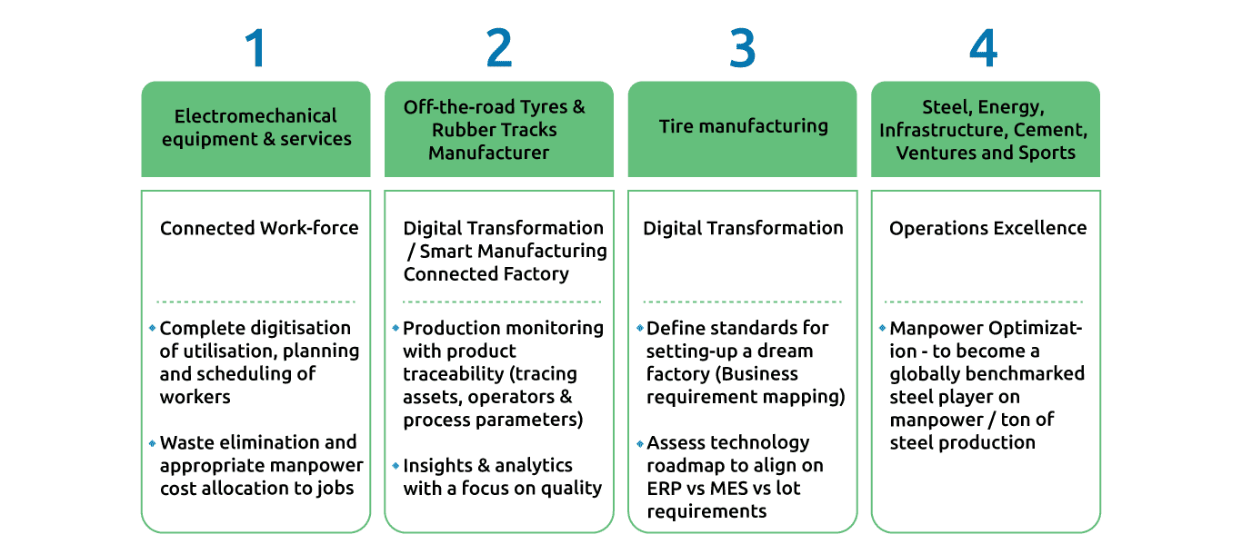
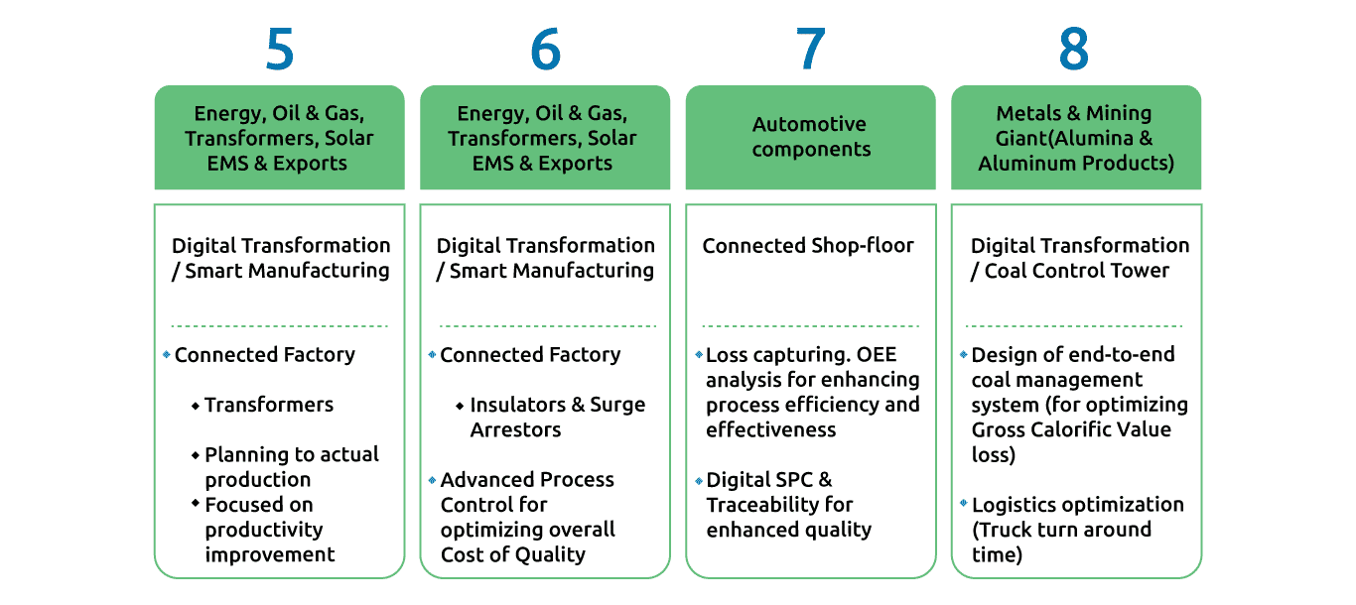
Conclusion
- •
It’s time to retire the conventional wisdom that a car loses value the moment someone drives it off the dealer’s lot. With today’s technological advancements, cars can become more valuable over time, not less. This change is driven by the growing prevalence of software within cars and the ability to upgrade that software over time in order to add new features.
- •
In this way, cars are becoming no different than phones, smart refrigerators and every other connected device. The rising expectation from consumers is that the underlying software in everyday hardware will be regularly updated with new functionality and features, without them having to buy a new model for that privilege.

